The Implementation of Gamification
Research Manual
by
Daniel Crimmins
C00221046
Institute of Technology Carlow
October 2019

Abstract
Gamification is the process of applying the mechanics typically found in games and applying them to a process. In this example, the process is a learning process, but the technique of gamification can be applied to almost any existing process to some extent. It is the aim of this document to inform of the techniques involved in the implementation of gamification and outline the details of developing an application which utilizes these techniques.

Table of Contents
Abstract 2
1. Introduction 3
2. Overview of areas researched 4
2.1 Gamification: What is it? 4
2.1.1. Achievements 5
2.1.2. High Scores 5
2.1.3. Self-Expression 6
3. Application Scope 6
3.1. GDPR 6
3.2. Networking 6
3.3. Incident Handling & Risk Analysis 6
3.4. Other Modules Considered 7
4. Similar Applications 7
4.1. Duolingo 7
4.2 Sponge 7
5. Technology Stack 8
5.1. Android v iOS 8
5.2. Software Development Tools 9
5.2.1. Android Studio 9
5.1.2. Eclipse 9
5.1.3 Xamarin 9
6. Conclusion 9
7. Bibliography 9

1. Introduction
Trying to grab somebody’s attention is hard, holding their attention is harder. This is the problem that many teachers are faced with currently. “How do I teach someone who doesn’t want to learn?” In a study published by Ofcom, it is stated that in the UK, the average time spent online using a phone is 2 hours and 38 minutes. [1] This is a large obstacle for educators who must compete with phones for people’s attention. As the idiom goes, you can drag a horse to water, but you can’t make it drink. So how do you encourage people to engage with a learning process where they otherwise would have no interest? Gamification.
Gamification is the introduction of mechanics typically found in video games to another area or process. The foundations for this train of thought are not novel. Just like a teacher might award ‘gold stars’ to young students for good behavior or academic excellence, gamification manipulates the reward receptors in the brain into enticing a user into engaging with an application. This can be done by implementing ‘reward’ mechanics such as achievements or points which can then be shared on a leaderboard, or by tracking progress which incentivize users to complete tasks.
This research manual will present an overview of gamification and the details of its application as it applies to a learning application.

2. Overview of areas researched

2.1 Gamification: What is it?
Gamification is the application of mechanics usually found in games to other areas or processes. Gamification is applied to increase engagement with a process. The techniques it uses to increase engagement are numerous, they include; rewards-based learning e.g. “if you get X% on this exam, you will receive Y”. This is a very basic form of gamification that will be familiar to almost anybody. A more basic form of this technique is often employed by parents when rising young children, “If you X, you will receive Y” this gamifies a learning technique, whether that technique is educational (school exam) or social (learning how to act when in certain social situations). The core concept is the same, a user will be compelled to complete a task in order to achieve something, or to feel a sense of achievement, both rewards are powerful motivators.
In an article from 2015 by Asha Pandey, she lists the motivators for learning and how several mediums stimulate the learning process. [10]
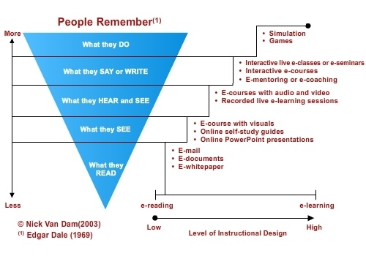
From this diagram the benefits of gamification over traditional learning processes can be deduced, put simply, the more engaged with a learning process the user is, the more effective the retention of information.
In J.J. Lee & J. Hammer’s report “Gamification in Education: What, How, Why Bother?” they compare the engagement of children in school, a place they consider to be a good environment for testing gamification, with the engagement of users who play online games.
“28 million people harvest their crops in Farmville on a daily basis, and over five million people play World of Warcraft for more than 40 hours per week. On the other hand, the default environment of school often results in undesirable outcomes such as disengagement, cheating, learned helplessness, and dropping out.” [2]
The reason for this amount of engagement is the game mechanics which are designed to keep users returning, this can be achieved through manipulation of dopamine receptors to give the user a ‘feel-good’ burst similar to that of cigarettes. [4] It is these mechanics that, when implemented unethically, can create a video-game addiction.
The techniques utilized are varied but include well known game mechanics such as:

2.1.1. Achievements
Rewarding achievements; this common game mechanic is a well-established technique that is used to increase engagement. It can be found in both the X-box One and the PlayStation 4 in the form of ‘achievements. These were introduced as early on as 2007 [5] and served as a method of enticing users into spending more time playing their games by introducing challenges which, when completed would unlock an achievement, which would increase their ‘Gamerscore’ by a specified amount.

2.1.2. High Scores
Comparing scores with other players; this mechanic was popularized by X-box to great success when they introduced ‘Gamerscore’. This score was increased by accumulating points gained by unlocking achievements, a look at the leaderboard can be found at https://www.trueachievements.com/leaderboard/gamer/gamerscore [6]. This engages users in a competitive and fun way, it also adds a social aspect to the process. This leaderboard can be localized or online.

2.1.3. Self-Expression
Self-Expression; this technique refers to the user’s ability to customize their experience with the gamified process. This increases their engagement as they can see themselves in the activity and will be motived to reach their goals. A good example of this is an in-game avatar. This allows the user to figuratively put themselves inside the application, increasing their engagement.
These are just some of the techniques that can be utilized when gamifying a process. The purpose of this research manual is to support an application that will gamify the process of learning the core principals of cybersecurity.

3. Application Scope
This application will focus on gamifying the process of learning the basics of cybersecurity and some topics linked to cybersecurity that will form a foundational knowledge for professionals who wish to increase their awareness in this field. This application will focus on areas which I feel are essential to learning the basics of computer security, including modules such as:

3.1. GDPR
GDPR as a regulation which affects data controlling in the European Union is essential knowledge for anybody hoping to enter the field of cybersecurity. It dictates the proper procedures of handling personal information [11] which will inevitably factor into the job description of a cybersecurity professional.

3.2. Networking
The transfer of data between computers and networks is something that all IT professionals should have a base knowledge of. The application will springboard off the topics covered by Cisco as a means of providing a brief overview of how data is transferred across a network.

3.3. Incident Handling & Risk Analysis
This module of the application will aim to impart knowledge of how to analyze a security process and identify potential threats. It will also teach users how to construct a basic incident handling report. This module will draw from my own studies in IT Carlow. [12]

3.4. Other Modules Considered
Other modules considered for the application are basic programming, algorithms & data structures, computer forensics and basic security practices.

4. Similar Applications

4.1. Duolingo
The application will take the same approach to gamification as some other successful eLearning apps such as Duolingo which, at the time of this writing has over 100 million downloads [7] and has an active userbase of 300 million as of August 2019 [8]. The app will focus on presenting engaging ways to cover the modules mentioned above, such as:
- Tracking progress with a progress bar and rewarding the user for each completed module
- Awarding points for completed milestones which can be used to purchase in-app cosmetics/features
- Comparing progress with other users via online database
- Allowing users to set up custom milestones
- Bundling modules together into ‘packages’
- Having a bright and user-friendly UI
Duolingo is the benchmark for gamified learning processes and although it would be optimistic to hope to emulate the level of success that Duolingo has, there are lessons to be learned in the approach and techniques that the application employs.

4.2 Sponge
Sponge are an organization that specialize in digital learning, they also have an application that specializes in cybersecurity [9]. This makes them an ideal candidate for comparison. The application developed by sponge consists of a series of questions or real-life scenarios and then asks the user a question based on these scenarios.
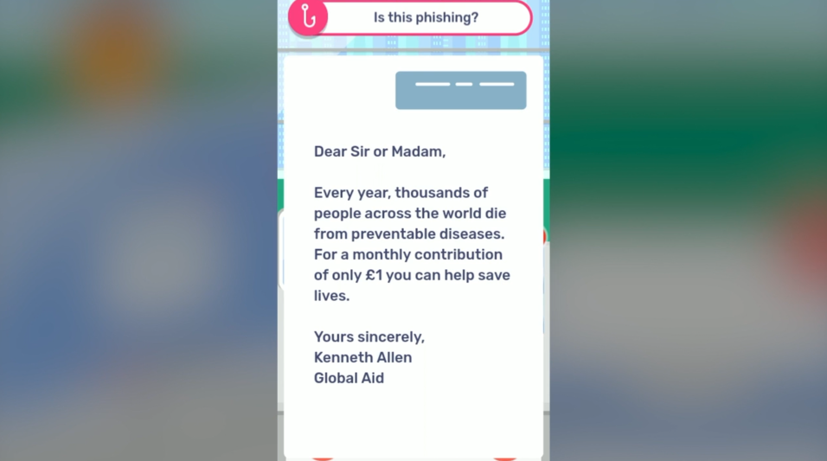
Sample question from Sponge Cybersecurity application demo.

Some of the gamification features utilized in this learning resource are; level-based progression, high score tracking and a training ‘level’. These gamification techniques combined with a bright and clear user interface, as well as a quick average play time of 25-30 minutes [9] allow for a quick and enjoyable experience that entices the users into returning to the application.
The similarities between this application and the application presented in this research manual, as well as the similar demographic at which the applications are aimed, make this an ideal candidate for comparison.

5. Technology Stack

5.1. Android v iOS
This section will focus on the research compiled when deciding on the technological aspects of the project. Upon researching the acceptance criteria of both Android apps on the Play Store [14] and iOS apps on the App Store [15] I decided to develop an android app, initially, as the criteria for successfully passing the screening process for android applications are less stringent. Some major differences include; the initial fee, which is $99 for iOS and $25 for Android development. The approval time is also significantly shorter at ~2 days for iOS and ~7 hours for Android.
Some of the drawbacks of Android development, namely, the struggle of monetization and open-source nature of the platform meaning there will likely be security issues were considered, but upon weighing up these drawbacks with the positives I decided on Android development.

5.2. Software Development Tools

5.2.1. Android Studio
Android Studio was the initial choice for the application development, this was due to my own familiarity with the development environment. I had also studied Java while attending college, so this again was a familiar language to me. It is also the official android development IDE and has many useful features such as Visual Layout Editor. [13]

5.1.2. Eclipse
Eclipse was the popular choice for Android development before the introduction of the Google-supported Android Studio, it also uses Java. It is a slightly more generic Java IDE and can run smoother than Android Studio depending on the setup of the environment.

5.1.3 Xamarin
Xamarin is an open source tool used for cross-app development. It is based on the .NET framework and uses C# for mobile app development. [16] It is unfamiliar to me as I have never used this tool before, it also has a smaller userbase than the tools discussed in 5.1.1 and 5.1.2. This would mean that the learning resources for this particular tool are likely to be harder to find or less expansive than the previously mentioned tools. It also requires Visual Studio which requires a subscription.

5.1.3 Corona
Corona is a lightweight framework that uses the Lua language. It is popular in the development of 2D games. It again has a smaller userbase in comparison with other tools mentioned in this document which may increase the difficulty of the learning curve. I am also unfamiliar to the Lua language.

6. Conclusion
After conducting the research mapped out in this manual, I have decided to develop an Android application using Android Studio. This application will be the vehicle for a learning process that will consist mainly of informative scenarios on the topics surrounding cybersecurity followed by questions. The application will include game mechanics such as, a customizable avatar, an achievement-based system where correct answers or actions will be rewarded, and a local leaderboard. A local leaderboard was chosen as the time constraints of a hosted online leaderboard may expand beyond the scope of this project. After researching similar applications on the market today it seems that the more successful applications in this field utilize a bright, colorful user interface so this is the approach I will also take when developing the application. I feel that through the research outlined in this report I have the knowledge base to increase user engagement and provide a solution to the question “How do I teach someone who doesn’t want to learn?”

7. Bibliography
[1] A Decade of Digital Dependency, 2 August 2018, Ofcom, accessed 25 October 2019 <https://www.ofcom.org.uk/about-ofcom/latest/features-and-news/decade-of-digital-dependency>

[2] J. J. Lee, J. Hammer, 2011, Gamification in Education: What, How, Why Bother?, ResearchGate, accessed 25 October 2019 <https://www.researchgate.net/publication/258697764_Gamification_in_Education_What_How_Why_Bother>
[3] R. Huling, 2010, Gamification: Turning Work Into Play, h+ Magazine, accessed 26 October 2019, <https://hplusmagazine.com/2010/03/25/gamification-turning-work-play/>
[4] D.J. Linden PhD, 2011, Video Games Can Activate The Brain’s Pleasure Circuts, Psychology Today, accessed 26 October 2019, <https://www.psychologytoday.com/us/blog/the-compass-pleasure/201110/video-games-can-activate-the-brains-pleasure-circuits-0>
[5] Addicted to Achievements?, Gamerscore Blog, 1 February 2007, accessed 28 October 2019, < https://web.archive.org/web/20100210173501/http://gamerscoreblog.com/team/archive/2007/02/01/540575.aspx>
[6] Gamer by Gamerscore, TrueAchievements.com, accessed 28 October 2019, <https://www.trueachievements.com/leaderboard/gamer/gamerscore>
[7] Duolingo Play Store Homepage, Google Play, accessed 28 October 2019, <https://play.google.com/store/apps/details?id=com.duolingo&hl=en_US>
[8] F. Lardinois, 1st August 2018, Duolingo hires its first chief marketing officer as active user numbers stagnate but revenue grows TechCrunch.com, accessed 28 October 2019, <https://techcrunch.com/2018/08/01/duolingo-hires-its-first-chief-marketing-officer-as-active-user-numbers-stagnate/ >
[9] Cybersecurity Sorted, Sponge, accessed 29 October 2019, <https://wearesponge.com/cybersecurity>
[10] A. Pandey, 17 June 2015, Top 6 Benefits of Gamification in eLearning, eLearning Industry, accessed 29 October 2019, <https://elearningindustry.com/top-6-benefits-of-gamification-in-elearning>
[11] EU GDPR, accessed 29 October 2019, <https://eugdpr.org/>
[12] I.T. Carlow Cirruculum – Incident Response & Risk Analysis, accessed 29 October 2019, <http://itcarlow.akarisoftware.com/index.cfm/page/module/moduleCode/ZANY%20H2201>
[13] Android Studio Homepage, accessed 30 October 2019, <https://developer.android.com/studio/>
[14] Android Launch Checklist, Google Play, accessed 30 October 2019, <https://developer.android.com/distribute/best-practices/launch/launch-checklist>
[15] Apple App Store Review Guidelines, Apple, accessed 30 October 2019, <https://developer.apple.com/app-store/review/guidelines/>
[16] Xamarin Docuentation, Microsoft, accessed 30 October 2019, <https://docs.microsoft.com/en-us/xamarin/>
[17] Corona Documentation, Corona Labs, accessed 30 October 2019, <https://docs.coronalabs.com/guide/programming/intro/index.html>

