The Implementation of Gamification
Functional Specification
by
Daniel Crimmins
C00221046
Institute of Technology Carlow
October 2019

Table of Contents
1. Introduction 2
1.1. Overview 2
2. General Description 3
2.1. System Functions 3
2.1.1. Home Screen Wireframe 3
2.2. Operational Scenario 4
2.2.1. Operational Flow Diagram 4
2.2.2 UI Palette 5
2.3. Constraints 6
3. Preliminary Schedule 6

1. Introduction

Overview
The application will be a stand-alone Android application. The application will be a gamified learning process that focuses on teaching the basics of cybersecurity for industry. The application is aimed primarily at people who currently work in the technical industry and want to develop their knowledge base in the cybersecurity field. It can also be a useful tool for organizations who wish to educate a group of employees.
The application will consist of a core group of modules, each divided by topic and then divided again by difficulty. As the users progress through these modules, they will be rewarded with points which will be reflected in a progress bar which is assigned to each user’s profile.
The user will also have a customizable profile and will receive rewards for progressing up through the progress bar.

General Description

System Functions
The application will function similarly to other similar applications. It will open with a landing page. This will lead to a home screen which will display the players progress as a main focus. The initial concept for the progress metric will be a large brightly coloured bar which will display current points against points needed to progress to the next level.
The home screen will also display any current modules in progress as a reminder to the user. This home screen will have a branch in the upper left-hand corner which will allow the user to navigate the application and user icon in the top right which will allow easy access to the user profile which houses personal information and a brief overview of the current progress. The preliminary outline for the home screen is as follows:

Home Screen Wireframe
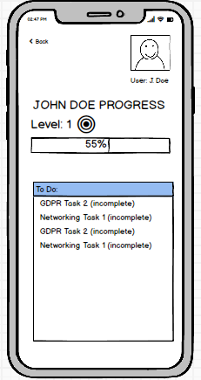
Home screen overview, Balsamiq.
This wireframe represents a concept homepage that the application will build off. The navigation menu will be located under the ‘back’ button in the upper left hand corner of the screen.

Operational Scenario
The users flow through the application will be smooth. At all times the user will be able to access the navigation menu which will allow them to navigate freely to another section of the application. There will be a direct flow which will lead the user from the homepage, to the learning modules menu, to the modules themselves. This will be clearly accessible as this is the main path the users will take when using the application. The navigation menu button will always be accessible, as well as a ‘back’ button which will return the user to the previous page in the application.
The flow of the application will look something as follows:

Operational Flow Diagram

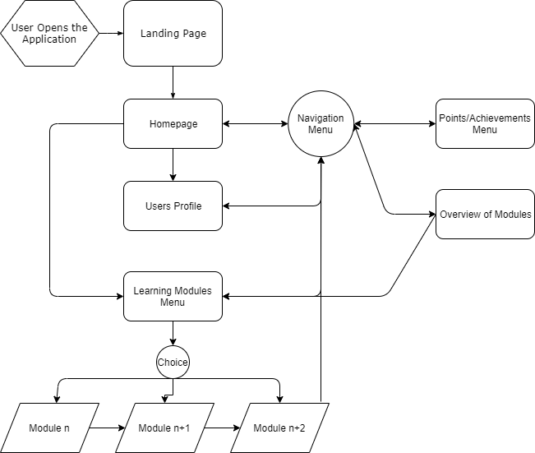
As can be seen in the above operational flowchart, the user is guided along a path from landing page to modules but has the option to revert to the navigational menu at any time.

2.2.2 UI Palette
The application will consist of bright primary colours. Research into contemporary applications in the same field show that they utilize this kind of palette. It makes the application cheery and uplifting. It also emphasizes the casual nature of the work. The palette will be very similar to the palette shown below
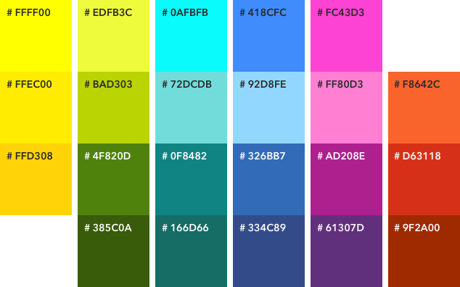

Constraints
The application will be under constraints mainly due to a time limit and the workforce behind the application. The application deadline is strict, and the work is undertaken by one person. The progression of the application will also be hampered by the level of development history the developer has.

User Groups
The target demographic for this application are professionals over the age of 18 who currently work in the I.T. sector. Targeting this demographic allows us to assume some level of technical competency and allows us to gloss over the basics of information technology so that we may better focus of the topics of cybersecurity. There is no prerequisite knowledge of cybersecurity assumed. If a user has a base knowledge of I.T. (e.g. how to operate a computer, has a base understanding of how computers communicate) then this application is tailored to build from this level of expertise.
Other demographics were considered in the conceptual phase of the application, but this user group seemed the most likely to adopt the application into day to day life and research into similar applications (namely Sponge. Cybersecurity) has shown that this user group does indeed have a use for this kind of application.

Metrics
For this application the metrics for success are:
- A functional application
- A user

Preliminary Schedule
As it stands the preliminary schedule for the application is as follows
Research Manual | 1/11th
Functional Specification | 15/11th
Design Manual | 29/11th
Presentation | 6/1st
Technical Manual | 3/4th
Final Report | 3/4th
Delivery | 20/4th

