Project Report
by
Daniel Crimmins
C00221046
Institute of Technology, Carlow
April 2020

Problems Encountered
During the course of this project I encountered some problems which impeded my progress in the development of this application. The first of these problems was hardware related. In order to properly test the application, it is recommended that a virtual device be enabled for testing the current build.
This requires hardware which supports virtualization which I did not possess at the outset of the project. I first attempted to run an older API virtual device in the hopes that it would be supported. It was supported by the hardware I was using but was unfortunately too slow to be an effective tool.
This problem was overcome by using an external device to run the application in this case it was a Nvidia Shield tablet.

Achievements/Missed Achievements
Throughout the course of this project I expanded my knowledge of android development which was a personal goal. I consider the final state of the application to be a missed achievement. I had hoped for a streamlined UI which would take the user through a quiz application, unfortunately this was not achieved.

Experience Gained
I am now familiar with the java used in android application development which is a step forward from the beginning of the project. I also had the opportunity to work with SQLite. I consider the insight into Java development to be the biggest learning experience of the project as it made up the bulk of the work.
Starting over I would stick to a set roadmap for software development. I feel time management was the largest contributing factor the setbacks encountered. I feel the time allocated to software development was overestimated in its ability to complete the tasks set out.
If possible, alternate hardware would be beneficial to the project as the time invested in circumventing the issues with emulation was considerable.

Difference from Original Report
The original wireframe can be seen in the following figure. This was the specifications that were aimed towards when development of the application began.
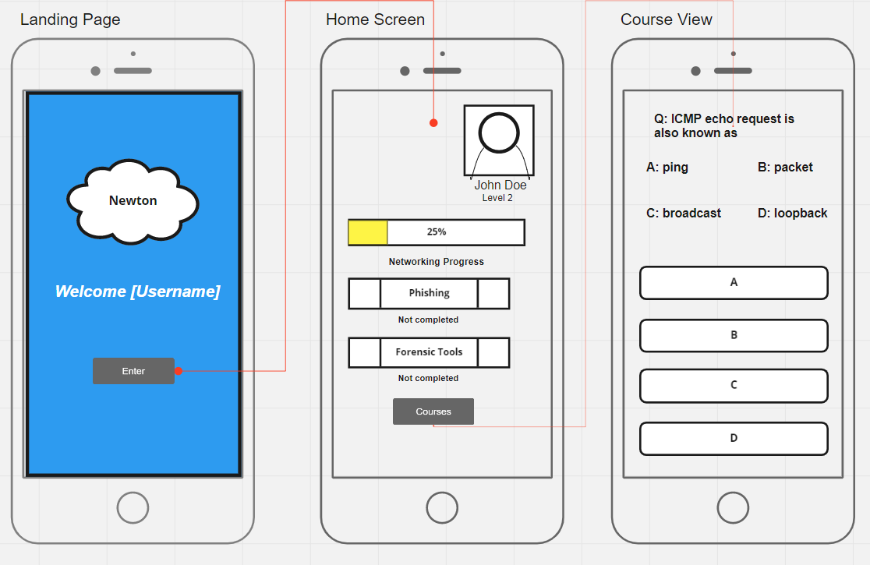
Due to time constraints relating to the software development, not all of the functionality planned for in the wireframes was achieved.

Data Structures
The SQLite database example that the quiz portion of the application was built around. This was to be replaced with a personalised database unfortunately this was not implemented in time.
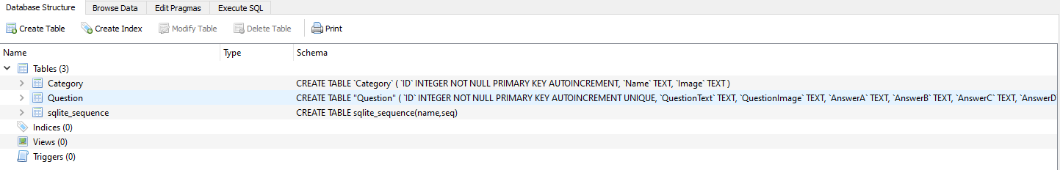
The data structure consists of 3 tables; Category, Question and sqlite_sequence. The Category table consists of 3 records:
- ID (Primary Key, Auto Incrementing, INT)
- Name (String)
- Image (String)
The Question table consists of:
- ID (Primary Key, Auto Incrementing, INT)
- QuestionText (String)
- QuestionImage (String)
- AnswerA (String)
- AnswerB (String)
- AnswerC (String)
- AnswerD (String)
- CorrectAnswer (String)
- IsImageQuestion (INT)
- CategoryID (INT)

