Usability Manual
by
Daniel Crimmins
C00221046
Institute of Technology, Carlow
April 2020

Usability
The application is bundled in an Android Studio workstation format. This can be downloaded from https://developer.android.com/studio. Once this has been installed the application (Newton) can then be opened by accessing the folder through “File > Open” to import this project into the workspace.
Once this is installed the device will be ran on an emulator. The Android Emulator component can be accessed in the SDK Tools tab of the SDK Manager. Once set up this device will become known as an Android Virtual Device (AVD).
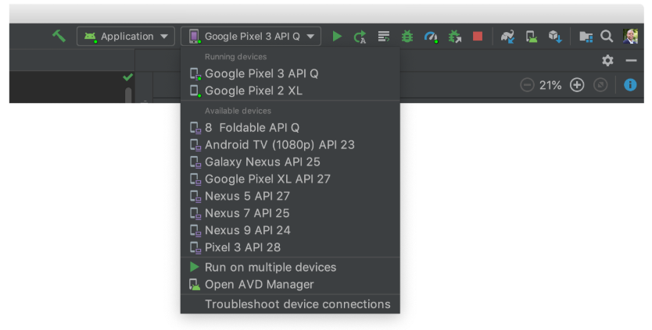
AVD’s can be created using the AVD Manager which can be found in the dropdown menu above. A wizard will then walk the user through the steps necessary for creating an AVD.
To then run the application, click the green start arrow seen in the figure above. This will build and run the application on the chosen AVD.
The user will then be presented with a splash page which will display for 4 seconds before launching the application.
This approach to launching has been verified as working on several machines.
The .java files can be accessed in the folder “Android Application Zipped.zip\Newton2\app\src\main\java\com\example\newton2”

