Instruction Cycles
Each time the central processor retrieves and executes an instruction, it performs a sequence of operations called an instruction cycle. A typical instruction cycle has five phases:
• Fetch
• Decode
• Retrieve operand(s)
• Execute
• Update PC
Figure 1 shows the phases of a typical instruction cycle. The cycle starts at the fetch phase. After the update-PC phase is complete, the cycle is repeated until all the instructions in the program have been executed.
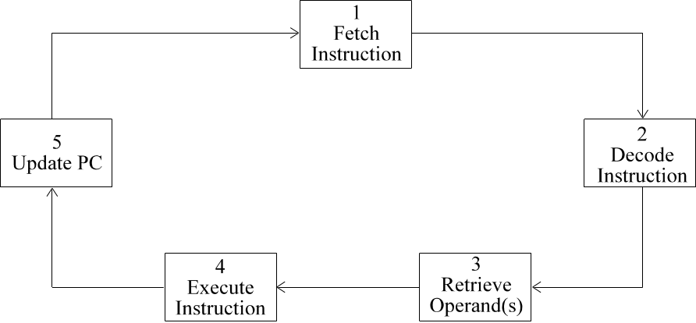
Figure 1. Typical Instruction Cycle

Fetch Phase
The first phase of the instruction cycle is the fetch phase, in which the instruction is retrieved from main memory. Figure 2 illustrates this phase. The following actions take place in the CPU during this phase:
a. The control unit signals the program counter (PC) to copy its contents into the address register (AR). The contents of the PC are then moved into the AR. So, the AR contains the memory address of the next instruction to be fetched and executed by the CPU.
b. The address contained in the AR is sent to main memory over the address bus, and the control unit signals the memory control unit to accept a memory address.
c. The control unit asserts a memory read. Main memory copies the instruction at that address, and sends the instruction over the data bus to the buffer register (BR).
d. The timing and control circuits establish a data path from the BR to the instruction register (IR). The instruction is passed to the IR, where it is available during the decode phase.
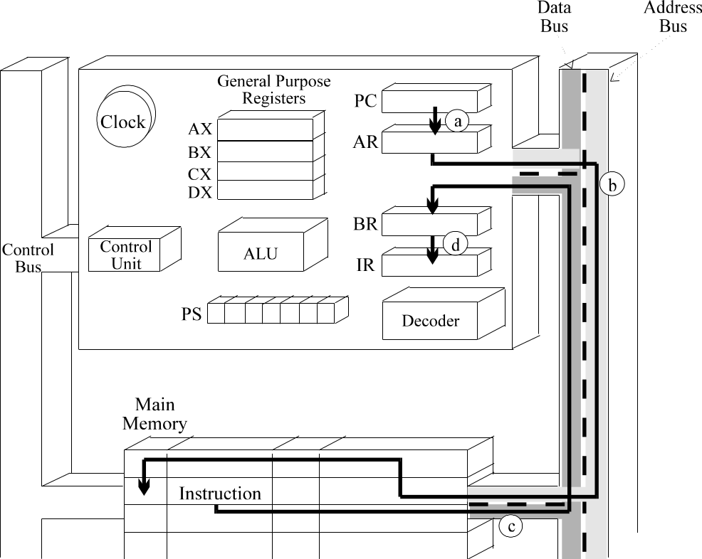
Figure 2. Fetch Phase

Decode Phase
During the decode phase, the instruction decoder examines the contents of the IR to determine what type of instruction is to be executed. Figure 3 illustrates the actions that occur during the decode phase.
a. First, the op code contained in the IR is passed to the instruction decoder.
b. The decoder converts the op code into a signal that identifies the operation to be performed. This signal is sent to the ALU.
c. Next, the operand field is sent to the decoder. The decoder converts the binary codes in the operand field into signals that identify the register(s) and addressing mode(s) to be used.
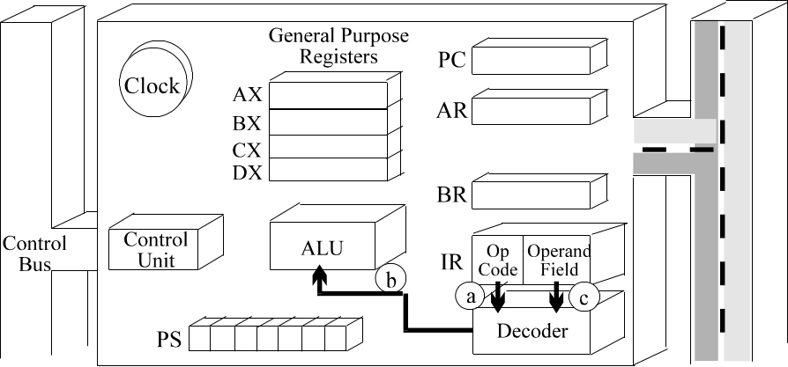
Figure 3. Decode Phase

Retrieve-Operand Phase
During the retrieve-operand phase, the CPU locates the operand or operands referenced by the instruction. If the operand is stored in main memory, the CPU addresses memory, retrieves the operand, and places it in one of its registers (either the BR or a GPR).
Figure 4 illustrates the actions that occur in the retrieve-operand phase with the INC [BX] instruction.
a. Since the address of the operand is in BX , the operand address is first passed to the AR.
b. The operand address is then sent over the address bus to main memory, and the memory control unit is given a memory accept signal (Ma).
c. The memory control unit is signalled again with Mr. Main memory copies the operand at that address and sends it over the data bus to the CPU. The CPU places the operand in the BR.
d. Finally, a pathway is established from the BR to the ALU so that the ALU can operate on the value contained in the BR.
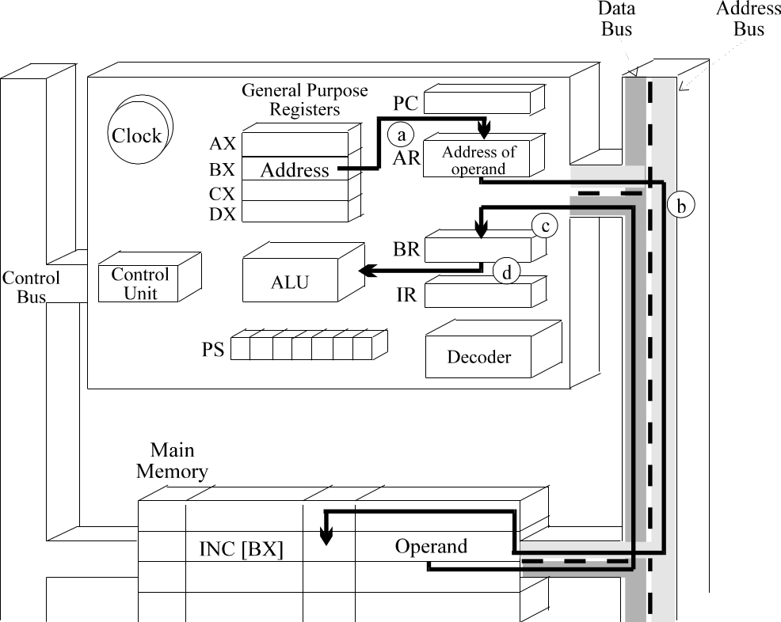
Figure 4. Retrieve Operand with Register Deferred Mode Addressing

Execute Phase
During the execute phase, the operation is performed on the operand or operands and the result is stored at the appropriate location. Figure 5 illustrates the execute phase for the INC [BX] instruction.
By this part of the instruction cycle, the signal for the increment operation has already been sent from the instruction decoder to the ALU, and the operand has been copied into the BR from main memory. In the execute phase:
a. The ALU performs the increment operation on the operand obtained from the BR.
b. The incremented result is then temporarily stored in the BR.
c. The address contained in BX is placed in the AR, and is sent over the bus to main memory.
d. The incremented result is sent over the data bus and is stored in the addressed memory location.
e. The appropriate condition code bits in the processor status register are set or cleared.
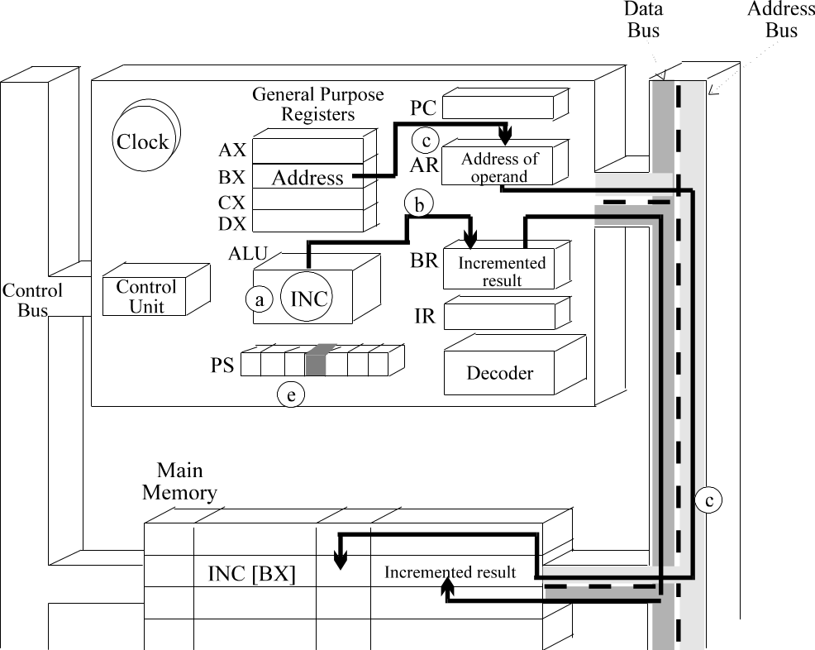
Figure 5. Execution phase for INC [BX]

Update-PC Phase
The last phase of the instruction cycle is to update the address in the program counter so that it points to the next instruction in the sequence. Figure 6 illustrates this phase.
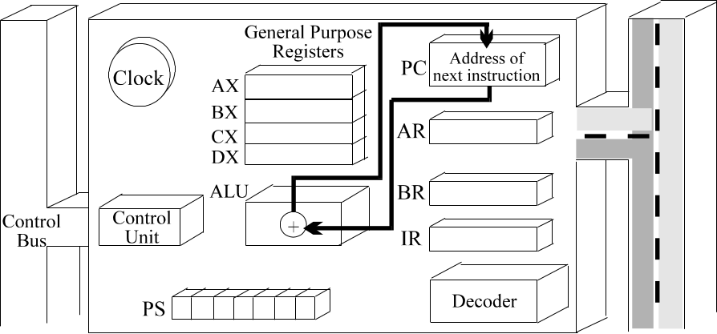
Figure 6. Update-PC Phase
The instruction cycle is now complete. The PC points to the next instruction, and the CPU is ready to begin the fetch phase for this instruction.

Jump Instruction Cycle
Jump instructions use a variation of the basic instruction cycle. There are two changes to the basic instruction cycle.
As noted in Figure 7, the retrieve-operand phase of the instruction cycle is not necessary because the jump instruction operates on the contents of the PC. This eliminates the need to locate the operand.
If the jump is taken, an offset value is added to the contents of the PC during the execute phase. So, when the jump is taken, the update-PC phase is not performed (see Figure 7).
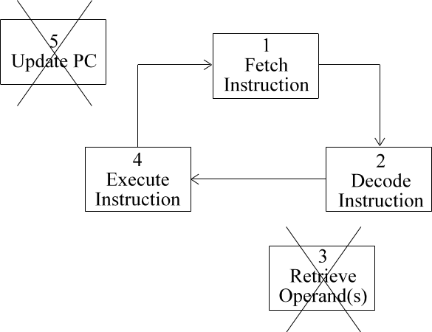
Figure 7. Jump Instruction Cycle if the jump is taken

Sample Program Segment
In this section, we will follow three instructions through the instruction cycle. Figure 8 shows the program segment in main memory. The program segment adds a list of values. The Starting address of the list is in DX.
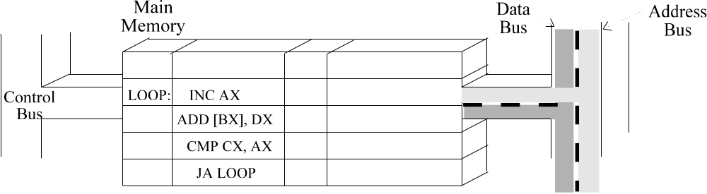
Figure 8. Program Segment from Instruction Sets Module
Figure 9 shows the fetch phase for the ADD [BX], DX instruction. The following activities occur during the fetch phase:
a. The PC contains the address of the ADD instruction.
b. This address is loaded into the AR and is then sent to main memory over the address bus.
c. Main memory accepts the address, retrieves a copy of the ADD instruction from its memory location, and sends the ADD instruction over the bus to the CPU. When the CPU receives the instruction, it temporarily stores it in the BR.
d. From here, the ADD instruction is passed to the IR, thus completing the fetch phase.
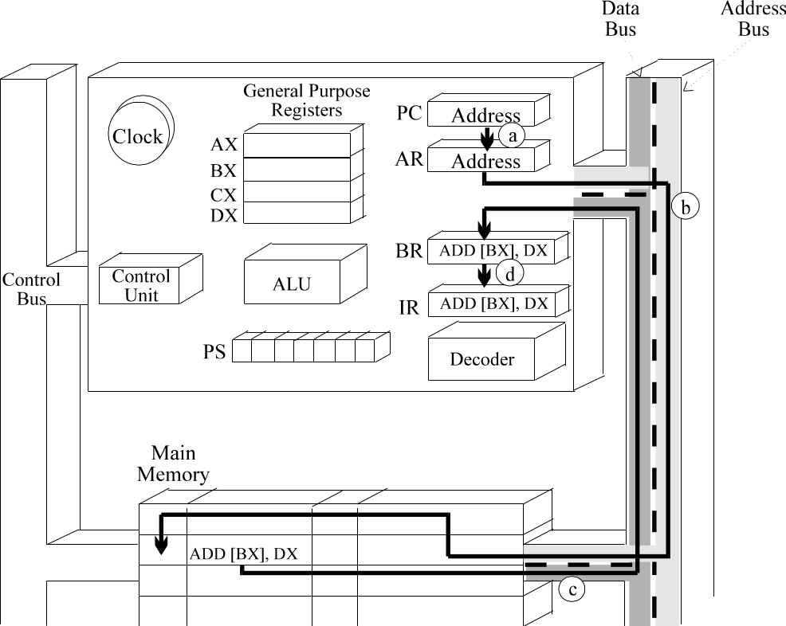
Figure 9. Fetch Phase ADD [BX], DX Instruction
Figure 10 illustrates the decode phase for the ADD instruction. During the decode phase, the following activities take place inside the CPU.
a. The instruction decoder receives the op code from the IR.
b. The instruction decoder converts the op code into a signal which tells the ALU to prepare for an ADD operation.
c. The decoder also examines the operand fields of the ADD instruction to determine which general-purpose registers and addressing modes are to be used to retrieve the operands. In this example, the first operand field references BX and uses register indirect addressing. The second operand field references DX and uses register-mode addressing.
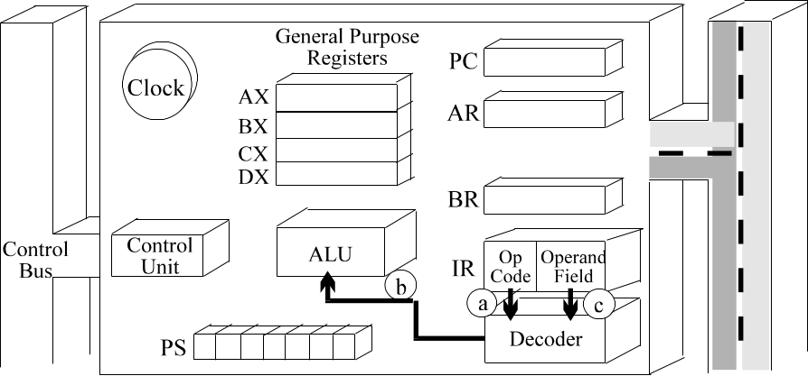
Figure 10. Decode Phase ADD [BX], DX Instruction
Figure 11 shows the retrieve-operand phase for the first operand of the ADD instruction.
a. The address of the value is transferred from BX to the AR.
b. The address is then sent to main memory where it is used to identify the storage location of the operand.
c. Main memory sends the operand over the data bus to the CPU, and the CPU temporarily places the operand in the BR.
d. A data path is now set up from the BR to the ALU so that the ALU can operate on operand.
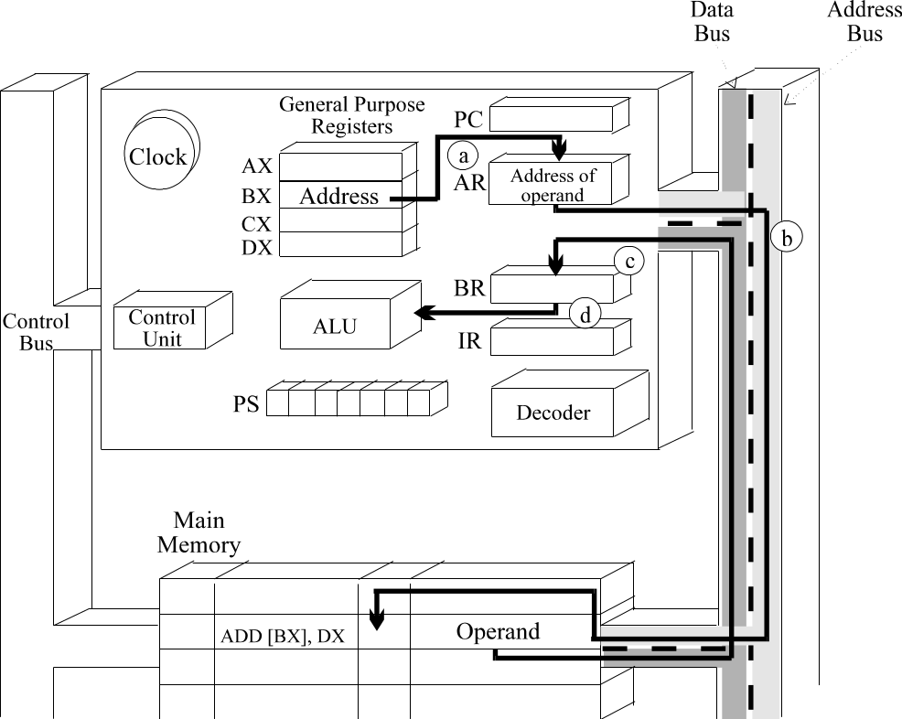
Figure 11. Retrieve Operand for the First Operand
Figure 12 illustrates the retrieve-operand phase for the second operand of the ADD instruction.
a. Since the second operand uses register addressing, a data path is simply established between DX and the ALU.
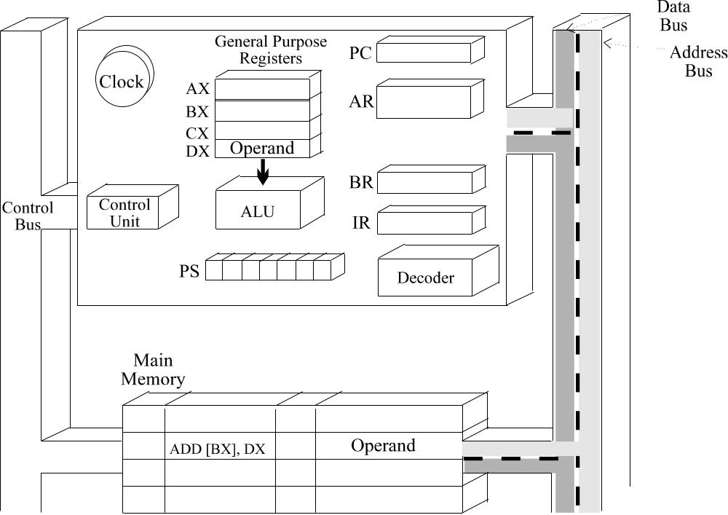
Figure 12. Retrieve Operand for the Second Operand
Figure 13 illustrates the execute phase for the ADD instruction. The following activities take place during this phase:
a. First, the ALU adds the two operands.
b. The condition codes are now set or cleared in the PS register to indicate the results of the ADD operation. For example, if the ADD instruction produces a positive result, the appropriate condition code is set to indicate the result is positive.
c. The sum is then stored in [BX]. This requires the result to be placed in BR and a memory write to be carried out. The result is then stored in the same memory location, thus over-writing the original operand.
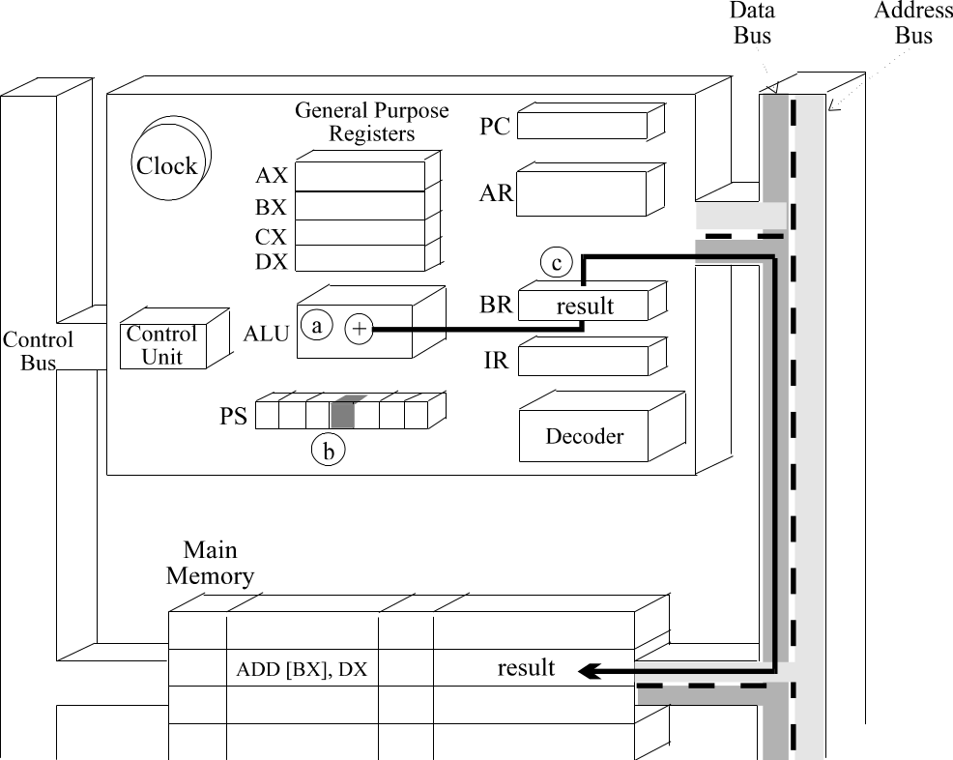
Figure 13. Execution Phase for the ADD Instruction
The update-PC phase is illustrated in Figure 14. During this phase, the CPU increments the address in the PC so that it will point to the next instruction in the program.
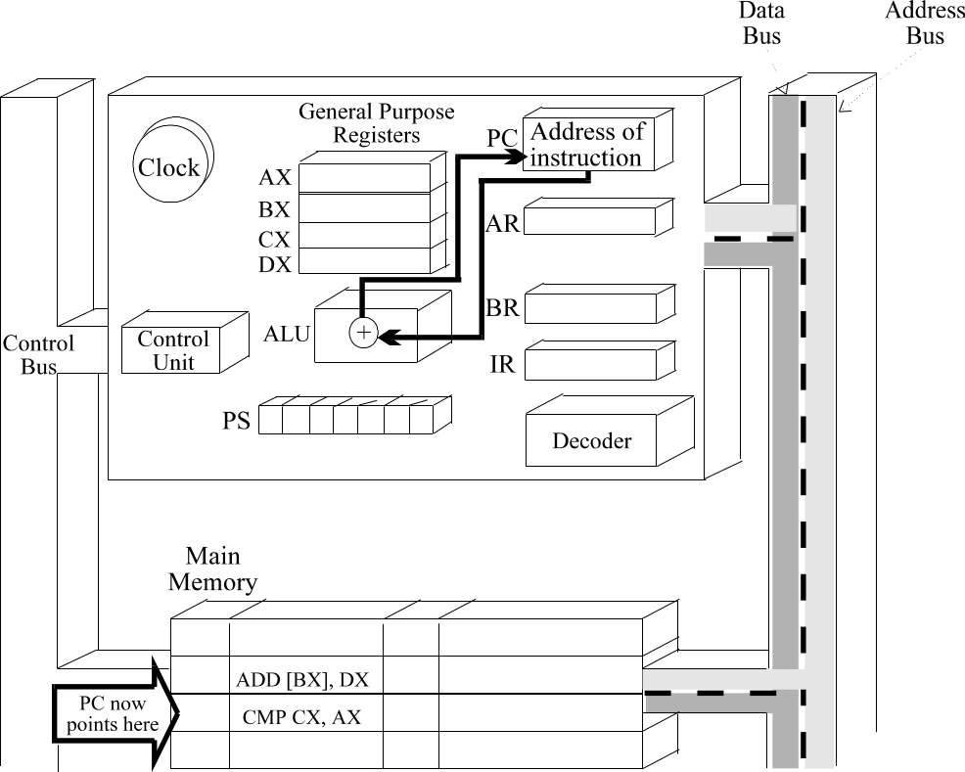
Figure 14. Update-PC Phase for ADD Instruction
The instruction cycle is complete for the ADD instruction and the PC is pointing to the compare (CMP) instruction.
The fetch and decode phase for the CMP instruction establish the same data paths as those set up for the ADD instruction.
The two operands referenced by the CMP instruction are located in registers AX and CX. Therefore, during the retrieve-operand phase, it is not necessary to access main memory to retrieve either operand.
Figure 15 shows the execute phase for the CMP instruction. The CMP instruction uses register mode addressing for both operands. For this reason, data paths are established between CX and AX and the ALU.
a. When the CMP instruction is executed, the second operand is subtracted from the first.
b. The result of this subtraction is stored in a temporary register.
c. The condition codes in the PS register are set or cleared to indicate results of the comparison. In the example shown in Figure 15, the result is positive. So, the PS register indicates a positive Status.
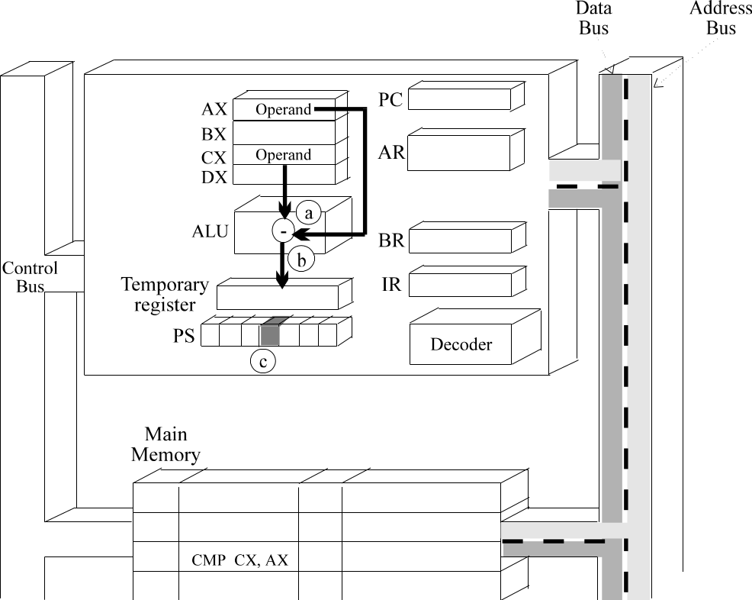
Figure 15. Execution Phase for the CMP Instruction
The PC is updated in the last phase and the CPU is ready to fetch the jump instruction.
The fetch and decode phases for the jump instruction are the same as in the ADD instruction. The retrieve-operand phase is not necessary, so we are at the execute phase with the Jump if Above (JA) instruction.

Execute Phase Jump if Above Instruction
Figure 16 shows the execute phase for the JA instruction when the jump is taken.
a. During the execute phase, the JA instruction looks to see if the condition codes indicate a positive status. In the example, they do, so the jump is taken.
b. An offset value is added to the contents of the PC. The new address in the PC points to the instruction at the label LOOP. Because the PC is changed in the execution phase, the update-PC phase is bypassed.
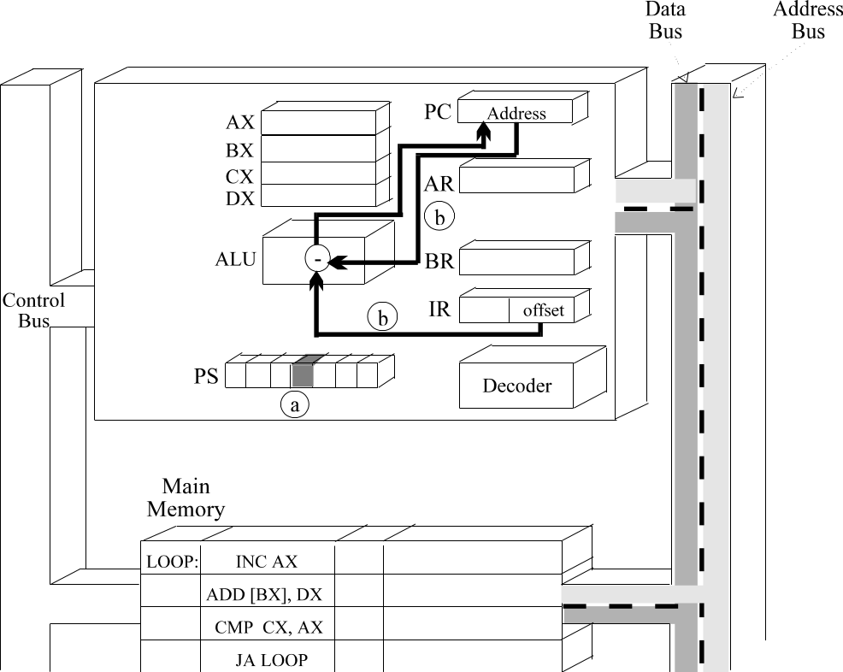
Figure 16. Execution Phase Jump if Above Instruction
This completes the instruction cycle for the three instructions in our program segment.

