2020

Design Manual
E-DOCHTÚIR – Online Healthcare Application

Holly Gunning
C00214010
Supervisor: dr. Hisain Elshaafi
Abstract
The purpose of this project is to create a progressive, single page web application to aid small to medium size clinics and their patients with a more online based experience, so as to reduce the need for as many physical consultations, enabling a more direct approach to prognosis and thereby limiting the spread of contagions amongst patients.
Table of Contents
Abstract 1
Table of Figures 3
1. Introduction 4
2. UX Design & Navigation 5
2.1. Shneidermans 8 Golden Rules for Interface Design 5
2.2. The Gestalt Principles 6
2.3. User Interface Wireframes 7
2.3.1. Login & Registration Screens 8
2.3.2. Dashboard Screen 11
2.3.3. Navigation Drawer Screen 12
2.3.4. User Profile Screen 13
2.3.5. Medical Record Screen 14
2.3.6. Track Medication Screen 15
2.3.7. Appointments Screen 16
2.3.8. Prescriptions Screen 19
2.3.9. Chat Screen 21
3. Database Schema 23
3.1. User Collection 23
3.2. Appointments Collection 24
3.3. Roles Collection 24
3.4. Rooms Collection 25
3.5. Prescriptions Collection 25
4. Plagiarism Declaration 26
5. Bibliography 27
5.1. References 27

Table of Figures
Figure 1: Login Screen on Desktop 6
Figure 2: Error Message on Login Screen 6
Figure 3: Forgot Password Dialog on Login Screen 7
Figure 4: Register Screen on Desktop 8
Figure 5: Login & Registration Screens on Mobile 8
Figure 6: Dashboard Screen on Desktop 9
Figure 7: Dashboard Screen on Mobile 9
Figure 8: Navigation Drawer on Dashboard Screen, on Desktop 10
Figure 9: Navigation Drawer on Desktop Screen, on Mobile 10
Figure 10: Profile Screen on Desktop 11
Figure 11: Profile Screen on Mobile 11
Figure 12: Medical Record Screen on Desktop 12
Figure 13: Medical Record Screen on Mobile 12
Figure 14: Medication Tracking Screen on Desktop 13
Figure 15: Medication Tracking Screen on Mobile 13
Figure 16: Patients’ Appointments View Screen on Desktop 14
Figure 17: Patients' Appointments View Screen on Mobile 14
Figure 18: Patients' Book Appointment Screen on Desktop 15
Figure 19: Patients' Book Appointment Screen on Mobile 15
Figure 20: Doctors' Appointment View Screen on Desktop 16
Figure 21: Doctors' Appointment View Screen on Mobile 16
Figure 22: Patient Prescription View Screen on Desktop 17
Figure 23: Patient Prescription View Screen on Mobile 17
Figure 24: Patient Request Prescription Form on Desktop 18
Figure 25: Patient Pre-Chat Screen on Desktop 18
Figure 26: Doctor Pre-Chat Screen on Desktop 19
Figure 27: Chat Screen on Desktop 19
Figure 28: User Collection Part 1 20
Figure 29: User Collection Part 2 20
Figure 30: Appointments Collection 21
Figure 31: Roles Collection 21
Figure 32: Rooms Collection 22
Figure 33: Prescriptions Collection 22

1. Introduction
The following design manual is intended to document the design process of the E-Dochtúir online healthcare application.
Any decisions and inspirations behind the user design and interface are discussed. The manual then provides the user design of the application in the form of visual wireframes. It also depicts any similarities and differences between the desktop and mobile layouts of the application. The database design of the application will also be depicted in this document, showing how the data will be stored and accessed.
The overall intention of this manual is to provide detailed documentation, as would be the case in a working environment where the project may change development teams during its lifecycle. Any developer who were to read this document should be capable of understanding the direction the application is taking based off of the architecture and design plans.

2. UX Design & Navigation

2.1. Shneidermans 8 Golden Rules for Interface Design

Whilst seeking inspiration for the design of this application, the design principles that most resonated with core aspects of the project, such as single-page and progressive, came from that of Ben Shneiderman, an American computer scientist and professor at the University of Maryland Human-Computer Interaction Lab. Shneidermans’ design principles, better known as the ‘Eight Golden Rules of Interface Design’, aim to guide the design of “great, productive and frustration-free user interfaces”. [1] Shneiderman states that to improve an applications usability it is vital that the applications user interface is well designed. The following are the rules that this application aimed to adhere to during the design phase:
- Strive for consistency – Actions within the application should be required in a similar format each time. Terminology used in prompts, menus or input hints should be consistent in both wording and format.
- Enable frequent users to use shortcuts – The more something within the application is frequently used, the more a user wishes to interact with it less to increase the speed at which they can complete a task. For instance, information such as user details should not need to be entered manually every time they fill in a form.
- Offer informative feedback – On every operator action, there should be some form of informative feedback to inform the user, such as on successful or failed submission of data rather than an error code that they will not be able to draw a conclusion from. The response should scale from modest to substantial, depending on the frequency and impact of the action within the application.
- Design dialog to yield closure – Users should be informed as to the results of their actions, rather than leaving them confused as to whether they have correctly completed a task. Providing users with informative feedback ensures the “satisfaction of accomplishment, a sense of relief, the signal to drop contingency plans and options from their minds, and an indication that the way is clear to prepare for the next actions”. [2]
- Offer simple error handling – Error handling should be as simple as possible, to ensure that the user cannot make a serious error. In the event that an error is made, the system should detect it and simple comprehensible advice should be given to the user on how to correct their error.
- Permit easy reversal of actions – Actions on the application should allow for easy reversibility, in the event that a user makes a mistake or error. This encourages the user to explore the application further without causing anxiety. Reversibility may be on a single action, data entry or even a group of actions.
- Support internal locus of control – For long term users who feel they are more experienced with the application; the overall system should respond in such a way that they feel they are the initiators of the actions rather than the responders.
- Reduce short-term memory load – Due to the limitations of the human attention span, interfaces should be as simple as possible. Displays should be kept simple, window-motion frequency reduced and the application should choose recognition over recall with regards to information on the application.

2.2. The Gestalt Principles

Another set of principles that provided informative and helpful guidelines to designing the user interface and general experience flow for the user was the gestalt principles. These principles were created though the observation and analysis of the psychological behaviour of humans, specifically, their innate capacity for grouping things together.
- The Law of Proximity – states that things that are closer to one another appear to be related whist things that are spaced farther apart appear to the user as a separate group. A great example of this are labels on text fields, which should be close to their corresponding text field to denote a corresponding relationship.
- The Law of Similarity – states that, not only do things that appear closer to one another appear to be related, but also are presumed to have the same function. On a form, a classic example of this would be the input fields and the submit button where the fields might be one size, but the button might be larger or a different colour. This would denote that the fields have one functionality, to take in information from the user, whilst the buttons functionality is separate.
- The Law of Common-Region – Similar to the law of proximity, it states that objects that are located within a closed region are grouped together. This can be seen in information cards displayed to the user. Each card contains different information but all information on that card is connected to the same individual record, separate from all other records displayed on other cards. An example of this might be profile cards, where each card is a different user but all information on the card pertains to that specific user.
- The Law of Focal Point – states that anything that stands out visually will capture and hold the users’ attention first. Just as law of similarity denotes what things are grouped, the law of focal point draws attention to that which stands out. For instance, the button on a form will always be a focal point on a page as it guides the user to the action or purpose of that page. It is more eye-catching in shape, size or colour from the other fields.
- The Law of Continuity – states that things that are arranged on a line or curve are perceived to be related more that things that are not. This is typically seen in navigation menus, where secondary menus are displayed beside the primary menu under one banner title, rather than underneath all other navigation titles to denote a more specific relationship.
- The Law of Closure – states that when a user interprets a complex visual arrangement, they try to look for a single, recognisable pattern. This is typically used to create logos with negative space.
- The Law of Figure-Ground – states that users instinctively perceive an object to either bee in the foreground of background. An example of this can be seen when applications use dialogs or modals that appear on the foreground in front of the application page, creating a level of depth where the user will understand that the dialog or modal is the currently active objective.

2.3. User Interface Wireframes
Below are the proposed layouts for each screen on the application and a description of how each screen intends to operate. A majority of the pages feature a generic toolbar at the top of the screen which will have a navigation drawer to navigate through the application. Due to the way in which the application will be developed, all screens will be scalable so that they can be used on a multitude of devices. The applications overall design is simplistic in nature so as to help the user easily navigate through and use each aspect of it regardless of their experience with technology. All of the following wireframes were created using wireframe pros mock flow and were heavily inspired by the principles explored in Shneidermans 8 Golden Rules and the Gestalt Principles

2.3.1. Login & Registration Screens
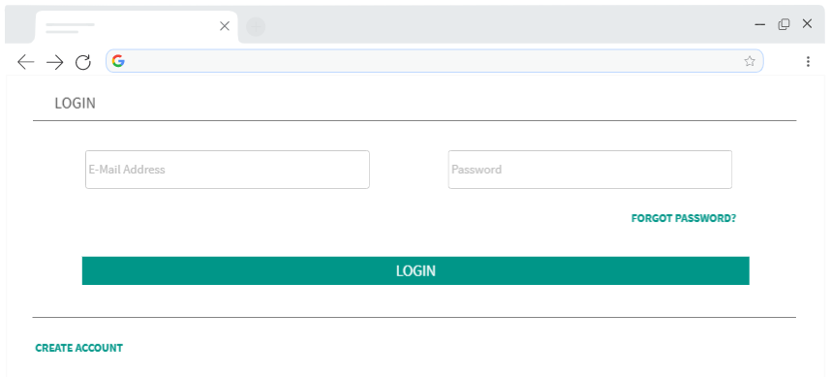
Figure 1: Login Screen on Desktop
In Figure 1, on the login screen, a user is required to enter their email address and corresponding password. They will click the ‘Login’ button, which will direct them to the user dashboard corresponding to their role type. If they have not got an account, or input the wrong password with their email credentials, an error message will be displayed telling them that the user doesn’t exist or may have been deleted or that the credentials do not match, as seen in Figure 2.
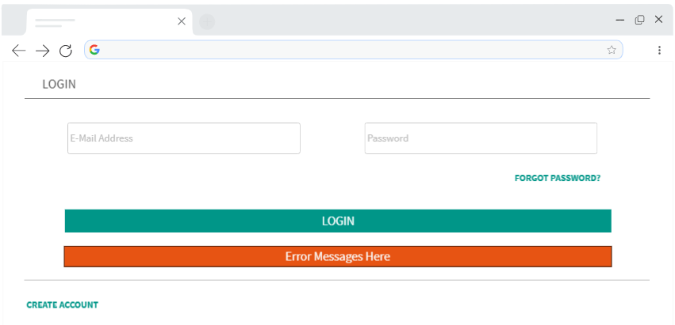
Figure 2: Error Message on Login Screen
If the user has forgotten the password to their account, they can click on the ‘Forgot Password?’ text button situated directly under the password text field. This will grey out the Login screen and open up a dialog box which will allow them to enter their email and submit it, as seen in Figure 3. Similarly, if an email has not been registered to an account but is entered it will display an error message to the user. Once the user has correctly submitted a password they will receive an email to change their password.
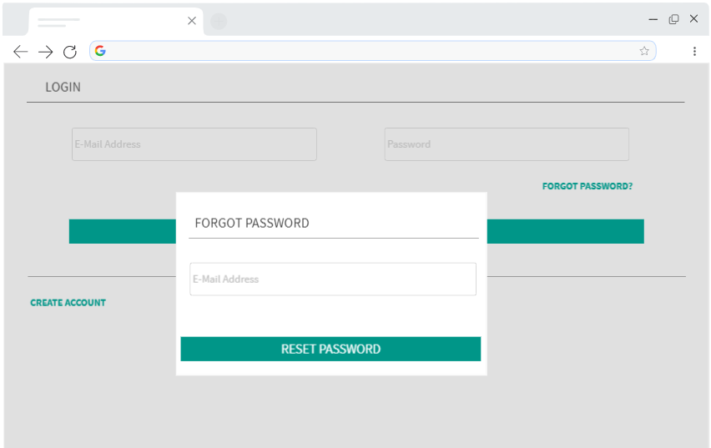
Figure 3: Forgot Password Dialog on Login Screen

If the user does not have an account they can click on the ‘Create Account’ text button situated under the ‘Login’ button shown in Figure 1, which will direct them to the register screen seen in Figure 4. On the register screen, the user is required to enter their first name, surname, date of birth, PPSN, e-mail address, mobile number and both a password and confirmation password. They will also need to confirm that they accept the terms of service before being allowed to register. If they attempt to register with an e-mail already in use an error message will be displayed under the ‘Register’ button. Once registered, the user will be redirected to the dashboard. Optionally, if the user already has an account, they can select the ‘Already Registered?’ text button which will redirect them to the Login screen.
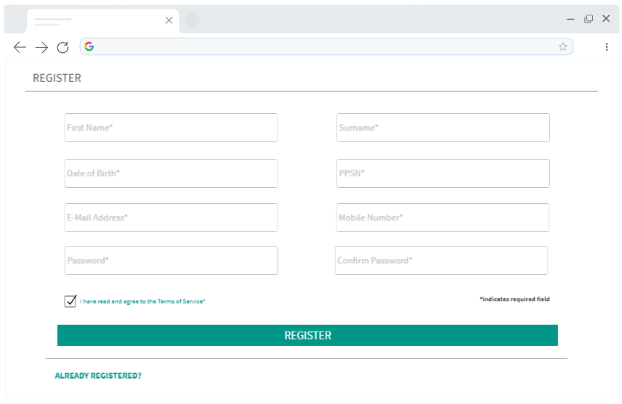
Figure 4: Register Screen on Desktop

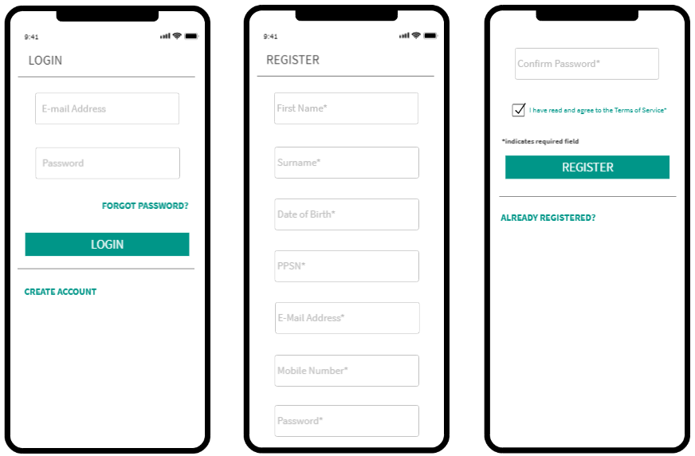
Figure 5: Login & Registration Screens on Mobile

2.3.2. Dashboard Screen
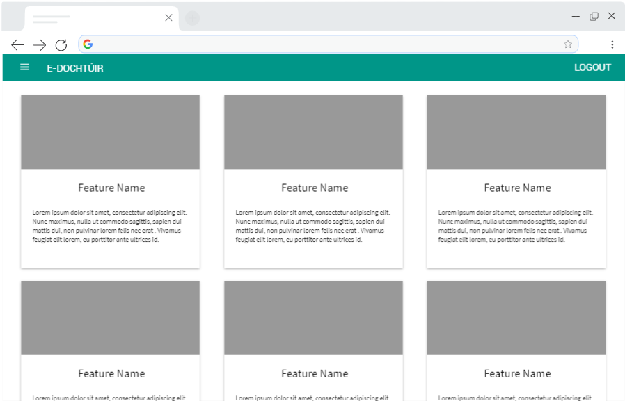
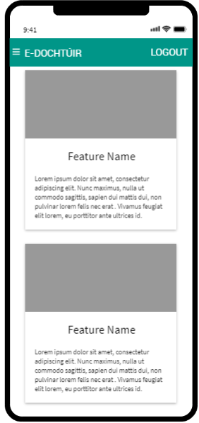
Figure 6: Dashboard Screen on Desktop

The dashboard depicted in Figures 6 and 7 is effectively the landing page of the application. It advertises the features of the application, so the user is made aware of what features are available to them. Each card displays an image or icon and underneath this a brief explanation of the feature.

Figure 7: Dashboard Screen on Mobile

2.3.3. Navigation Drawer Screen
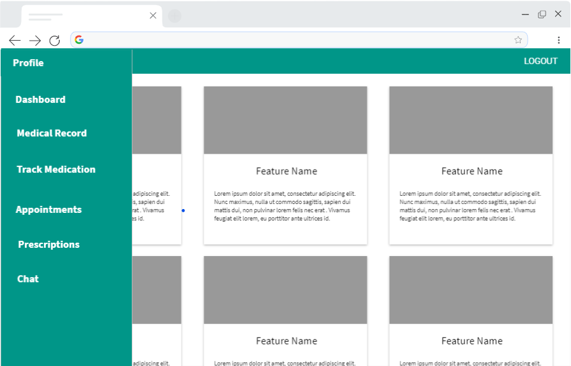
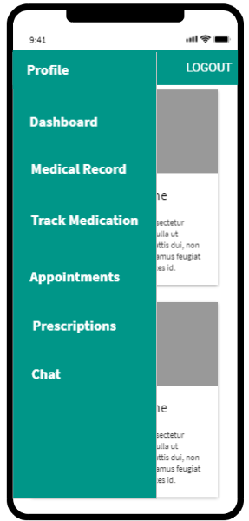
Figure 8: Navigation Drawer on Dashboard Screen, on Desktop

The Navigation drawer depicted in Figures 8 and 9 allows the user to navigate through the different pages of the application. It is opened when the three-line button on the toolbar is selected.

Figure 9: Navigation Drawer on Desktop Screen, on Mobile

2.3.4. User Profile Screen
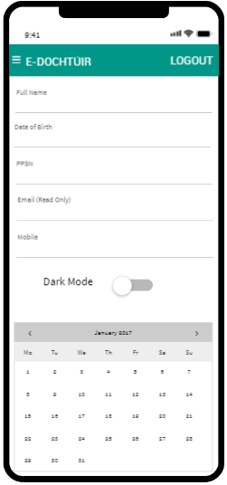
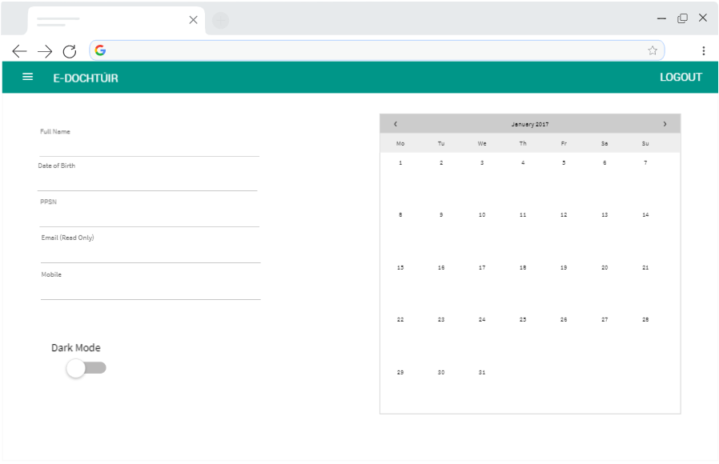
Figure 10: Profile Screen on Desktop

The profile screen, depicted in Figures 10 and 11, will allow a user to see the information they logged during registration and update certain aspects of it, except for the email as it is their main defining credential for accessing the application when logging in. They can see a calendar of all their appointments as well as toggle between light and dark mode as and when they so choose to.

Figure 11: Profile Screen on Mobile

2.3.5. Medical Record Screen
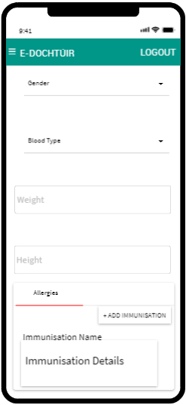
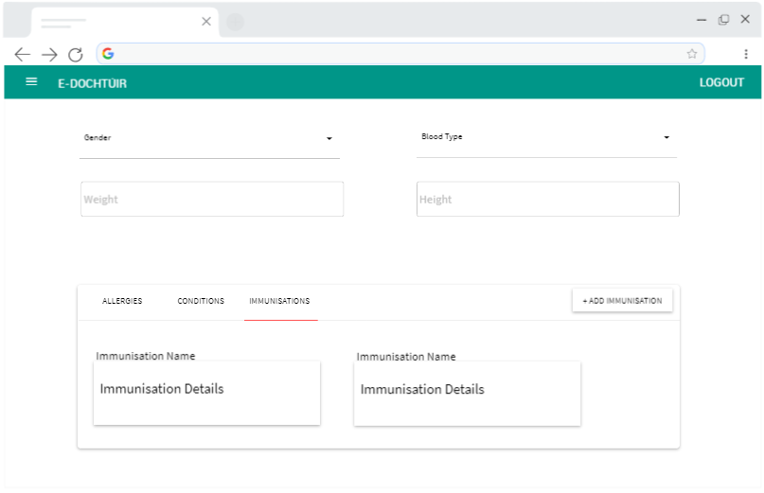
Figure 12: Medical Record Screen on Desktop

The medication record screen depicted in Figure 12 will store any medical history pertaining to the patient. The user can store information such as their gender, bloody type, weight and height as well as any allergies, conditions or immunisations they have/have had. These fields will be updated in real-time to display the most up-to-date information.

Figure 13: Medical Record Screen on Mobile

2.3.6. Track Medication Screen
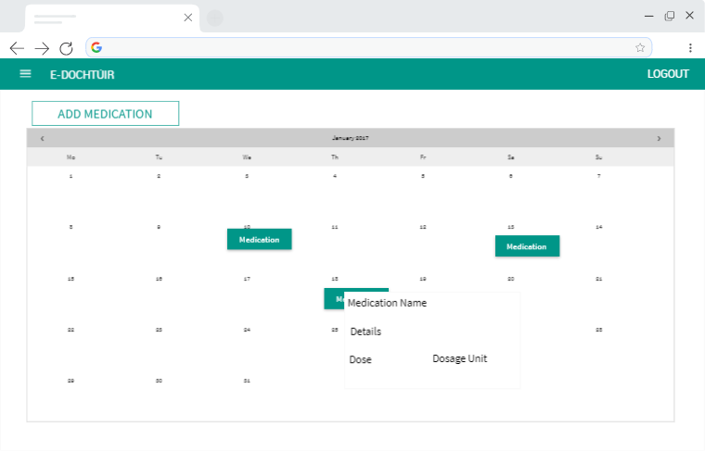
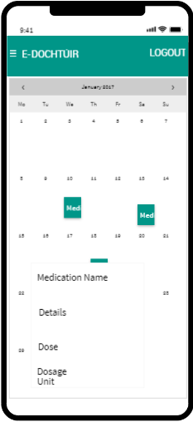
Figure 14: Medication Tracking Screen on Desktop

The track medication screen depicted in Figures 14 and 15 will allow a patient to input any medication that they have taken in order to keep track of all medications ingested. Patients will be able to add medication by pressing the ‘Add Medication’ button which will pop out a dialog form for them to fill in details such as the date, time, dose taken and dosage type.

Figure 15: Medication Tracking Screen on Mobile

2.3.7. Appointments Screen
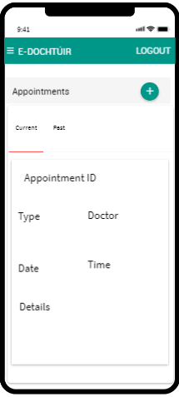
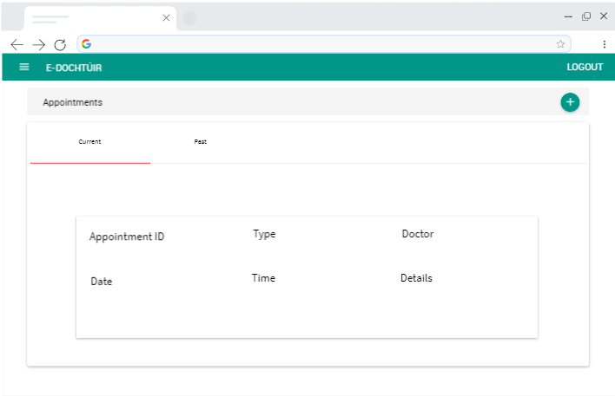
Figure 16: Patients’ Appointments View Screen on Desktop

The view appointments screen, depicted in Figures 16 and 17, allows patients to view any appointments, both current and past. They will be able to swap between views using a tab bar. All of the information about the appointment will be on a card within the tab.

Figure 17: Patients' Appointments View Screen on Mobile
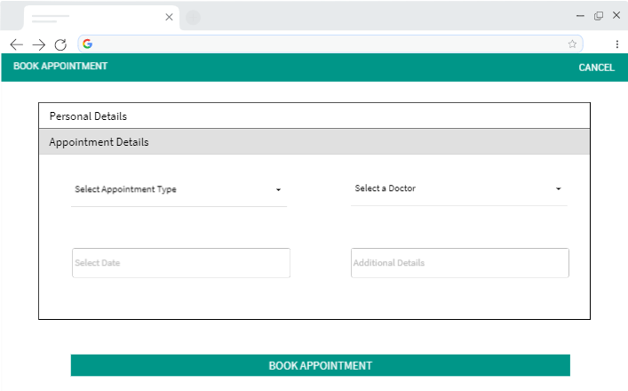
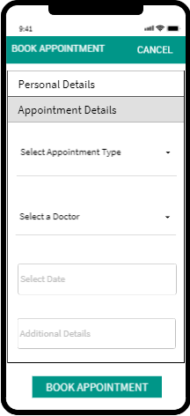
Figure 18: Patients' Book Appointment Screen on Desktop

The book appointments screen, depicted in Figures 18 and 19, allows patients to book an appointment with a doctor. This screen is accessed when the patient presses the “+” button on the view appointments screen, located on the appointments header as seen in Figure 16. If they cancel the page before booking the appointment all fields will clear of any data and validations. When the patient successfully books an appointment, the form will also clear and they will be redirected back to the view appointments screen.

Figure 19: Patients' Book Appointment Screen on Mobile

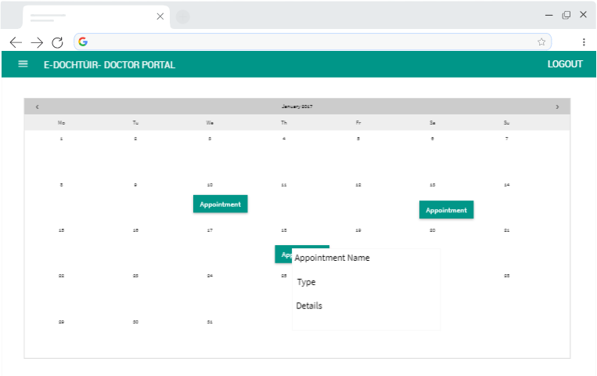
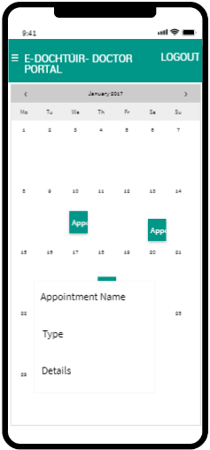
Figure 20: Doctors' Appointment View Screen on Desktop

The doctors’ appointment screen, depicted in Figures 20 and 21, allows the doctor to see all appointments where patients have chosen them specifically for their appointment. All appointments are populated in on a calendar and selecting the appointment will show the doctor more information about the appointment.

Figure 21: Doctors' Appointment View Screen on Mobile

2.3.8. Prescriptions Screen
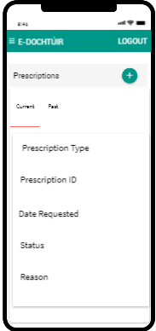
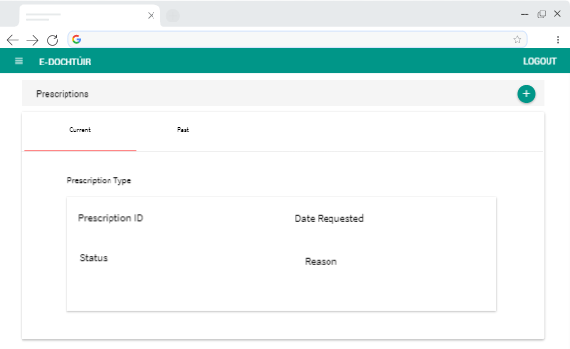
Figure 22: Patient Prescription View Screen on Desktop

The patient prescription view screen, depicted in Figures 22 and 23, allow the patient to view any prescriptions they have submitted a request to the doctor for. Each prescription will have a status and reason field, which will be updated by a doctor and will populate on update on the patients’ screen.

Figure 23: Patient Prescription View Screen on Mobile
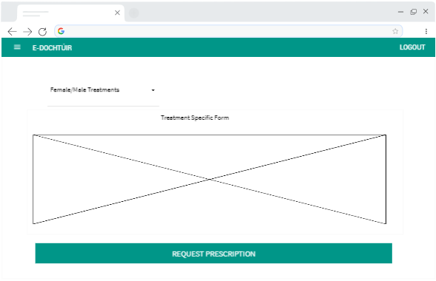
Figure 24: Patient Request Prescription Form on Desktop

The patient will be able to request a prescription by selecting the “+” button seen in Figure 22. This will open a new page which will allow them to select a prescription from a drop-down menu. Each prescription will have a different form. If the user cancels the page before submitting, all data will be cleared. If the patient successfully submits a request they will then be directed back to the prescription

2.3.9. Chat Screen
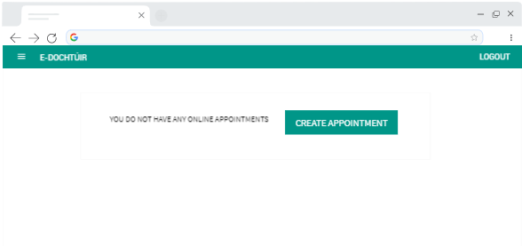
Figure 25: Patient Pre-Chat Screen on Desktop

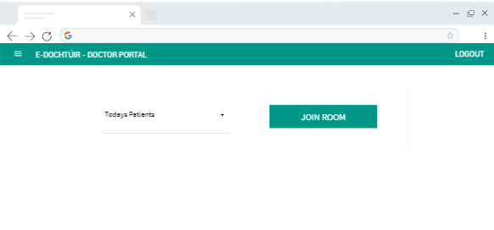
Figure 26: Doctor Pre-Chat Screen on Desktop

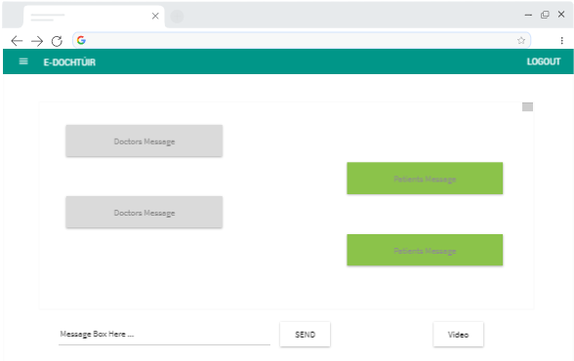
Figure 27: Chat Screen on Desktop

3. Database Schema

3.1. User Collection
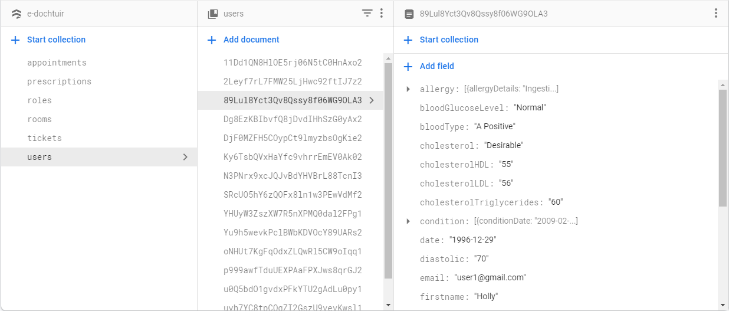
Figure 28: User Collection Part 1

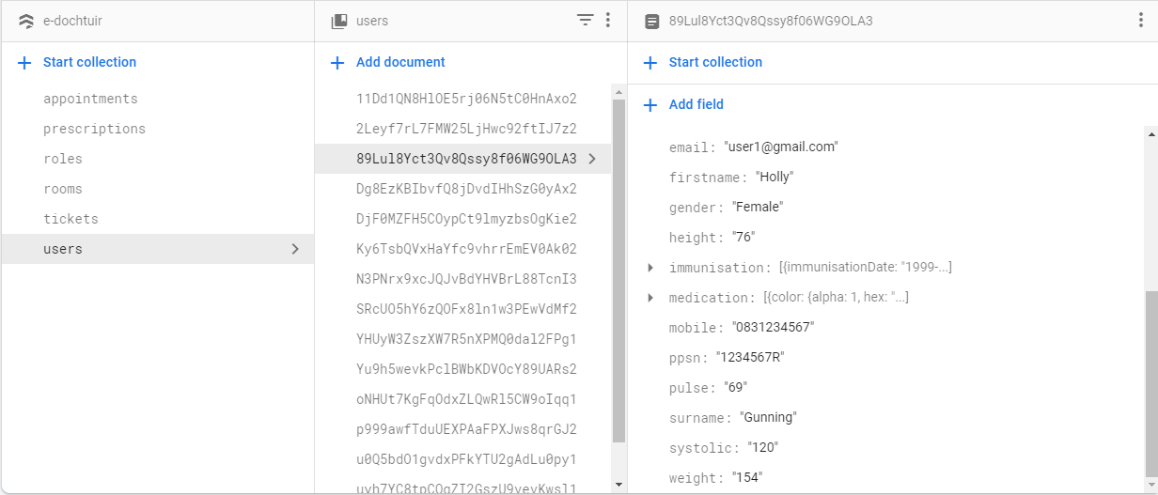
Figure 29: User Collection Part 2

3.2. Appointments Collection
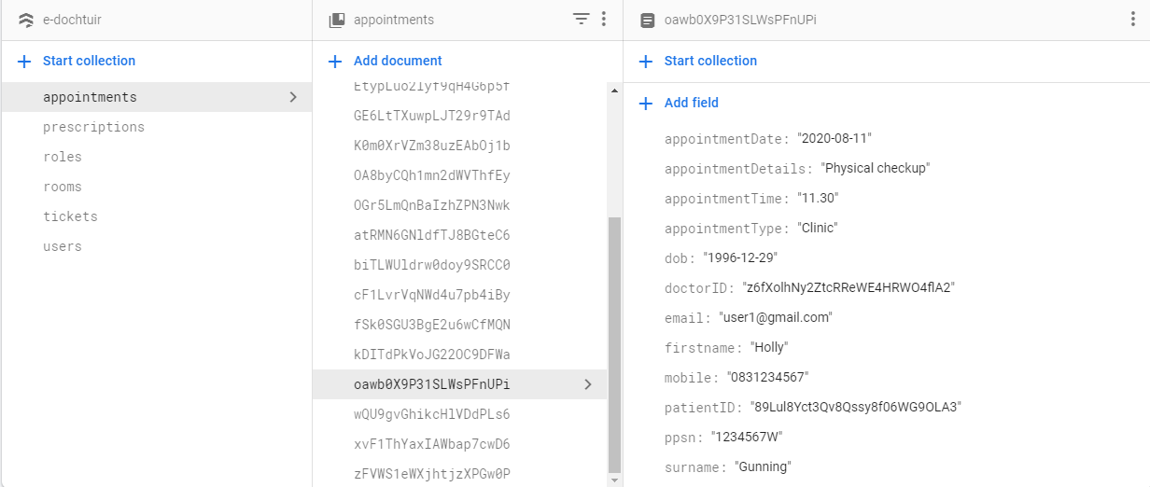
Figure 30: Appointments Collection

3.3. Roles Collection
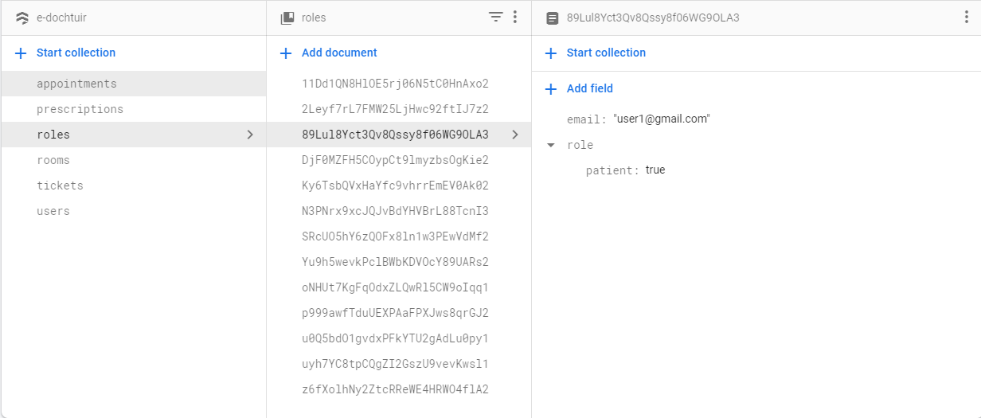
Figure 31: Roles Collection

3.4. Rooms Collection
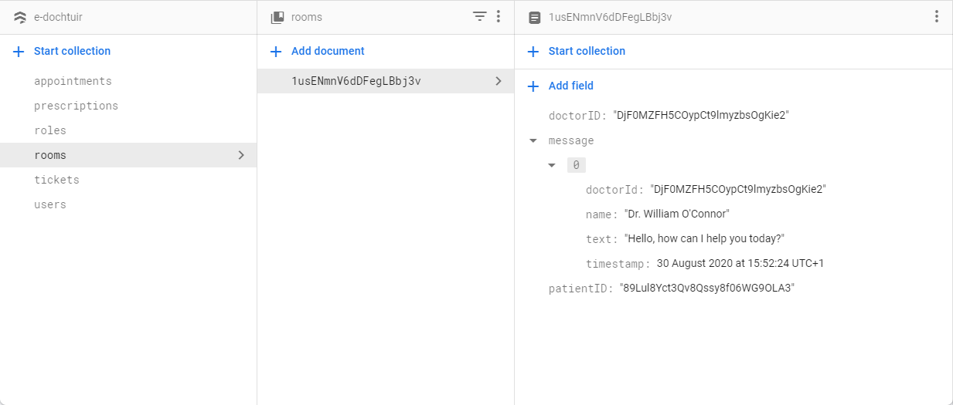
Figure 32: Rooms Collection

3.5. Prescriptions Collection
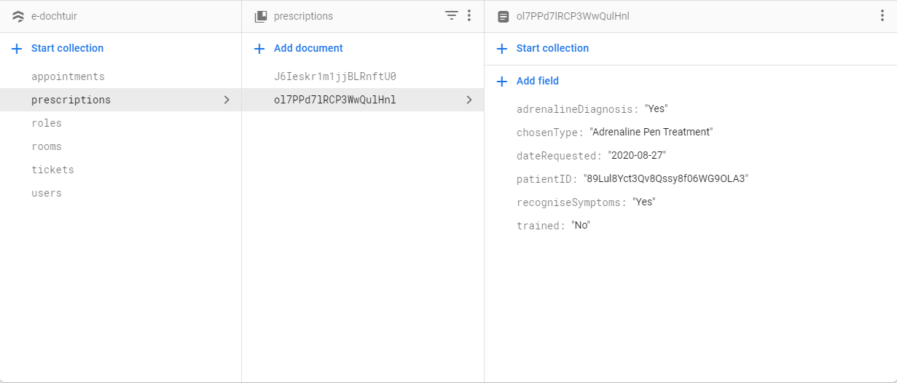
Figure 33: Prescriptions Collection

4. Plagiarism Declaration
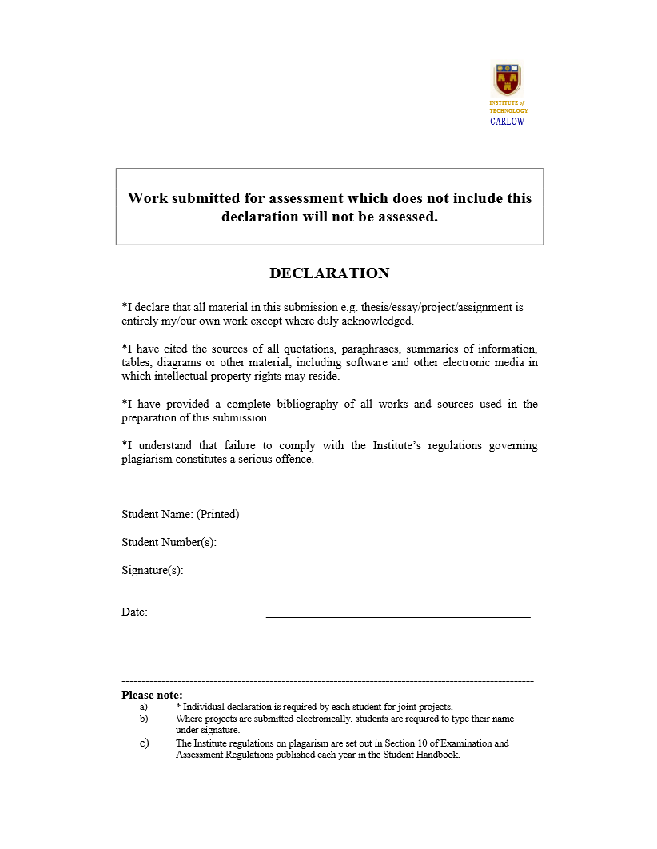
C00214010
Holly Gunning
20/12/2019

5. Bibliography

5.1. References

[1] The Interaction Design Foundation. 2020. Shneidermans’ Eight Golden Rules Will Help You Design Better Interfaces. [online] Available at: <https://www.interaction- design.org/literature/article/shneiderman-s-eight-golden-rules-will-help-you-design- better-interfaces> [Accessed 2 February 2020].

[2] Shneiderman, B., 1998. Designing The User Interface. Reading, Mass.: Addison- Wesley.

