Institute of Technology Carlow
Functional Specification
Match Tracker Mobile Application
Laura O’Callaghan Conlon
12/13/2013

This document will define the high level features of the proposed Match Tracker Application, the scope and the purpose of the project. Stating problems, proposed solutions and establishing expectations.

Table of Contents
1. Introduction 3
2. Project Vision 3
2.1. Business Case Summary 3
2.2. Summary of Software Features 4
2.3. Main Risks Summary (todo) 5
3. Use Case Diagram 5
4. Use Cases 5
4.1. Register 5
4.2. Login 6
4.3. Create Player 6
4.4. Edit Player 6
4.5. Delete Player 6
4.6. Create Panel 7
4.7. Edit Panel 7
4.8. Delete Panel 8
4.9. Create Team 8
4.10. Edit Team 8
4.11. Delete Team 9
4.12. CRUD Match 9
4.13. Track Match 10
4.14. Review Match 10
4.15. Delete User 10
4.16. Edit User Profile 10
4.17. Logout 11
5. Supplementary Specification 11
5.1. Functionality 11
5.2. Usability 11
5.3. Reliability 12
5.4. Performance 12
5.5. Supportability 12
5.6. Security 12

- Introduction
The aim of this project is to create a mobile application and website to track the details of rugby matches that have been played just after the match has finished. The application will allow users to track the scores, break down of scores, offences committed, time, date, team names, player details and location. The main aim of the application is to streamline the process of reporting match statistics to head office of Leinster Branch Rugby, currently this is done with a mixture of hand writing and posting paper team sheets and manually sending text messages with the statistics which are manually input into to a third-party website.
The main features proposed are:
- A mobile application that will allow uploading of text input to a central database stored in a cloud application.
- The application must feature a log in to allow users to only have access to their own registered teams, thus eliminating the risk of unauthorised users corrupting data.
- Clear and simple navigation required to allow for quick data input and accessibility for less technologically experienced users.
- Alert messages if incorrect data is submitted or required data is omitted.
- Website to display results of fixtures, details of upcoming fixtures and creation of team lists.
- User, player and match databases in which to store associated data.
In these days of smartphones being commonplace, most mobile phone users own a smartphone, this application will reduce the workload for team coaches, managers and Leinster Branch administration staff.
This application will also reduce the possibilities of incorrect results being submitted to the Leinster Branch staff as both team involved in a match will be submitting the results though the same application and this will allow for the system to compare and verify the results that have been submitted, reducing the number of errors as users may be automatically alerted to any inconsistency in the submission of results for the one fixture.
- Project Vision

Business Case Summary
The results of a survey sent to a group of potential application users indicates that just under 95% of same own a smartphone. Given this statistic a mobile application appears to be the most accessible option for these users to submit the necessary data to the branch head office. Another question asked of the same group was whether they had regular internet access to which 100% responded with a positive answer.
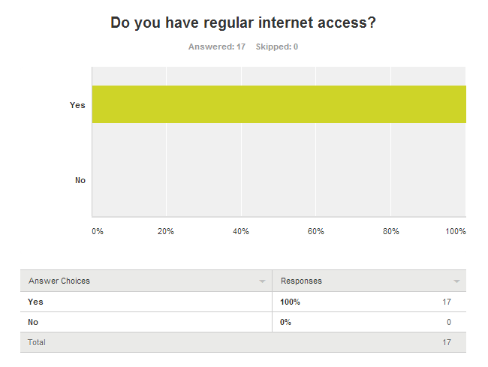
Based on the results of this survey the effort and cost of submitting results may be reduced with one mobile application and a supporting website, rather than the current system which involves many people submitting results through many formats.

Summary of Software Features
The system will feature a hybrid mobile application to allow usage on both Android and iOS devices. Also featured in the system is a web based application that will allow users to access the system through a variety of web browsers.

Main Risks Summary (todo)
- Business Risks:
  - There are similar systems available but as of yet there is nothing that fulfils all the requirements of the Irish rugby structure.
  - Cost of development and distribution has not yet been estimated
  - Expected revenue has yet to be determined
- Technological Risks:
  - The chosen cloud platform must be suitable
  - Developing for and supporting many web browsers is very difficult
  - Development for various mobile platforms is difficult although the use of PhoneGap should aid in this.
- Project Risks:
  - The time scale given may present problems for developing the full system on time.
  - The level of development ability required may be higher than is available.
  - User requirements are constantly changing and growing.
  - Technology is advancing rapidly with respect to hardware, operating systems and data connections. User expectations are growing continuously.
- Use Case Diagram
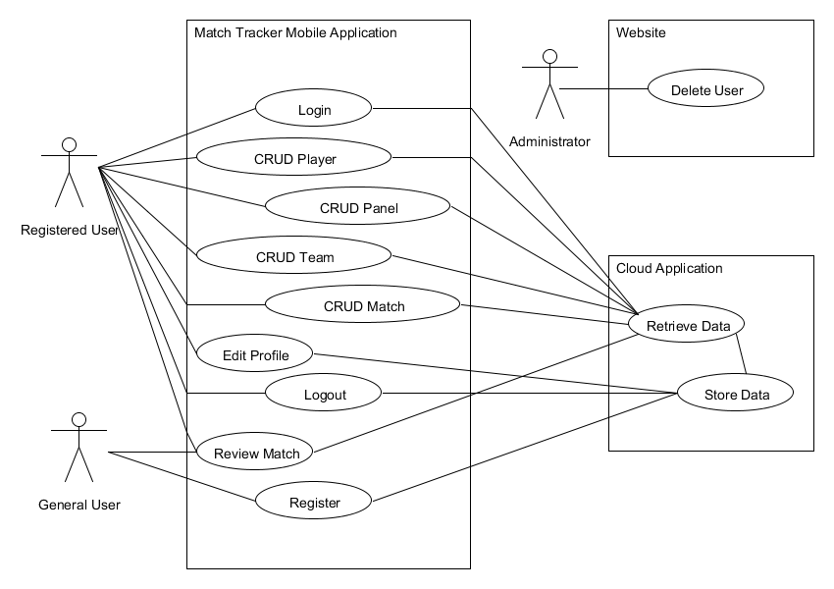
- Use Cases
  - Register
Name: Register
Actors: General User
Description: When a user wishes to sign up to the system they must first register. They do this by submitting their name, email, password and cub name into a form that is displayed on the Login screen. The user then clicks the submit button and their information is stored in the user database.
  - Login
Name: Login
Actors: Registered User
Description: When a user wishes to use the Match Tracker system they must first log in to the webpage or mobile application to access the features of the system. To achieve this, the user must input username and a password, as set up on registration. This information is checked against the entries in the User Database and if correct, the user’s session is started and they are redirected to the Home/Main Menu screen.
  - Create Player
Name: CreatePlayer
Actors: Registered User
Description: When the user wishes to create a new player they must select the Create New Player option from the Player Menu which is found in the Main Menu. This will allow the user to enter data about the new player, each player must have a first and last name and a registration number. This information is entered into text boxes in the form of strings and integers. Once the user has entered the required information they may then submit this record which will be stored in the Player Database. The user will be alerted that the player profile has saved correctly when the record is submitted.
  - Edit Player
Name: EditPlayer
Actors: Registered User
Description: When the user wishes to edit an existing player record they may do so by selecting the Edit Player option in the Player Menu which is found in the Main Menu. This will display to the user an option to search for a player by name. Once the user has entered a name, a list of all matching players will be displayed on the screen. The user may then select a player from this list and the details for same will be displayed on the screen, these details may then be edited from here. When the user is satisfied with the changes made they may submit the updated record for submission. The user will be alerted that the player profile has been updated.
  - Delete Player
Name: DeletePlayer
Actors: Registered User
Description: When the user wishes to delete an existing player record they may do so by selecting the Delete Player option in the Player Menu which is found in the Main Menu. This will display to the user an option to search for a player by name. Once the user has entered a name, a list of all matching players will be displayed on the screen. The user may then select a player from this list and the details for same will be displayed on the screen, the player may then be deleted from here, once they have verified that it is the correct player by checking the player details. The user will be asked to confirm deletion, once the user has confirmed same the player record will be deleted.
  - Create Panel
Name: CreatePanel
Actors: Registered User
Description: When a user wishes to create a new panel of players they may do so by selecting the Create New Panel option from the Panel Menu which is found in the Main Menu. When selected, this option displays the Create New Panel screen. On this screen the user must enter a name for the new panel then they may select any number of players from the full list of players stored in the Player Database which will be displayed on the screen. When all required players have been selected using checkboxes, the user may then select to add these players to the new panel. When the user is satisfied with the selected players they then may save that panel. The player records are updated in the Player Database to add the new panel ID to their individual records.
  - Edit Panel
Name: EditPanel
Actors: Registered User
Description: When a user wishes to edit an existing panel of players they may do so by selecting the Edit Panel option from the Panel Menu which is found in the Main Menu. When selected, this option displays the Edit Panel screen. This screen will display a dropdown menu from which the user can select the panel they wish to edit. Once the panel is selected the list of players contained in same will be displayed on the screen for the user to edit along with the full list of players in the Player Database. If the user wishes to add a player to the panel this may be done by selecting any number of players from the full list of players in the Player Database. When all required players have been selected using checkboxes, the user may then select to add these players to the existing panel. If the user wishes to remove a player from the panel this may be done by selecting the players from the panel using checkboxes. When the user is satisfied that all required players are selected for deletion they may then select the delete option and those selected players will be removed from the panel. The player records will be updated in the Player Database to either add panel ID to, or remove panel ID from, their individual records.
  - Delete Panel
Name: DeletePanel
Actors: Registered User
Description: When a user wishes to delete a new panel of players they may do so by selecting the Delete Panel option from the Panel Menu which is found in the Main Menu. When selected, this option displays the Delete Panel screen. This screen will display a dropdown menu from which the user can select the panel they wish to delete. The chosen panel will then be displayed on the screen. When the user is sure this is the correct panel they may then select to delete the panel. The user will be asked to confirm deletion, once confirmation has been made the panel will then be deleted from the database and the panel ID will be removed from all associated player profiles.
  - Create Team
Name: CreateTeam
Actors: Registered User
Description: When a user wishes to create a new team of players they may do so by selecting the Create New Team option from the Team Menu which is found in the Main Menu. When selected, this option displays the Create New Team screen. On this screen the user must first select a panel to choose players from then the user must enter a name for the new Team, then they may select a minimum of 15 and maximum of 22 players from the list of players which have previously been stored in the Player Database under a certain panel which was chosen previously and will be displayed on the screen. When all required players have been selected using checkboxes, the user may then select to add these players to the new team. When the user is satisfied with the selected players they then may drag and drop players within the new team list in order to place the players in the correct positions, the user may then save that team. The player records are updated in the Player Database to add the new panel ID to their individual records.
  - Edit Team
Name: EditTeam
Actors: Registered User
Description: When a user wishes to edit an existing team of players they may do so by selecting the Edit Team option from the Team Menu which is found in the Main Menu. When selected, this option displays the Edit Team screen. This screen will display a dropdown menu from which the user can select the Team they wish to edit. Once the Team is selected the list of players contained in same will be displayed on the screen for the user to edit along with the full list of players from the chosen panel. If the user wishes to add a player to the team this may be done by selecting any number of players from the full list of players in the chosen panel. When all required players have been selected using checkboxes, the user may then select to add these players to the existing team. If the user wishes to remove a player from the team this may be done by selecting the players from the team using checkboxes. When the user is satisfied that all required players are selected for deletion they may then select the delete option and those selected players will be removed from the team. Players may also be dragged and dropped from position to position in order to alter the team. The player records will be updated in the Player Database to either add team ID to, or remove team ID from, their individual records as well as changing the players current position.
  - Delete Team
Name: DeleteTeam
Actors: Registered User
Description: When a user wishes to delete a team of players they may do so by selecting the Delete Team option from the Team Menu which is found in the Main Menu. When selected, this option displays the Delete Team screen. This screen will display a dropdown menu from which the user can select the team they wish to delete. The chosen team will then be displayed on the screen. When the user is sure this is the correct team they may then select to delete the team. The user will be asked to confirm deletion, once confirmation has been made the team will then be deleted from the database and the team ID will be removed from all associated player profiles.
  - CRUD Match
Name: CRUDMatch
Actors: Registered User
Description: When a user wishes to create or edit a match they may do so by selecting either of these options from the Match Menu which is found in the Main Menu. When selected, these options display either the Create Match screen or the Edit Match screen depending on user selection. The Create Match screen allows the user to enter details of the match such as teams involved, location, date, time and competition. Once the user has entered all these details they may then save that match so that it may be tracked at a later date. If the user has selected to edit a match the screen that is displayed requires the user to select a previously created match from a drop down box containing the list of existing matches. Once the user has selected a match the details of same are then displayed on the screen in text boxes where they may be edited by the user. When the user is satisfied that all information is correct they may save this match. The match database is then updated with the relevant information which may then be displayed to other users.
  - Track Match
Name: TrackMatch
Actors: Registered User
Description: When the user wishes to track the details of a match they may do so by selecting this option from the Match Menu which is found in the Main Menu. On selection the user is presented with the Track Match screen which requires the user to enter various details about the match that has been played. The details include final score, tries scored, conversions scored, penalty kicks scored, drop goals scored, yellow cards, red cards and if scrums were contested or not. On entering this information the user may then save the details relating to the match played. The match database is updated with this information which may then be displayed to other users.
  - Review Match
Name: ReviewMatch
Actors: General User
Description: If a user wished to review the results of a previously played match they may do so by accessing the Review Match page on the website or in the mobile application. The user does not have to be registered or logged in to access this page. The user may select the match they wish to review by selecting from a list of all recorded matches which will be displayed on the initial Review Match screen. Once the user has made their selection the details of same will be displayed on screen.
  - Delete User
Name: DeleteUser
Actors: Administrator
Description: When a user profile needs to be deleted this may be done by an administrator, by accessing the list of user profiles from the User Database. The administrator may then mark the chosen user for deletion, following which the record will be removed from the User Database.
  - Edit User Profile
Name: EditProfile
Actors: Registered User
Description: When a registered user wishes edit their own profile they may select this option from the Main Menu. Once selected, the Edit Profile screen will be displayed to the user. From this screen the user may view and edit their personal profile details. The user may change their name, email address, club name or password. They may also upload or change a previously uploaded profile picture. Once the user is satisfied with the changes they have made they may save this as their new updated profile.
  - Logout
Name: Logout
Actors: Registered User
Description: When the user wishes to logout they may do so from anywhere in the system by selecting the logout option which appear on every screen of the system. When the user selects this option they will be asked to confirm that they want to log out, if the user has a Create or Edit session open then they will be asked if they wish to save their progress in that session before logging out. When the user confirms that they want to log out their session will be ended and they will be redirected back to the login screen.

- Supplementary Specification

Functionality
- The system must auto save all changes made at regular intervals of 60 seconds.
- A registered user must be able to remain logged in, maintaining an inactive session for at least 180 minutes before being prompted to log out.
- Registered user must be able to access all aspects of the system from both mobile and web application
- Administrator need only be able to access administrator options through the web based application
- Registered user may only edit details of matches relating to the teams that they have created themselves and may not access data relating to any other teams or matches that do not involve their own teams.

Usability
- Simplistic Design – The GUI for both mobile application and web based application must be easy to navigate around and comply with design standards
- A help menu must be available to access from all screens of the web based application and there must be a help option which is accessible from the Main Menu of the mobile application
- The web based application must include a site map or index to allow users to quickly and easily find the section the require
- The layout of each web based page must be uniform throughout site and each page of the mobile application must be uniform throughout the application to allow for easy navigation and to allow users to develop familiarity with the applications quickly.
- The application must cater for high speed data connections as well as slower mobile data connections with very little difference in performance between the varying connection types.

Reliability
- The system must be available 24 hours a day 7 days a week as it may be used at any time, throughout many various locations to access all available options with less than 5% downtime.
- Data must be backed up at regular intervals to avoid loss. This option may be configured by the user to back up data only when connected to WiFi if using the mobile application

Performance
- The system must be able to support multiple users. Although the initial target user base is between 150 and 200 users the system should be able to support up to 1000 users to allow for expansion outside of women’s rugby, to include men’s and youths teams also.
- Each user must be able to have multiple teams associated with the one user account as many times the one manager will be responsible for multiple teams.
- The response time of the system must allow for all actions to be performed in real time. When a new team or match is created it must be available immediately to allow for match tracking. When a new match is tracked the results must be available for review instantly, once the data has been verified to allow users access to the most up to date data.

Supportability
- The website must be compatible with all major browsers and the mobile application must look and perform in the same way across platforms.
- Upgrades and bug fixes must be continuously developed and released at regular intervals for download on the internet.
- There must be adequate user support in the form of online forum and FAQ section on the website.

Security
- A secure login facility must be provided to allow users ensure that they can protect their own accounts and data from being accessed or altered by any unauthorised users.
- Only registered users are allowed access to the data entry and editing aspect of the applications.
- Registered users are only allowed access and alter data related to the teams that they have created or the matches that their teams are participating in. This will avoid any unauthorised users altering the results of matches or team members.

SurveyMonkey (2013). Team Communication Technology. Available: http://www.surveymonkey.com/s/NQFG8WF [accessed 12 November, 2013]

