Institute of technology carlow
Project Plan
Match Tracker Mobile Application
Laura O’Callaghan Conlon
12/13/2013

This document will breakdown and outline the various tasks that must be completed in order to develop a fully functioning system for tracking match results on a mobile application and web site.

Table of Contents
1. Introduction 2
2. Proposed Project 2
3. Project Schedule 2
3.1. Version 1.0 2
3.2. Version 2.0 2
3.3. Version 3.0 3
4. Gantt Chart 4
5. Conclusion 5

- Introduction
This document contains a breakdown of all the tasks that require completion in order to bring the Match Tracker App project to completion. Included is a Gantt chart which outlines the various tasks to be undertaken, the duration of each task, the point in time during the development cycle of the project that the task must begin and end. A brief description of the proposed project is also included and an outlined schedule of the development versions.
- Proposed Project
Match Tracker Mobile Application is a mobile application that incorporates a cloud backend and also an online website. The mobile application will allow users to create and edit players, panels and teams on the go as well as the ability to create, edit and track matches that have been played by recording a set selection of match details on the side of the pitch. This allows for real time updating and access to the most recent match results for all teams using the application.
- Project Schedule
The outline below shows the various versions of the project that are to be developed and the timing of same.
  - Version 1.0
Version 1.0 is the first stage of the development. The core functionality and design will be what is focused on in this version. The ability to allow users to CRUD players, teams and matches will be developed in this version on the mobile platform. The GUI that is developed in this version will be minimal and simplistic in design there will be very little focus placed on styling. The administration section of the website will be developed in this version to allow user registration and deletion.
Basic elements of the backend data storage will be developed in this version to allow the core features to function correctly.
  - Version 2.0
Version 2.0 is the second stage of the development. The website for the project will be the main focus for development on this version. The ability for registered users to log in and access all the CRUD features will be developed as well as the ability for the website to display up to date results from matches that have been tracked to general users.
The backend data storage will be further developed in this version to allow all advanced features of the application to be accessible.
  - Version 3.0
Version 3.0 will finalise the development of the website and backend data storage as well as adding all styling to the mobile application and website. Any issues that may have arisen in Version 2.0 will be addressed and rectified in Version 3.0.
- Gantt Chart
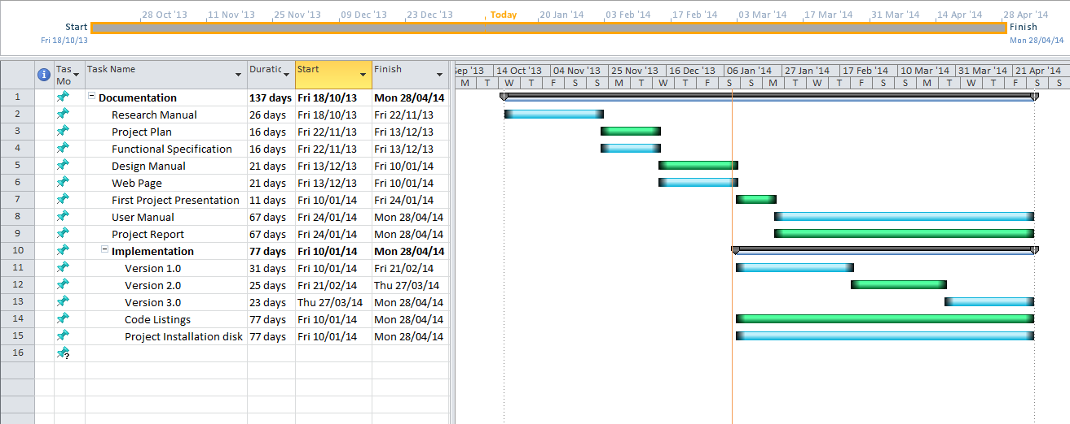

- Conclusion
In conclusion the project will be full completed if the schedule is adhered to. Although there is some flexibility in the implementation phase for the initial, core phase of development to run over time, this could possibly result in the final application lacking in the finer aspects of styling. This overrun would not be ideal however it will in no way affect the functionality of the application.

