Institute of technology carlow
Research Document
Match Tracker Mobile Application
Laura O’Callaghan Conlon
11/22/2013

This document contains all information gathered in the process of researching technologies and methods while developing a mobile application for live tracking of match statistics. This application will be used by managers and coaches of sports teams throughout the duration of their teams’ matches.

Table of Contents
1. Introduction 3
2. Mobile Application 6
2.1 Target Platform 6
2.2 Survey Results 6
2.2.1 Do you own a smartphone? 6
2.2.2 What type of mobile telephone do you PRIMARILY use? 6
2.2.3 How many people are involved in team management? 7
1.4 Native vs. HTML5 vs. Hybrid 9
1.4.1 Native Android Applications 9
1.4.2 Native iOS Applications 9
1.4.3 Non-native HTML5 applications 10
1.4.4 Hybrid Applications 11
1.5 Target Platform Conclusion 12
1.6 Application GUI 13
1.6.1 Login Screen 13
1.6.2 Main Menu/Home Screen 14
14
1.6.3 Create Team Screen 15
15
1.6.4 Edit Team 16
16
1.6.4.1 Edit Team 17
1.6.5 Create Match 18
1.6.6 Track Match 19
1.6.7 Review Match 20
3. Similar Products 21
3.1 SportingPulse 21
3.1.1 LiveStats 21
3.1.2 LiveScore 21
3.1.3 Online Results 22
3.1.4 Stadium Scoring 22
3.2 Match Reports 23
4. Website 24
4.1 Website Sample Design 24
4.1.1 Login Page 24
4.1.2 Main Menu/Home Page 25
5. Cloud Solution 26
5.1 Google Cloud Platform 26
5.2 Amazon Web Services 27
5.3 Windows Azure 27
5.4 Cloud Solution Conclusion 28
Reference List Error! Bookmark not defined.

Research Document

1. Introduction
The purpose of this document is to research and gather all information relevant to the development of a mobile application for tracking sporting match statistics in real time after a match has been played. The aim is
- To investigate the various platforms available for developing a mobile application
- Choose the most appropriate platform
- Research and develop the various features of the application
- Prototype a GUI for the application and gather user feedback
- Prototype a website for the application and gather user feedback
- Research and choose most appropriate cloud solution
The application will be tailored for a specific group initially which is the women’s section of Leinster Branch Rugby organisation, although the concept of this application is applicable to all sporting teams and categories and can be easily tailored to suit any specific organisation. The research that has been carried out through the course of this project has involved active members of the Leinster Branch organisation, surveys have been sent to all active coaches and managers of each women’s team in the Leinster area. In total there is between 30 to 40 teams in this area, each team has approximately 4 people responsible for team management and coaching which, in total, allows for feedback from between 120 to 160 users. Each user is actively participating in the specific target area therefore their feedback is relevant and up to date.
Currently the process within Leinster Branch on a match day is that the final scores, as well as a breakdown of the tries scored, conversions scored, penalties scored and drop kicks scored must be recorded on a paper team sheet as shown below (Figure 1, Figure 2). Along with the scores it must also be recorded if there were any yellow or red cards issued and against who. Also on the team sheet it must state if scrums were contested or uncontested and if uncontested which team requested this. There must also be a record made of each player, what position they played and their personal player pin number. This sheet must then be signed by the referee and posted to Leinster Branch head office. Following this a text message must be sent to a fixtures secretary in the Branch again stating the final scores, a breakdown of the scores and yellow or red cards issues as well as contested or uncontested scrums. The fixtures secretary then manually inputs this information into a third party website which generates a results table and if there has been a yellow or red card issued she must also input this information into a player database so it will appear on the player’s record.
This project aims to provide an application with the feature to record all the match statistics outlined above and instantaneously submit these records to a cloud based storage platform. Following this submission of data a results table may be then generated and displayed on a website for review by users. The initial stages of the project will only include the ability to record match data and players names. The ability to record player pin numbers and then verify players eligibility will be developed at a later stage.

1.1 Current Paper Team/Match Sheets
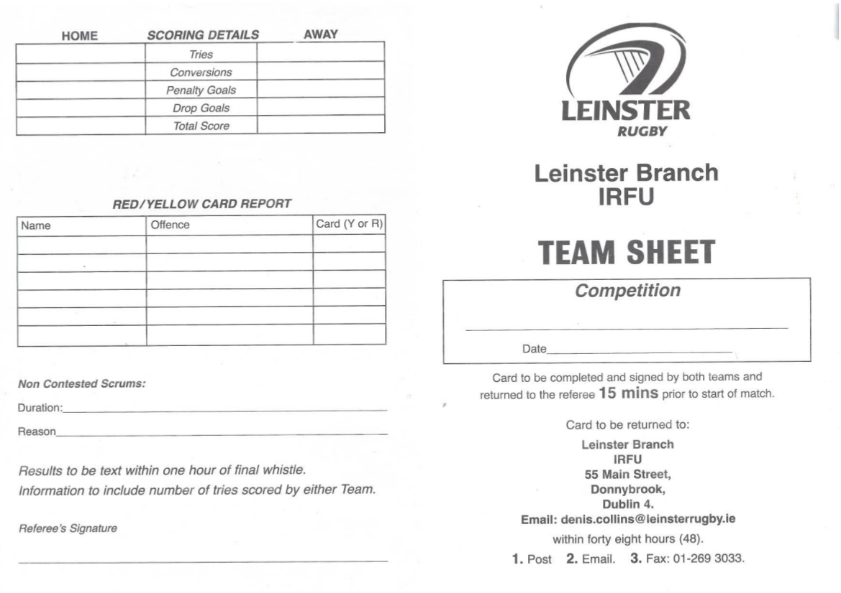
Figure 1
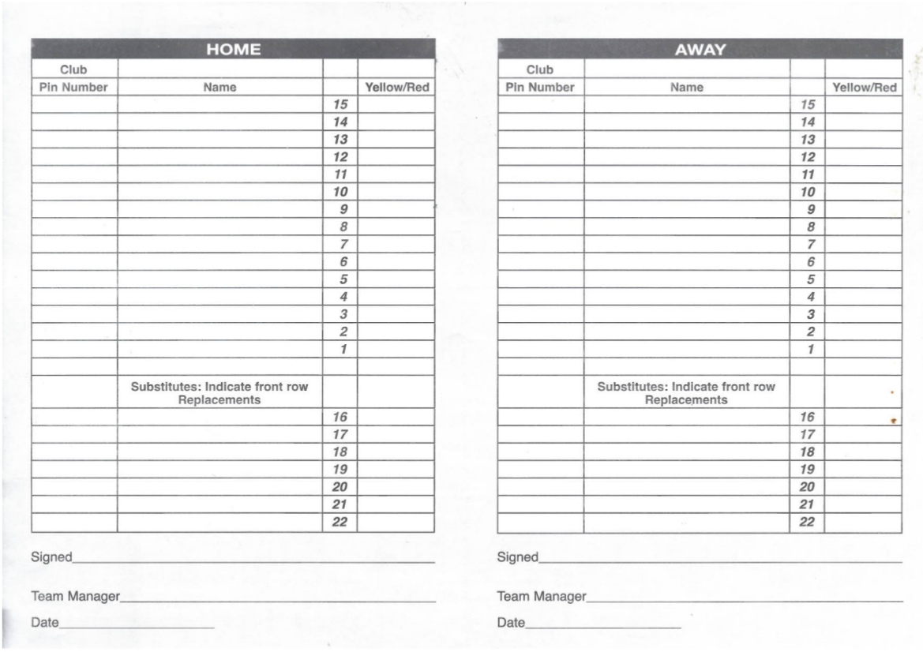
Figure 2

2. Mobile Application

2.1 Target Platform
As part of research into the most appropriate target platform to start development for this mobile application a survey was sent out to all managers and coaches of ladies rugby teams within the Leinster area. There are approximately 30 teams in this area and there was a 60% response rate on the survey. The results are outlined below, in the next section.

2.2 Survey Results

2.2.1 Do you own a smartphone?
The first question that was posed to the recipients in the survey was if they owned a smartphone, the result was a resounding yes, with over 94% of the recipients owning a smartphone. This is a positive result albeit a predictable.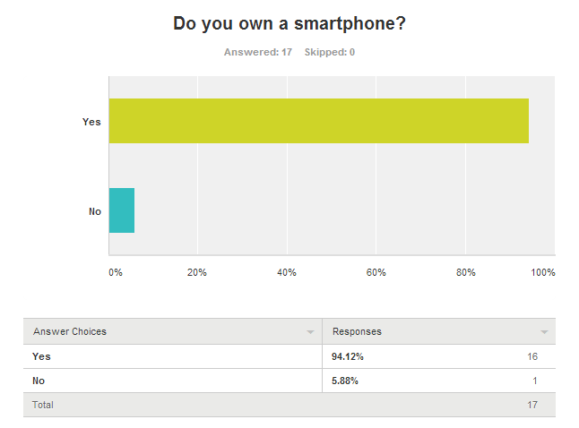

2.2.2 What type of mobile telephone do you PRIMARILY use?
Once it was established whether or not the group of recipients owned smartphones the next question posed to them was what type of phone they owned. This question will help to determine which mobile platform should be targeted to begin with. The result was actually a 50/50 result between Android and iPhone as the one response that was submitted as “Other” falls into the category of Android. Therefore the decision was made to focus initial development on Android. Due to the fact that the results for Android and iOS were even it was the developers choice which platform to target and the decision was made based on resources available, knowledge and experience, all factors that will affect timescale and quality of the project.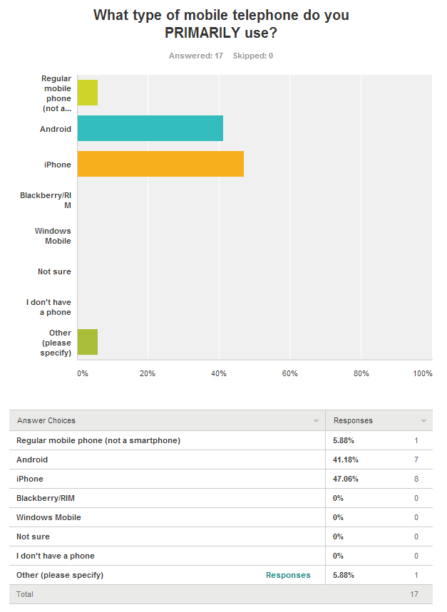

2.2.3 How many people are involved in team management?
The final question that was posed to the recipients was to determine how many people per team would make use of this type of application. Although the survey was only sent out to around 30 teams, each team has a number of people who are responsible for team management on any given day. Each of these people will need access to this application in order to run their team most efficiently. The image below is only 7 of the results received, leaving out a further 10 responses. When calculated, the average number of people associated with team management in this area is 4.
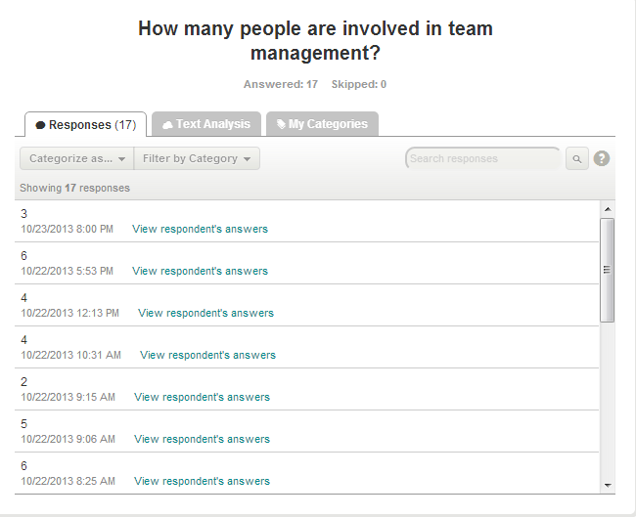

1.4 Native vs. HTML5 vs. Hybrid

1.4.1 Native Android Applications
A native application is an application that is built for a specific platform or device. The options in this case are an Android application or and iPhone application. If it were to be an Android application it would be written in Java or if it were an iPhone application it would be written in Objective-C.
If building an Android app there are development tools provided which offer full Java IDE for development, debugging and packaging the applications. There is a single application model that means your application will adapt the UI to work most effectively depending on the various devices that it is installed on. Android applications also allow for distribution to millions of users through the Google Play Store which is preinstalled on hundreds of millions of devices across the globe
Currently Android covers over 81% of the smartphone market worldwide although in the survey about it only accounts for 47% of the users that responded. In this scenario market share is not a definitive deciding factor in platform selection as Android and iOS have a 50/50 split in this scenario. If development was focused on an Android application it would essentially rule out almost half of our target audience which has the potential to be a large number of users and would decrease the effectiveness of the application.
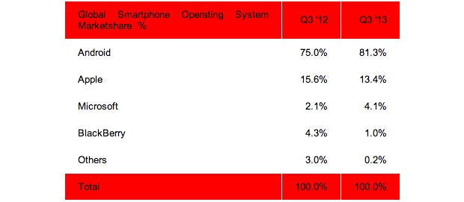

1.4.2 Native iOS Applications
Although Android has the majority market share globally, as seen above, in the target audience we are focusing on it is a 50/50 split between Android and iOS therefore native iOS applications must be considered equally with Android.
One major advantage of developing an iOS application over an Android application is the fact that although Google’s Play Store appears to have an impressive number of downloads and holds the majority device market share the revenue generated from the Apple App Store is far greater than that of Google’s Play Store
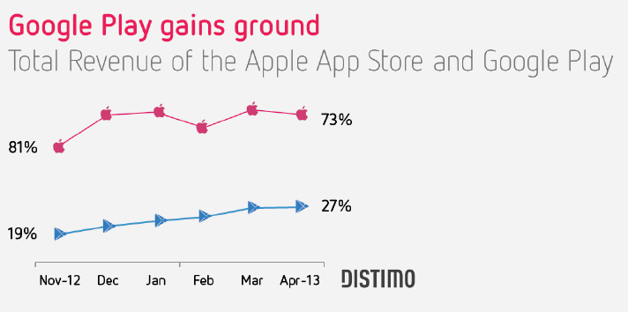
Although the tools and revenue figures reported for native applications are attractive it still leaves the problem of ruling out a high percentage of potential users if one native application is to be chosen over another.

1.4.3 Non-native HTML5 applications
A non-native application is essentially a web application, developed typically using HTML5, Javascript and CSS. A major benefit of non-native applications is that they are fully portable. In so far as they need to be written only once and can be used across a wide range of devices. Due to the fact that the application runs inside a web browser it allows users of any platform whether it be Android, iOS or any other system to run the same application with the same user experience. A non-native application also allows for faster development and deployment. Any changes that need to be made can be rolled out instantly to the entire user base without requiring each user to update the application themselves which leads to enhanced performance.
A disadvantage to developing this way is the HTML5 technology itself, it is still improving and therefore does not have the level of specific development tools that are featured for Android or iOS development. Another disadvantage is the lack of revenue streams compared to Android or iOS. There is no dedicated non-native application store and therefore there is no centralised place to sell the application. This can be combatted by charging a subscription service to users or selling advertisement space within the application, both of which are not as attractive an option as having a once of purchase fee. It also leads to the issue of having to independently find and develop a large customer base to market the application to rather than having access to the millions of users already provided by the Google Play Store and the Apple App Store.
Despite the negative aspects of non-native development it still may be the best option in this particular situation as it allows access for all sectors of the target audience rather than one half or the other.

1.4.4 Hybrid Applications
A hybrid application is an application that is written as a web application but runs inside an native application container. Therefore the application is written as a non-native which is featured in the section above, using HTML5, Javascript and CSS but is wrapped in and iOS or Android wrapper allowing access to native APIs and the individual app stores for distribution.
PhoneGap is a an open source framework which allows web applications to be developed and wrapped for each specific platform. Development is done in Javascript, CSS and HTML5 and then with the help of PhoneGap the application is wrapped and packaged for distribution on each of the native platforms, accessing the native device APIs.
The following table is a breakdown of the three types of application development strategies, outlining the differences, advantages and disadvantages of the various options.
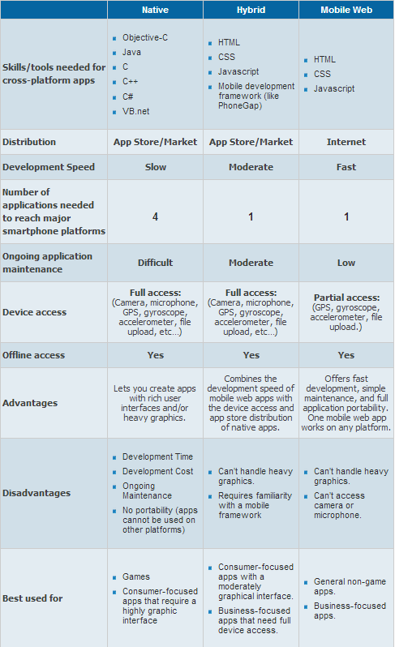

1.5 Target Platform Conclusion
Following research on the various options for application development the conclusion was reached to develop a hybrid application as this will allow for development in web technologies but also deployment as a native application. Due to the nature of the application being developed it will not be necessary to support heavy graphics and it will also allow for the application to be used without immediate network access. By developing a hybrid application it makes distribution possible through the native app stores rather than solely through independent websites which gives access to millions of potential customers that are provided by each app store.
The tool that will be used in order to build this application is PhoneGap. The user interface of the application will be written in Javascript, HTML5 and CSS using an advanced text editor such as SublimeText. The native os functions will then be accessed through the API provided by PhoneGap, using Javascript to write the logic element for the application which will be communicated through the PhoneGap API to the native operating systems.

1.6 Application GUI

1.6.1 Login Screen
The login screen of the mobile application allows a user to log in to their account in order to create, track or review teams and matches. User must register their accounts online through the website after which they may then access their accounts through the mobile application. As previously mentioned in this document, a survey was distributed to potential users, one question on said survey was in relation to regular internet access to which 100% of participants answered that they had regular access to the internet which indicates that a one time website registration would not pose an issue.
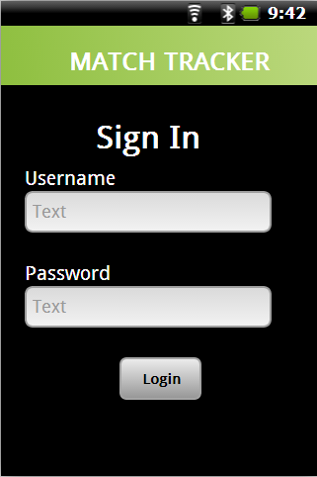

1.6.2 Main Menu/Home Screen
The main menu screen of the mobile application allows the user to select from the various options offered by the application. User must create at least one team in order to start tracking matches, this team can later be edited. Users may create matches in advance of the fixture to allow quick access on the day. Past matches may also be reviewed which potential users have found very beneficial in order to predict future performances.
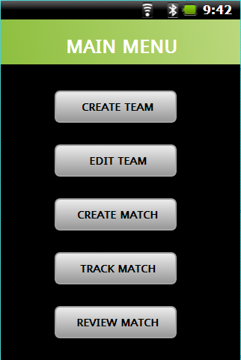

1.6.3 Create Team Screen
As a large number of clubs are now developing second and subsequent teams which may be managed by the same person, there needs to be an option to create more than one team to track matches for. Each number on the team represents a specific position which is useful to users who may not be very familiar with the game, which is a surprisingly regular occurrence. This feature makes it easier for the user to determine what person plays at what position.
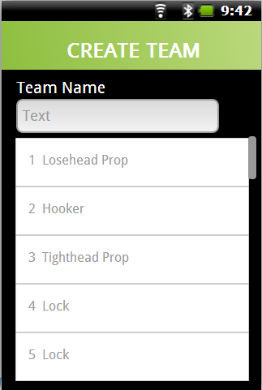

1.6.4 Edit Team
Once a team has been initially created that team may be edited as and when needed. This is something that potential users requested due to the fact that on any given match day the players available for selection can vary greatly.
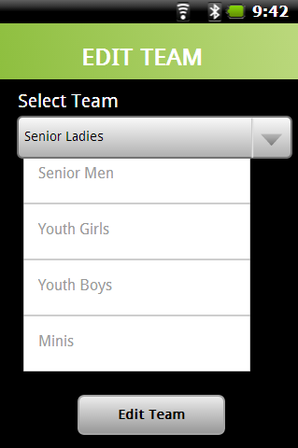

1.6.4.1 Edit Team
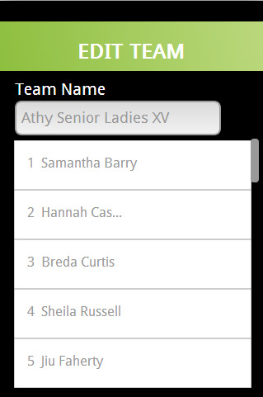
This screen is a follow on from the above, after selecting team to edit a list of current players on team is displayed and each entry is available for editing.

1.6.5 Create Match
This screen allows user to set up the match details before the actual event. This is a feature that was requested by potential users in light of the fact that a match day can be a very busy time for coaches and managers and many do not have time to input this data before the match starts.
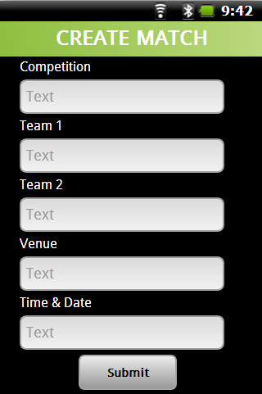

1.6.6 Track Match
This screen of the application allows the user to enter the details of the match once same has been completed. It has input fields for all the information that is required by the Leinster Branch head office which makes it very straight forward to the users to record all necessary statistics without forgetting anything. The requirements for this feature were finalised with members of the Leinster Branch Women’s committee, based on exactly the information they require to be submitted and the fact that they find there are many instances where coaches and managers fail to submit certain statistics and this then leads to a member of the committee having to individually chase down each manager or coach in order to obtain this information.
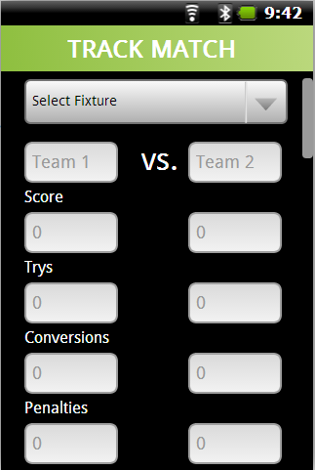

1.6.7 Review Match
Once the statistics for a match have been submitted to Leinster Branch the user of the application may then review any past submissions. This was requested as a feature due to the fact that many teams play home and away fixtures against the same opponents throughout the year, this can be something that is difficult to keep track of and something that may need to accessed on the day of a match in order to determine if the opponents have previously had a high try scoring rate or point kicking rate. It also provides data that can be used to determine the strength of an opponent’s defence or attack.
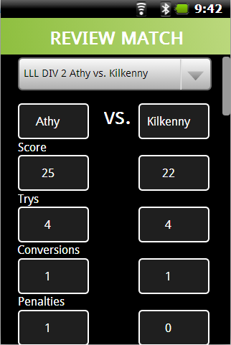

3. Similar Products

3.1 SportingPulse
After extensive research, only one product currently available seemed to be in anyway similar to the proposed project covered by this document. There are a number of options available from the one company called SportingPulse. This seems to be mostly web based applications although they do feature one mobile application that is available for iPhone and most recently there was an Android application launched called SportingPulse which appears to be only for viewing match results, fixtures and tables for teams that are using the service
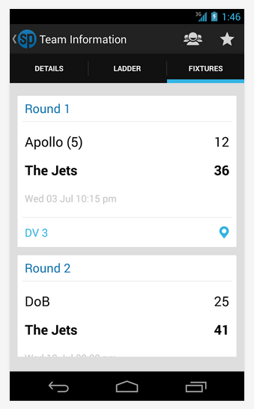
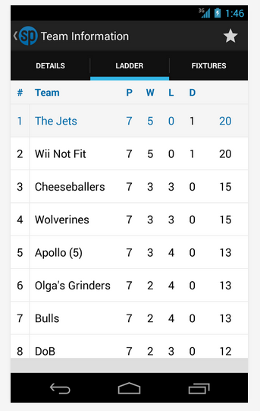
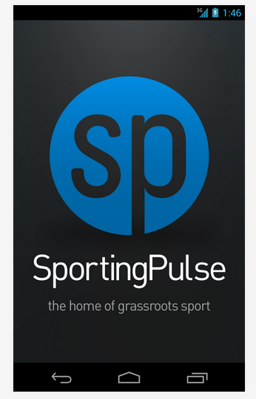

3.1.1 LiveStats
This is a note-book based application featured on the SportingPulse website that appears to be in conjunction with the FIBA (Fédération Internationale de Basketball Amateur) which allows for live, real time recording of basketball games. This features recording of match statistics, play by play and shot chart reporting along will all FIBA statistics. These results can then be broadcast on the web for fans and followers to view
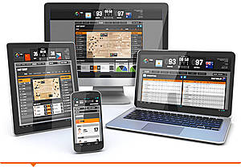

3.1.2 LiveScore
This is the one product in the SportingPulse suite that is most similar to the proposed project covered by this document. The LiveScore application is an online application that allows the user to record match scores on a mobile device as and when they happen, pitch or court side. It allows for play by play, quarter by quarter or half by half recording of results. It is available to users of the SportingPulse suite and is not a stand alone product. The results can be published to the web and various social media websites for review
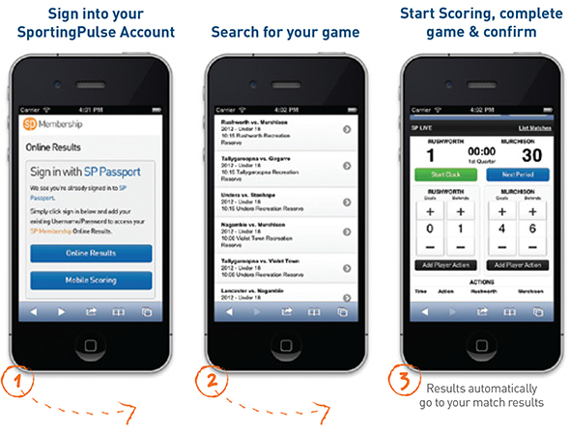

3.1.3 Online Results
This online application allows teams to submit results over the internet and then allows the data to be used to create team sheets and player stats. This is a similar product to the web based aspect of the project that is covered by this document. Again this is not a standalone product and is only available with a subscription to the SportingPulse product suite

3.1.4 Stadium Scoring
This application allows basketball teams to score and record basketball games online rather than on the previous system of paper score sheets. The application must be loaded on the machine directly rather than accessed through a web browser. It allows creation of player and game stats when linked with SportingPulse website
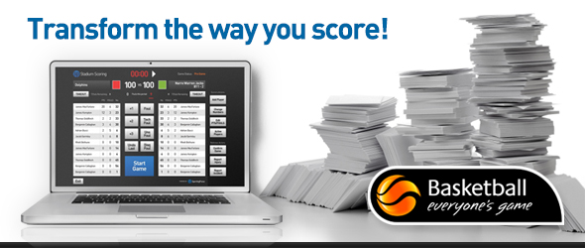

3.2 Match Reports
Match Reports is an application that allows soccer players and managers record the results of a match that has been played. It features the recording of scores, scorers and players who assist. It also allows the user to write and record a match report.
The user may create a panel of players to choose from when recording all future matches and this also allows for a record to be kept of how many matches the players have played individually. The data recorded by this application can be exported to Microsoft Excel or Open Office in the form of a spread sheet.

4. Website

4.1 Website Sample Design
The purpose of the website is to allow users to view upcoming fixtures for their chosen teams and also review previous results that have been generated from the input of match results from the application users.

4.1.1 Login Page
This is the initial page the user will be presented with upon navigating to the website. This page allows the user to log in or register a new account. A sample of this page was shown to potential users and the feedback was very positive, each user was of the opinion that the log in and registration was very simple and straight forward allowing users of all technical abilities easy of use.
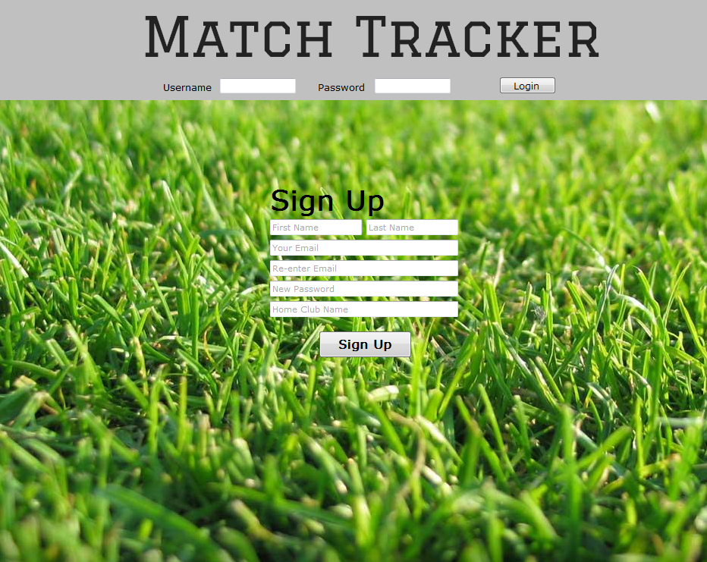

4.1.2 Main Menu/Home Page
Again the feedback on this page was very positive, potential users found the ability to personalise their home page with a club banner a major plus and have a news feed feature on their homepage allows quick access to the latest results and inputs related to their chosen teams.
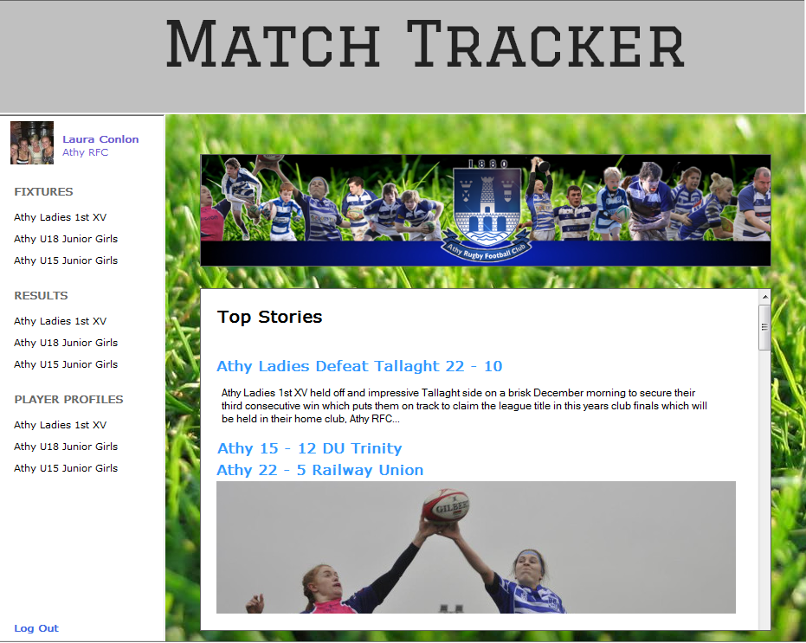

5. Cloud Solution
There are many options available for cloud solutions but for this project, research will be focused mainly on the major companies providing cloud solutions currently. The options that have been researched are Google Cloud Platform, Amazon Web Services and Windows Azure. A cloud solution is essential in this project in order to store and access information that the user will input through the mobile application which in turn will be accessible to web users to access through the website in order to view results of matches and upcoming fixtures. As this information needs to be accessed from both the mobile application and the website it must then be stored in a centralised location that is constantly accessible. The best option for this is to use a cloud solution. The cloud solution can store data such as images associated with user or player profiles or other data such as results that are input to the system.

5.1 Google Cloud Platform
Google has developed a new technology called Google Cloud Endpoints to work within the Google Cloud Platform. Endpoints allows web and native mobile clients access data and developers create a backend for all devices while eliminating the need for individual wrappers to handle communication with App Engine.
Google Cloud Storage will allow larger files to be stored, such as images. The storage in Google Cloud Storage works using a hierarchical process which moves data from high availability storage to less expensive storage based on ageing of data. This service also provides notifications of new data, version management to backup older versions of data and unlimited capacity. The App Engine Datastore which can store data such as results that the user inputs in the form of strings, integers or other entities. Operations can be performed on the data in the Datastore such as get, put, delete and query therefore allowing for access to and basic manipulation of the data.
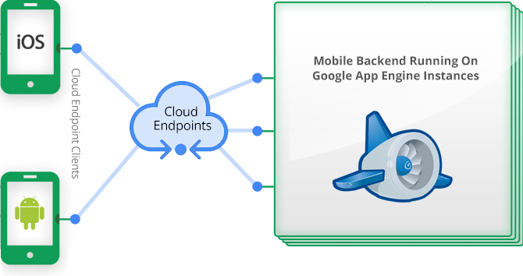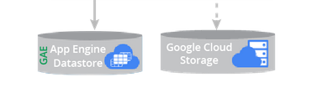
Google App Engine is a Platform as a Service used to build and host applications using cloud technology. This service is automatically scalable and uses the same infrastructure as that used by Google applications.

5.2 Amazon Web Services
AWS is not dependant on any one development language or operating system in that your mobile or web application can be written in any language such as Java, PHP or Objective C and AWS will work just the same with the application. AWS is capable of providing servers, storage, databases, content delivery, cache and search amongst other applications AWS incorporates Amazon RDS which is a relational database that supports MySQL amongst others. Amazon Web Services also features Amazon S3 or Amazon Simple Storage Service which is a web service interface that allows storage and access to any amount of data at any time. With Amazon S3 data is stored in a Bucket which resides in a region of the users choosing to allow full control over latency, cost and regulatory requirements. Below is a snippet of all the products that are offered by Amazon Web Services.
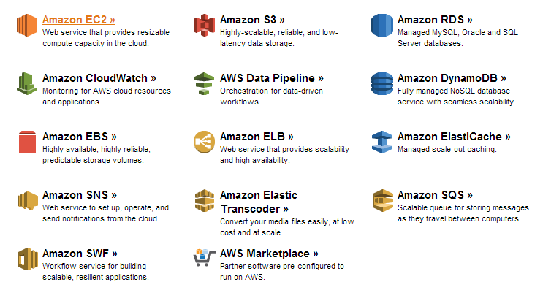

5.3 Windows Azure
Windows Azure from Microsoft supports applications built for all platforms including Android, iOS and HTML5. Mobile Services from Windows Azure provides data storage, user authentication and the ability to send push notifications.
Windows Azure allows for storage and data management. The various storage solutions offered are Blob (Binary Large Object) Storage. This service allows for the storage of large amounts of data such as images and videos.
The Import/export service allows for the user to move data into and out of Blob storage. Data migration, content distribution and data recovery are all services offered under the umbrella of Windows Azure Storage Services.

5.4 Cloud Solution Conclusion
For the infancy stages of this application the most appropriate solution seems to be Google App Engine. This service provides free hosting for applications up to a certain level and then a very competitive pricing scheme thereafter. Included in this option is 5GB of Blob storage which should be sufficient for the initial stages of this application and allows for expansion, in the form of add on packages and services as the application grows. A pricing guide is shown below.
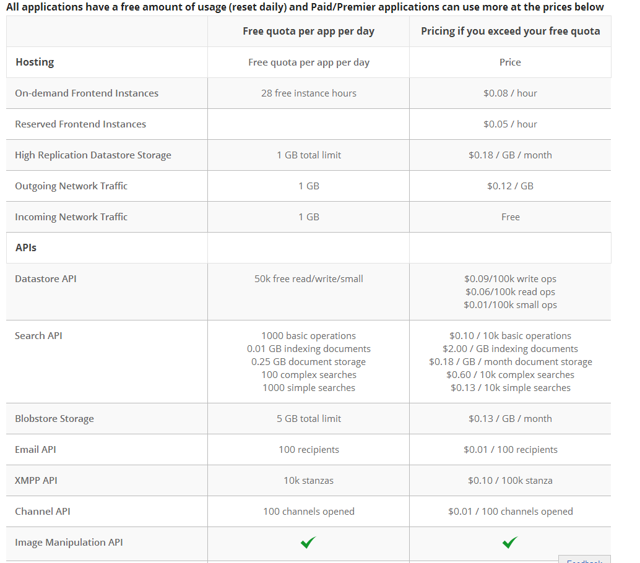
As the application grows more storage options are available using Google Cloud Storage and the pricing guide is available below.
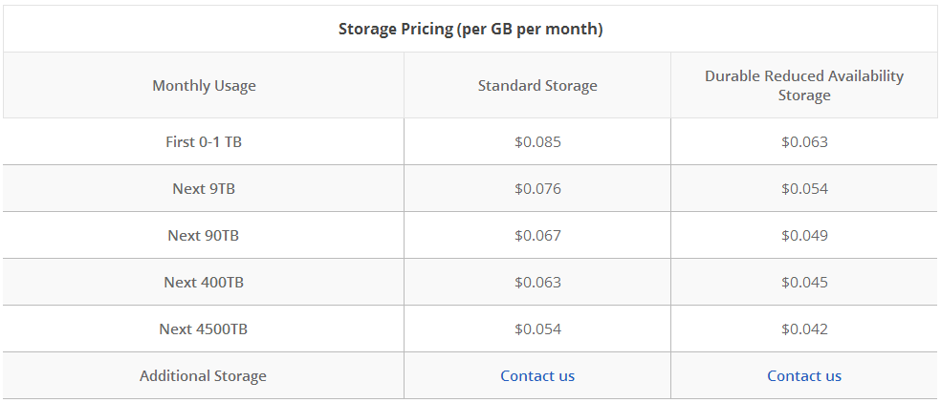
Google also offers the Google Cloud SQL service which provides the ability to run MySQL databases in the cloud and maintain and administer databases. This is something that is required to process, store and use the information that is provided by the coaches and managers for each match that is recorded. Pricing is shown below.
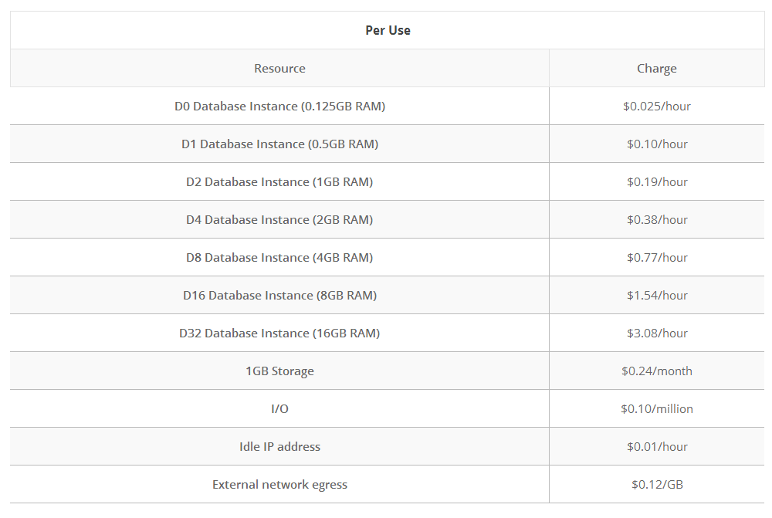
This application requires the ability to store data in a database in the form of strings and integers mostly. There will also be a requirement to store images to some degree for use as profile pictures and the possibility of future features of adding match photos and reports.

Bibliography

SurveyMonkey (2013). Team Communication Technology. Available: http://www.surveymonkey.com/s/NQFG8WF [accessed 12 Novemeber, 2013]
TechTarget. (2103). Native app. Available: http://searchsoftwarequality.techtarget.com/definition/native-application-native-app [accessed 17 November, 2013]
Google. (2013). About Android. Available: http://developer.android.com/about/index.html [accessed 12 November, 2013]
AOL Inc. (2013). Engadget. Available: http://www.engadget.com/2013/10/31/strategy-analytics-q3-2013-phone-share/ [accessed 12 November, 2013]
Distimo. (2013). A Granular App Level Look at Revenues: Google Play vs. Apple App Store. Available: http://www.distimo.com/publications/archive/Distimo%20Publication%20-%20May%202013.pdf [accessed 13 November, 2013]
VentureBeat. (2013). Native vs. HTML5: How the auto industry is forcing change for the mobile web. Available: http://venturebeat.com/2013/10/05/native-vs-html5-how-the-auto-industry-is-forcing-change-for-the-mobile-web/ [accessed 13 November, 2013]
ICENIUM. (2012). What is a Hybrid Mobile App?. Available: http://www.icenium.com/blog/icenium-team-blog/2012/06/14/what-is-a-hybrid-mobile-app- [accessed 19 November, 2013]
Wikipedia. (2013). PhoneGap. Available: http://en.wikipedia.org/wiki/Phonegap [accessed 16 November, 2013]
MRC Ltd. (2013). Hybrid vs. Native vs. Mobile web comparison chart. Available: http://www.mrc-productivity.com/blog/2012/03/hybrid-vs-native-vs-mobile-web-comparison-chart/ [accessed 13 November, 2013]
SurveyMonkey (2013). Team Communication Technology. Available: http://www.surveymonkey.com/s/NQFG8WF [accessed 12 Novemeber, 2013]
Google. (2013). Play Store, Apps. Available: https://play.google.com/store/apps/details?id=com.b2cloud.sportingpulse [accessed 30 October, 2013]
Fox Sports Pulse PTY Ltd. (2013). Available: http://sportsolutions.foxsportspulse.com/products/ [accessed 6 November, 2013]
SportingPulse Pty Ltd. (2013). LiveStats. Available: http://corp.sportingpulse.com/index.php?id=39 [accessed 30 October, 2013]
SportingPulse Pty Ltd. (2013). LiveScore. Available: http://corp.sportingpulse.com/index.php?id=197 [accessed 30 October, 2013]
SportingPulse Pty Ltd. (2013). Online Results. Available: http://corp.sportingpulse.com/index.php?id=38 [accessed 30 October, 2013]
SportingPulse Pty Ltd. (2013). Stadium Scoring. Available: http://corp.sportingpulse.com/index.php?id=40 [accessed 30 October, 2013]
Apple (2013). iTunes App Store, Match Reports. Available: https://itunes.apple.com/us/app/match-reports/id420245915 [accessed 12 November, 2013]
Google. (2013). Overview of Google Cloud Endpoints. Available: https://developers.google.com/appengine/docs/java/endpoints/ [accessed 20 November, 2013]
Google. (2013). Google Cloud Storage Overview. Available: https://developers.google.com/storage/docs/overview [accessed 20 November, 2013]
Google. (2013). Java Datastore API. Available: https://developers.google.com/appengine/docs/java/datastore/ [accessed 20 November, 2013]
Google. (2013). Google App Engine. Available: https://cloud.google.com/products/app-engine [accessed 20 November, 2013]
Amazon. (2013). Web, Mobile and Social Apps on AWS. Available: http://aws.amazon.com/web-mobile-social/ [accessed 20 November, 2013]
Amazon. (2013). Web, Mobile and Social Apps on AWS. Available: http://aws.amazon.com/web-mobile-social/ [accessed 20 November, 2013]
Amazon. (2013). Amazon Relational Database Service (Amazon RDS). Available: http://aws.amazon.com/rds/ [accessed 19 November, 2013]
Amazon. (2013). Amazon Simple Storage Service (Amazon S3). Available: http://aws.amazon.com/s3/ [accessed 20 November, 2013]
Amazon. (2013). AWS Free Usage Tier. Available: http://aws.amazon.com/free/ [accessed 20 November, 2013]
Microsoft. (2013). Mobile Apps | Windows Azure. Available: http://www.windowsazure.com/en-us/ [accessed 20 November, 2013]
Microsoft. (2013). Mobile Services. Available: http://www.windowsazure.com/en-us/services/mobile-services/ [accessed 20 November, 2013]
Microsoft. (2013). Storage Services. Available: http://www.windowsazure.com/en-us/services/storage/ [accessed 20 November, 2013]
Google. (2013). Google App Engine. Available: https://cloud.google.com/products/app-engine [accessed 20 November, 2013]
Google. (2013). Google App Engine Pricing. Available: https://cloud.google.com/pricing/ [accessed 22 November, 2013]
Google. (2013). Google Cloud Storage. Available: https://cloud.google.com/products/cloud-storage [accessed 22 November, 2013]
Google. (2013). Google Cloud Storage Pricing. Available: https://cloud.google.com/pricing/cloud-storage [accessed 22 November, 2013]
Google. (2013). Google Cloud SQL. Available: https://cloud.google.com/products/cloud-sql [accessed 22 November, 2013]
Google. (2013). Google Cloud SQL Pricing. Available: https://cloud.google.com/pricing/cloud-sql [accessed 22 November, 2013]

