Institute of Technology, Carlow

B.Sc. (Honour) in Software Development

CW228

Project Plan

Thread Pool Benchmarking

Name: Bowen Nong
Login ID: C00163585
Supervisor: Joseph Kehoe
Date: December 14th 2012

Contents
1. Introduction 3
1.1. What is the plan for 3
1.2. Requirements 3
2. Major Milestones in Chronological Order 3
2.1. Scheduling Form 3
2.2. Plan Description 3

Introduction

What is the plan for
The threads were used to increase the speed of running programs. They allow the computer to work seen like doing job on the same time. Actuary, the CPU just allocate the work time for each thread. When the threads are created or killed by system, the CPU will give the sources and time. If each task needs to create a thread for working, it will waste lots of sources and time. However, on the other way, we created a group of threads for jobs. Then we do not kill the thread. When a thread finishes a task, it will “sleep” in the queue. According to the scheduling algorithms of threads, the thread goes out of queue for the new task. It will re-use the threads and save the time and sources. So the “box” which we use to create, kills and manages the group of threads is thread pool.

Thread pool is managed by the system, so that programmers do not need to spend time taking or cart thread management. And they can concentrate on application tasks. The threads are stored by priority.

According to this project, the thread pool schedule algorithms will be known, and which schedule algorithms are suitable in games. The timing metrics will be used in the project.

Requirements

- C or C++
- OpenMP
- Games Algorithms
- Benchmark code

Major Milestones in Chronological Order

Scheduling Form
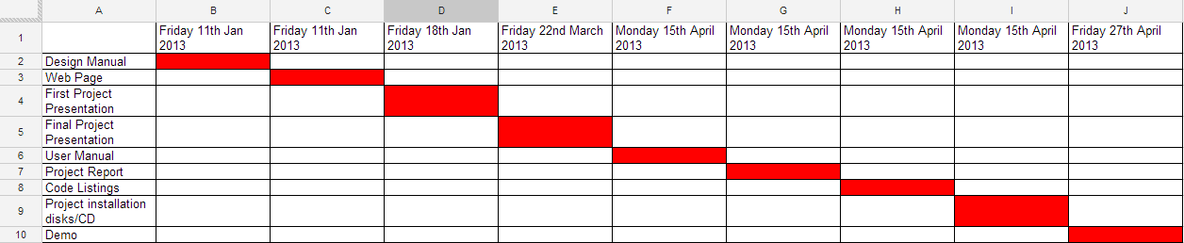

Plan Description

    - Design Manual
Days: 25
Deadline: Friday 11th Jan 2013
Description:
- Design and describe what technologies and expected results are.
- Thread pool Design.
- Benchmarking code Design
- Coding benchmark algorithms

    - Web Page
Days: 5
Deadline: Friday 11th Jan 2013
Description:
- Create one or two simple web pages.
  - Project prepared.
  - Relevant web pages.

    - First Project Presentation
Days: 7
Deadline: Friday 18th Jan 2013
Description:
- The algorithms with OpenMP
  - Random Numbers algorithms
  - Minimax algorithms
  - Path Finding algorithms
  - Flocking algorithm

    - Final Project Presentation
Days: 4
Deadline: Friday 22nd March 2013
Description:
- Design own thread pool algorithms
- Testing results

    - User Manual
Days: 5
Deadline: Monday 15th April 2013
Description:
- How to use OpenMP
- How the benchmark to be used
- Coding Thread pool algorithms

    - Project Report
Days: 10
Deadline: Monday 15th April 2013
Description:
- Benchmark results
- Thread pool algorithms
- Benchmark algorithms

    - Code Listings
Days: 5
Deadline: Monday 15th April 2013
Description:
- Thread pool code
- Benchmarking code

    - Project installation disks/CD
Deadline: Monday 15th April 2013
Description:
- Hand up Benchmarking code
- Hand up Thread pool code

    - Demo
Days: 12
Deadline: Friday 27th April 2013
Description:
- Thread pool how to work
- What the benchmark code is
- How to benchmark
- Results of project

