

MOS Plugin Design

B.Sc. (Honours) in Software Development

C00164522 – Luca Venturelli

Table of Contents
Table of Contents 2
1. Introduction 4
1.1 Purpose 4
1.2 Main Overview 4
2. Data Design Overview 5
2.1 Data Object 5
2.2 Use Case Diagram 5
2.3 Detailed Use Case 6
2.4 Domain Model 6
2.5 Class Diagram 6
3. Procedural and Interaction Design 9
3.1 Sequence Diagram 9
4. Contracts 9
4.1 Analyze 9
5. Interaction Diagram 10
6. Data Definition 10
6.1 ER Schema 10
6.2 SQL code 11
7. Test Design 12
7.1 Introduction 12
7.2 Network test 12
7.3 Hardware test 13
7.4 User Experience 13
7.5 Conclusion 13
8. Reference 13

Introduction

Purpose
The purpose of this document is to describe and explain the software architecture, with a detailed look at the main classes and the interaction between each class.
It will also provide the description of the tests that have to be done in order to prove the quality of the metric that we are going to propose.

Main Overview
As mentioned in the specification document the objective of the software is to create a plug-in for the game engine id Tech 4 . The programming language used for this application will be C++.
The main functionalities of the plug-in are:
- Hardware analysis: analysis of the hardware of the user's using C++ functions such as GetSystemInfo for the CPU or GlobalMemoryStatusEx for the RAM. The components we are going to analyze are:
  - The Processor speed. We will rank the existing processors basing it on the benchmark available. All the data about the quality of the processors will be stored in the database, in order to always have the most up to date list of processors.
  - The Graphic card. We will rank the existing graphical cards starting from the best graphic card (AMD Radeon HD 6990 or NVIDIA GeForce GTX 590) ending with the integrated graphic cards.
  - The Monitor resolution and size. We will give the maximum score to the best resolution (2560x1440) and the minimum score to the worst resolution (800x600).
  - The Mouse. We will rank the precision of the mouse starting from the most precise (like the Razer Mamba 2012) to the worst mice (Apple USB mouse also known as “hockey puck”). The rank will be based on the benchmarks done.
- Network analysis: analysis of the network quality using the libraries provided by the game engine. This analysis will be performed interacting directly with the server responsible for the game management. In this way we can have a more precise estimation of the network quality. The parameters we are going to analyze are:
- The jitter between the server and the user's machine.
- The packet loss between the server and the user's machine.
- The delay of the packets between the server and the user’s machine.
To analyze this
- User experience: we will ask the user about the number of hours he has played FPS games. Based on the frequency of use We will then have a subjective opinion on the quality of the player.
- Metric implementation: it will also implement the metric developed and it will save the MOS calculated into the database.
- Database interaction: the plug-in will store all the data in the database that will be installed in our main server.

Data Design Overview

Data Object
The application has to be able to keep track of the data it produces. The data objects the application needs to keep track of are:
- The MOS calculated by the plug-in.
- The network status.
- The player opinion.
- The hardware quality.
All these data have to be stored in a database located in the main server that controls the entire network and the players.

Use Case Diagram
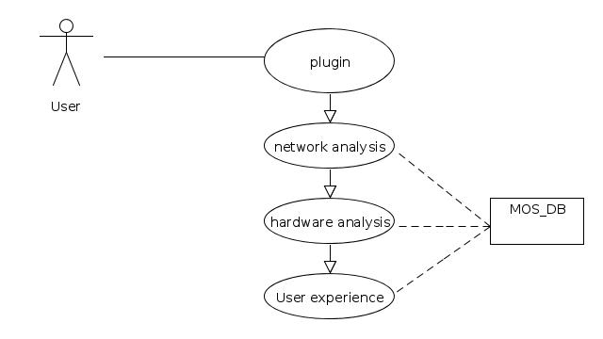

Figure 1: Use Case diagram

Detailed Use Case
Use Case Name: User Experience
Actor: User
Precondiction: The user starts the game.
Success Scenario:
- The system provides a form to the user
- The user insert the data in the form
- Clicks continue
- End Use Case

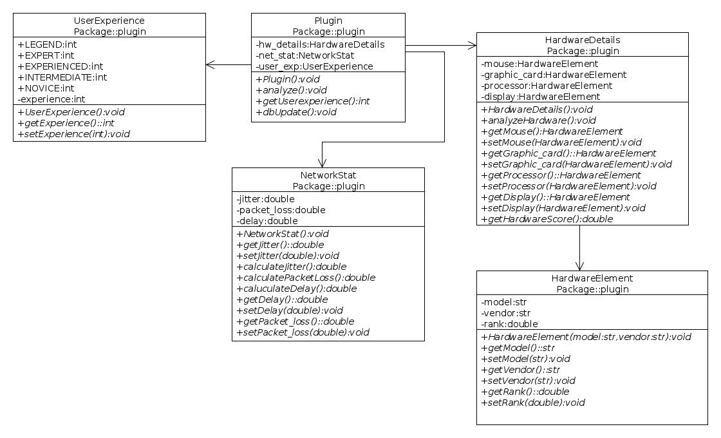
Domain Model

Figure 2: Full Domain Model

Class Diagram
Plugin Interface:
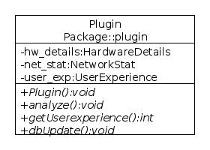

Figure 3: Plugin class schema
Responsibility: This class implements the main functionalities of the plug-in.
- analyze() analyzes the hardware and the network status;
- dbUpdate() updates the database with the information of the user;
- getUserExperience() asks the user for his game experience and returns the value chosen;
- DbUpdate() updates the information collected into the database.
HardwareDetails Class:
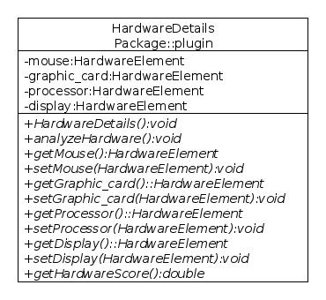

Figure 4: HardwareDetials class schema

Responsibility: This class is used to analyze the hardware of the PC where the plug-in is installed.
- getHardwareScore() returns the score calculated by the evaluation of each single component.
HardwareElement Class:
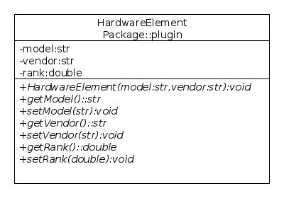

Figure 5: HardwareElement class schema
Responsibility: HardwareElement describes a generic hardware element with the model, the vendor and the rank.
Class NetworkStat:
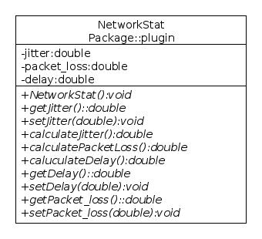

Figure 6: NetworkStat class schema
Responsibility: This class is used to analyze the network status.
- calculateJitter() analyzes and calculates the jitter of the network.
- CalculatePacketLoss() analyzes and calculates the packet loss of the network.

Procedural and Interaction Design

Sequence Diagram
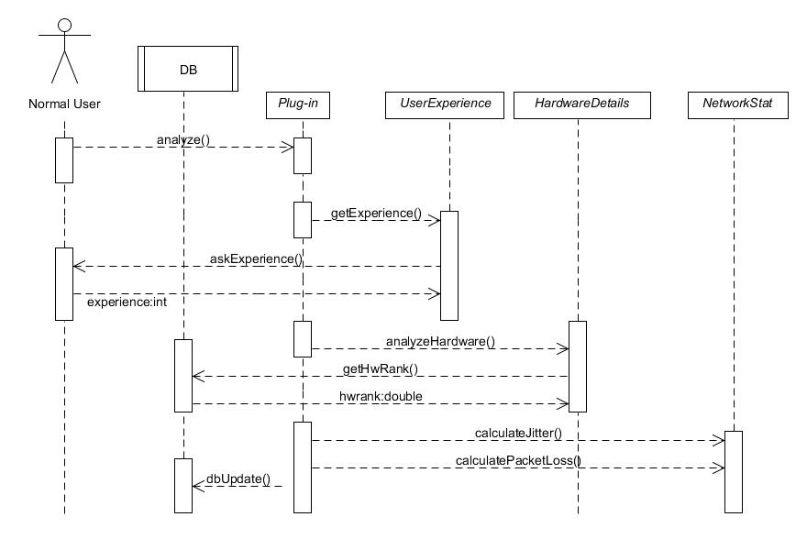
Figure 7: System sequence Diagram

Contracts

Analyze
Contract: Plugin
Operation: analyze()
Preconditions: user starts the game.
Post Conditions:
- A new instance of the class Plugin is created (instance creation).
- A new instance of the class UserExperience is created (instance creation).
- A new instance of the class HardwareDetails is created(instance creation)
- A new instance of the class NetworkStat is created (instance creation)
- All the data collected are stored into the database with a query.

Interaction Diagram
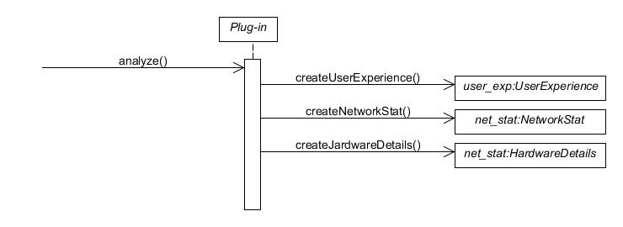
Figure 8: Interaction Diagram

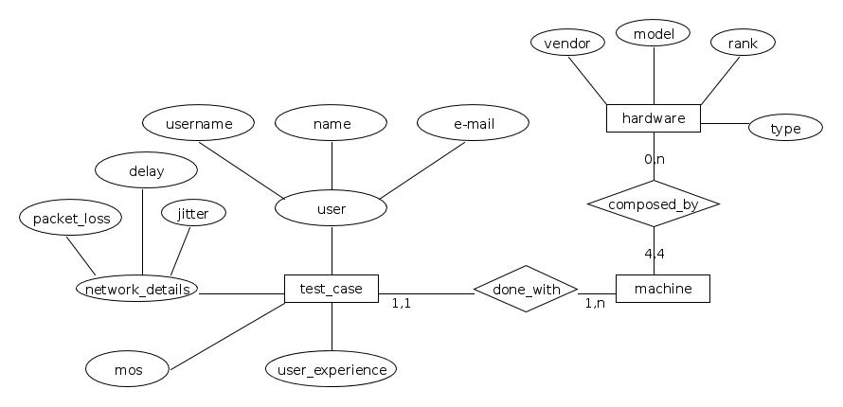
Data Definition

ER Schema

Figure 9: ER Schema

SQL code
CREATE TABLE user(
username VARCHAR(20),
name VARCHAR(100),
email VARCHAR(100),
PRIMARY KEY (username)
);
CREATE TABLE test_case(
user VARCHAR(20),
packet_loss NUMERIC(10,2),
jitter NUMERIC(10,2),
delay NUMERIC(10,2),
user_experience NUMERIC(1,0),
machine BIGINT,
mos NUMERIC(10,2),
PRIMARY KEY(user),
FOREIGN KEY (user) REFERENCES user (username)
);
CREATE TABLE machine(
id SERIAL,
user VARCHAR(20),
mouse_id BIGINT,
monitor_id BIGINT,
cpu_id BIGINT,
graphic_card_id BIGINT,
PRIMARY KEY (id),
FOREIGN KEY (mouse_id) REFERENCES hardware (id),
FOREIGN KEY (monitor_id) REFERENCES hardware (id),
FOREIGN KEY (cpu_id) REFERENCES hardware (id),
FOREIGN KEY (graphic_card_id) REFERENCES hardware (id)
);
CREATE TABLE hardware(
id SERIAL,
vendor VARCHAR(100),
model VARCHAR(50) UNIQUE,
rank NUMERIC(10,0),
type CHAR,
PRIMARY KEY (id)
);

Test Design

Introduction
We will make two test sessions. A first session with eight people, two frequent players with a high experience in FPS games, two with a good experience in FPS games, two with some experience in game playing and two with none or a very little experience in FPS games.
The second session will be made with different people with the same experience of the group before. In this second session we will setup the environment with different machines and different parameters for the network quality in order to test the accuracy of the metric.
The tests will have duration of five minutes. For each of the following test the users will be asked to evaluate the game quality. The players can select one of the following five opinion scores according to the ITU-T ACR scale [1]:
- 5:Excellent gaming quality;
- 4: Good gaming quality;
- 3: Fair gaming quality;
- 2: Poor gaming quality;
- 1: Bad gaming quality.

Network test
This test will measure the influence of the network in the game quality. For this test we will use a tool called
The first session will measure the jitter influence. 5 tests with different values of jitter will be done.
The second session will measure the packet loss influence. 5 tests with increasing values of packet loss will be done.
The third session will measure the delay influence. 5 tests with increasing values of delay will be done.
The fourth session will measure the combination of packet loss, jitter and delay influence on the game quality. 10 tests with a combination of different values of jitter, delay and packet loss will be done.

Hardware test
This test will measure the influence of the hardware in the game quality.
We will evaluate the impairment of mouse, monitor, processor and graphic card. We will provide for each component a high quality, a medium quality and bed quality hardware. We will test all the possible combinations of the hardware we will provide. For each combination the testers have to give a score. For this test we will guarantee the maximum quality of the network. At the moment we don’t have the details of the hardware we are going to use.

User Experience
This test will measure the influence of the user experience in the game quality.
At the beginning of the tests the users will be asked to tell how many times per week he plays fps games. Based on this answer we will understand the type of player.

Conclusion
All the information coming from the previous tests will be stored in the database previously described in chapter 5.

Reference
[1] ITU-T Recommendation P.800. Methods for subjective determination of transmission quality. http://www.itu.int/rec/T-REC-P.800-199608-I/en, 1996.

