2020

Research Manual
E-DOCHTÚIR – Online Healthcare Application

Holly Gunning
C00214010
Supervisor: dr. Hisain Elshaafi

Abstract
In recent years, it has become increasingly difficult to provide adequate services to patients due to overcrowding of local practises and understaffing. Introducing online healthcare for small to medium size clinics would allow patients and doctors alike to securely access healthcare and avail of a more online based experience. In doing so this would reduce the amount of physical consultations, enabling a more direct approach to prognosis and thereby eliminating not only the overcrowding of these practises, but also the spread of contagions amongst patients.
This document provides a detailed account of the research conducted prior to the development of the online healthcare application, E-DOCHTÚIR. It documents the assessment of previous medical applications, methodologies and technologies best suited. The overall objective of the application is to provide patients with a level of access to their medical records, the ability to book appointments, request prescriptions and communicate with a doctor of their choosing. Meanwhile, a doctor can access a patients’ medical records, view a schedule of their own appointments and has the ability to either accept or deny prescription requests.

Table of Contents
Abstract 1
Table of Figures 4
1. Introduction 5
2. Research Problem 6
2.1. Objectives 6
3. Existing Applications 8
3.1. Superdrug 8
3.2. VHI 10
3.3. VideoDoc 11
3.4. Irish Life Health 12
4. Application Methodology & Features 14
4.1. Mobile Applications 15
4.1.1. What is a Mobile Application? 15
4.1.2. Native Mobile App Development 16
4.1.3. Cross-Platform Mobile App Development 16
4.1.4. Native V.S Cross-Platform 17
4.1.5. Mobile Application Security 17
4.2. Web Applications 18
4.2.1. What is a Web Application? 18
4.2.2. Progressive Web Applications 19
4.2.3. Web Application Security 20
4.2.4. Single-Page Applications 20
4.3. Chosen Application Model 20
5. Technologies 21
5.1. Front-end Technologies 21
5.1.1. HTML5 21
5.1.2. CSS3 21
5.1.3. JavaScript 21
5.1.4. XML 21
5.1.5. JSON 22
5.1.6. AJAX 22
5.2. Back-end Technologies 22
5.2.1. C# 23
5.2.2. Python 23
5.3. Databases 23
5.3.1. SQL & MySQL 23
5.3.2. MongoDB 23
5.4. Frameworks 23
5.4.1. Semantic UI 23
5.4.2. Bootstrap 24
5.4.3. AngularJS 24
5.4.4. Django 24
5.5. APIs 24
5.5.1 WebRTC 24
5.6. Additional Technologies 25
5.6.1. Blockchain 25
5.6.2. Lighthouse 25
5.6. Chosen Technologies 25
6. Conclusion 26
7. Plagiarism Declaration 27
8. Bibliography 28
8.1. References 28

Table of Figures
Figure 1. Screenshot of Superdrug’s appointment booking process, on desktop (Booking.healthclinics.superdrug.com, 2019) 6
Figure 2. Layout of the VHI mobile application (Vhi.ie, 2019) 8
Figure 3. Online services page and message doctor page on the website (Digital Doctor, 2019) 10
Figure 4. High level overview of mobile application development architecture 13
Figure 5. Diagram of the web request-response cycle (AltexSoft, 2019) 16
Figure 6. Diagram of how AJAX operates (W3schools.com, 2019) 20

1. Introduction
The following research manual is intended to document any research undertaken to achieve an understanding of the overall project and its requirements. The main aim of this project is to create an application that provides patients and doctors with secure access to online healthcare services.
In order to achieve this, a number of topics and technologies are researched. A high-level overview of standard GP services and current online healthcare systems is necessary to understand the users’ needs. Similar existing health applications are reviewed, and their functionality taken into consideration, to help narrow down the project’s essential features.
Once the concept of the application and its’ general features are clearly defined, the document explores a number of tools and technologies, to determine those most suitable for the applications development based on security, accessibility and availability. Whilst a variety of material has been researched, not all of this material will be incorporated into the project’s final development, as it is more of a comparative rather than a comprehensive list.
The document weighs the benefits and disadvantages of focusing on native mobile application development vs. web-based development, taking into consideration the user base. Technologies for front-end and back-end as well as databases are analysed in order to choose the most appropriate combination for developing the application based on outlined functionality and methodology.

2. Research Problem
One of the major issues Ireland’s GP (General Practitioners) practises are currently facing is the ability to provide incoming patients with the services they require. According to an investigation undertaken by the Sunday Independent, “almost half of Ireland’s GP practises are operating at maximum capacity” and “44% of surgeries are unable to see new patients because of a lack of GPs.” [1] Not only does this affect the potential of receiving any medical support but also impacts the quality of treatment existing patients are receiving. Combine this with overcrowded waiting room conditions and consultation delays and it is safe to assume that the current model of providing and receiving general healthcare is becoming obsolete. By allowing patients to conduct appointments and access similar services through online applications, these issues can be easily remedied.
In the last decade, an increase in the “attention, resources and interest toward internet-related healthcare activities, often called 'e-health', is dramatic and a most significant development in the healthcare environment.” [2] This growing trend within the health industry seeks to modernise outdated manual systems, transforming the way in which patients experience medical services. However, in reforming a system that has performed in a specific manner for an extended period of time, a number of challenges are presented. Most noticeably, handling of private and confidential information and the laws and clinical best practises currently surrounding this information, as well as the ever-expanding range of developmental technologies and tools to choose from.
Some of the major issues regarding the outdated systems and practises found in healthcare services across the country have only been highlighted further in 2020. A worldwide outbreak of the coronavirus disease (COVID-19) has impacted everyday life and the way in which public facilities such as schools and places of work can operate. Covid-19 is an infectious disease which spreads ruthlessly and can be carried asymptomatically, effecting each person differently regardless of gender or race. As it has already been proven that community exposure is one of the main factors of spreading, it stands to reason that allowing groups of people to wait in close proximity in small and medium size clinics is now more deadly than ever. The more healthcare services can do to reduce the number of people seen physically, the better the chances of reducing the rate of transmission are.

2.1. Objectives
The overall objective of the research manual is to identify functionality within application that will allow patients to access a range of services typically available to them if they were to visit their local GP practise. Based on the research problem discussed above, these might include, but are not limited to:
- Communication between a patient and a registered doctor or specialist.
- The ability to request sick leave, a doctor’s note or prescription, depending on the outcome of a consultation.
- Access to free health information/medical advice, such as methods to quit smoking or links to external support for weight loss etc.
- Booking or appointments and services such as vaccinations or blood tests in the patients’ local clinic.
- Access to the patients’ own personal medical record.

3. Existing Applications
A number of existing healthcare applications were reviewed to gain a better understanding of the features and functionality that healthcare facilitators provide to their users, as well as to source ideas for a user-friendly interface and overall enjoyable user experience. These applications were found through Google searches and some have corresponding mobile applications on the Google Play Store.

3.1. Superdrug
Superdrug is a health clinic that specialises in general health and travel health appointments in over 60 stores nationwide and supplies a range of services from accessible emergency contraception and STI self-test kits to travel vaccines and general health checks.
Through their website they allow the user to book an appointment in advance through call or online booking and provide free consultations and advice with every service. Figure 1 shows the online booking process, which is split into four sections; choose location, choose service, choose staff and choose time.

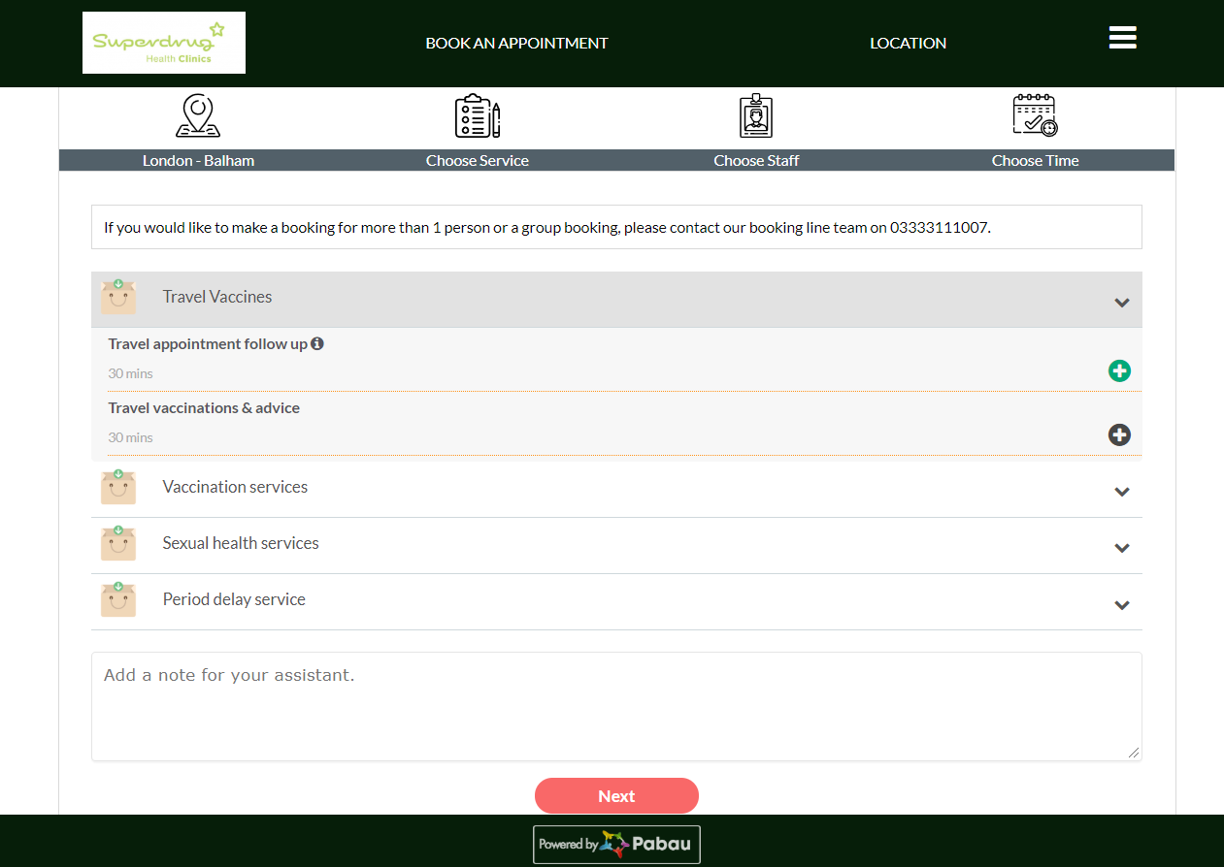
Figure 1. Screenshot of Superdrug’s appointment booking process, on desktop (Booking.healthclinics.superdrug.com, 2019)
In the first section, the user can scroll through a list of locations that also inform them what the age demographic of the centre is, if it is a yellow fever centre and if it caters to a mole screening service. Next the user must choose a service, which is categorised into four main services: travel vaccines, vaccination services, sexual health services and period delay service. These main headings are dropdowns which provide more specific categories within the services. After selecting a service and pressing the next button the user selects an appropriate date on the calendar and a corresponding time and in doing so completes the booking. [3]
Within the site, the user can enter their postcode or town and the website will show them their nearest store. They can also enter in the country that they are visiting and find out if they require any vaccines before they travel. A search function on the website also allows the user to search for a specific illness or medicine and provides them with relevant information regarding their search. [4]

The application is visually clean and scalable as you change the size of the browser and can be accessed while browsing on the mobile, providing a similar feel to the desktop version. An accompanying mobile application allows the user to order their NHS repeat prescriptions from their local pharmacy. Using the audit developer tool ‘Lighthouse’ on the desktop, the overall results of Superdrug were:
- Overall performance is 90, with minor delays to the time it takes to interact with the page and overall max potential first input delays of 2,070 milliseconds.
- Accessibility is 75 but the contrast between background and foreground colours could be improved for readability.
- Best practices is 86 but includes front-end JavaScript libraries with known security vulnerabilities.
- Search engine optimisation (SEO) is 91 with minor improvements needed to decorative elements for images.
- Progressive web app stats indicate that it runs fast on desktop and mobile but does not register service worker for offline capability and does not meet installability requirements.
The overall functionality of the application is slightly limiting, and it appears to be more of an online documentation repository with the ability to book appointments for services that can only be accessed through a health clinic.

3.2. VHI
Voluntary Health Insurance (VHI) is Ireland’s leading health insurance provider and supports one million customers to date. They provide a range of health coverage plans for individuals, couples, and families and offer coverage plans for dental care, life insurance with mortgage protection and multi trip travel insurance. From a software perspective, VHI offers a number of online services through their VHI Mobile Health Assistant dual platform native app for iOS and Android devices, developed by experienced design studio ribot. [5]

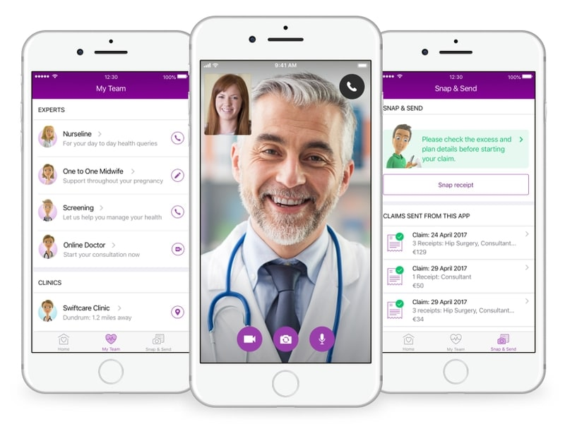
Figure 2. Layout of the VHI mobile application (Vhi.ie, 2019)

On the mobile application there are a number of different features available to the client. The ‘Medical ID’ section allows the user to create a medical ID to keep a personal record so that they can access their medical records on the go and with ease. Information from contact details including phone, email and home address to medical details including blood type, emergency contact, allergies and medical conditions and any medications they are currently taking can all be stored here. The ‘My Policy’ section keeps track of any information relevant to the client’s policies such as the policy name and number and any details pertaining to the coverage allowing them to quickly access any necessary information they may need or improve upon their overall understanding of their policies. If any further explanation is required, then the client can go to the ‘My Team’ section where any questions they have will be answered by VHI operatives. A section called ‘VHI Swiftcare’ provides the client with their nearest VHI clinic based on their location and tells them whether it is open and when it is due to close. The ‘Snap & Send’ section allows them to claim everyday medical expenses by taking a picture of any receipts and including a short description before submitting. A reward program called ‘Parkrun’ is also on the application to encourage fitness and community.
A brand-new experience, ‘Online Doctor’ has recently been integrated into the application to allow clients to communicate with doctors via face to face video consultations. The client simply checks in through the app and fills in the purpose of the consultation and, if applicable, any payment details. Most of the information is pre-populated using the information from the ‘Medical ID’ section. They will be contacted by a doctor though a push notification within 25 minutes of checking in. The doctor is capable of issuing a prescription to the clients chosen pharmacy and a sick note, if required. [6]
From available imagery such as Figure 2, the overall flow of the application appears to be designed for a smooth and enjoyable user experience. The navigation is well thought out and clients can access all the information they require quickly. VHI provides their clients with a multitude of features, some of which are simple in theory, but add to the overall experience. For instance, the Member ID section allows the client to not only keep their personal record on hand at all times but is also used efficiently to populate the form filled out when requesting a consultation, reducing the time it takes to request consultations. A possible shortcoming of the app is that there are no features that support a follow up consultation if the patient requires further information or treatments; instead, they must restart the process. There are also no records of past appointments or reoccurring ones kept inform patients if they are due any check-ups.

3.3. VideoDoc
VideoDoc is an online video communication service which provides patients with access to registered Irish Medical Council doctors and accredited specialist therapists. Prior booking of an appointment is not required; these medical professionals are available throughout the week between the hours of 8am to 10pm, excluding public holidays. Once a patient has registered with VideoDoc, its services can be accessed through the online website on a computer as well as the mobile app which is on both Androids Google Play store and the iOS Apple app store.
Through secure video chat, patients can talk to a doctor within minutes and seek a diagnosis and treatment for everyday illnesses so long as they do not require a physical assessment. VideoDoc also provides sick notes or referral letters, if applicable, and if a prescription is required the doctor can contact the patients chosen pharmacy to arrange for collection or have it delivered to the patient for free by the next working day. [7]
Unfortunately, without registering as a patient access is limited to the service and the applications functionality cannot be fully explored. From any available imagery and online customer reviews, it can be determined that the application allows the user to initiate a video call, where they are first asked to pay. Once the transaction has successfully completed, they briefly wait in a digital lobby until the doctor picks up their call.

3.4. Irish Life Health
Irish Life Health is a health insurance company that was formed in 2016 following the acquisition of Aviva Health and Irish Life acquiring 100% ownership of GloHealth. Its aim is to create a compelling alternative to existing health insurance offerings, for customers, through a focus on innovation and customer value. Irish Life Health provides a number of exclusive services, available on select insurance plans, but from a software development perspective the most interesting service is the online services found in Digital Doctor, which allows clients to speak to a fully qualified GP anytime from anywhere.

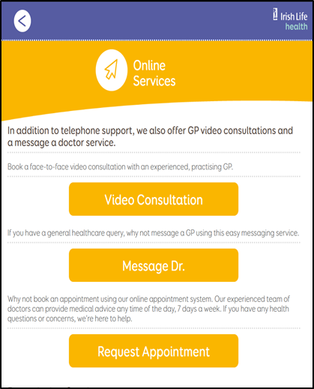
Figure 3. Online services page and message doctor page on the website (Digital Doctor, 2019)

The client can message a doctor with the option to attach an image if they have a general healthcare query. As shown in figure 2, they must fill in a form with their policy number, name, date of birth, gender and email address, then type their question in a message box that allows up to 140 characters of input. They can optionally attach an image and then click a button which will send the form. If the client feels they would benefit more from a telephone consultation they can book an appointment by calling a 24 hour a day phone service. Digital doctor also offers face to face GP consultation through a video service which the client can access on their smart device or computer. The consultation is conducted securely via a web browser and uses webcam to allow the user to visually interact with the doctor. If the user is using a desktop or laptop, they must have Adobe Flash Player installed. If they are on a mobile device, there is a free app called ‘VCI Mobile’ from the App Store or Google Play prior to the appointment. The consultation will be accessed via a link emailed by the doctor.
A prescription service is also available, where the client can arrange for it to be sent to local pharmacy. The doctor will fax the prescription to a pharmacy of the clients’ choosing and the client can collect and pay for it at the pharmacy. In line with clinical best practice guidelines, digital doctor GPs are unable to issue repeat prescriptions for the ongoing treatment of long-term conditions. [8]

The application is scalable as you change the size of the browser and can be accessed while browsing on the mobile, providing a similar feel to the desktop version. There is a lot of documentation on each page to help the client understand how to use the application. However, this text also makes the pages difficult to take in, visually speaking. Using the audit developer tool, the overall results of Irish Life Heath were:
- Overall performance is 81 with the time it takes the page to be interactive at 5.1 seconds.
- Accessibility is 59 and the application could do with significant improvement to text contrast ratios and the html does not specify a language element for screen readers.
- Best practices is 86 but it utilises front-end JavaScript libraries and the tool has detected 7 security vulnerabilities.
- Search engine optimisation (SEO) is 78 and only needs to implement a few changes to the HTML.
- Progressive web app stats indicate that it does not implement service workers and is not configured for splash screen, which decreases the user experience when loading the application from their home screen.
This application has a lot of online functionality in regard to communication methods; a client can choose between message, phone or video call. They also allow the option of what device the client wants to use for a video conference and have a supporting mobile native application for mobile video calls. A doctor can arrange for a prescription to be sent to the client’s local pharmacy through fax where they can pay for and collect it, further removing the need to have to see a doctor in person.

4. Application Methodology & Features
Based on the assessment of the four previous online healthcare applications it was evident that the companies favoured method of development was either a web application that functioned on multiple browsers, a mobile application that was supported on Android and iOS or a combination of a web application with an optional mobile application service. The main feature that appeared throughout all of the applications was a form of communication between patient and doctor, be that from an online form for a consultation booking or an online message and video chat feature. “The way in which people rely on new communication channels matters greatly for the future of digital medicine.” [9]
An important aspect that should be considered when developing these types of applications is the level of human interaction that the patient is receiving. A common problem associated with the expansion of the digital era is the demise of personal and social relationships. When designing applications for this industry, developers must “be honest about which losses are survivable and which are not, and to build in fixes that recreate (or reimagine) the parts of the exchanges that remain crucial to the work.” [10] In order to create an application desirable to a consumer base resistant to change, it is vital provide them with an experience just as personal as if they were in their local clinic, talking face-to-face with their GP.
Another careful consideration should be the security measures implemented when handling sensitive data. “Ordinary people have been slow to embrace technology in managing their personal health care” because they are concerned “about the confidentiality of medical records, and professionals fear that the costs of technology will outweigh the benefits.” [9]
For the minimum requirements, the application should be capable of providing at least one form of communication between the patient and a qualified GP, be this through a one to one message or video meeting feature. The patient should also be able to request a sick note or prescription. The application should store essential personal medical information pertaining to the patient so that they can access it quickly and with ease. The application will allow the patient to book and keep track of regular appointments, for instance upcoming and past appointments. They will also have the option of viewing these appointments on a calendar with the ability to cancel the appointment if necessary.
Depending on how well the development process is going additional features could be considered for implementation, such as a secondary communication method and online payment methods for prescriptions so that they can be paid and delivered to the patient. Before deciding upon the technologies that will be used to develop these features, the differences between mobile and web applications is assessed to decide upon the most suitable method of development.

4.1. Mobile Applications

4.1.1. What is a Mobile Application?
A mobile application (mobile app) is a smaller scaled software program developed for mobile devices such as smart phones and tablets. It provides the user with services similar to those found on a desktop but with increased interactivity and viewability of information in a concise manner on smaller more portable devices. Over the last couple of years, there has been a dramatic increase in the number of mobile apps being downloaded by consumers. “In 2018, consumers downloaded 194 billion mobile apps to their connected devices, up from 143.7 billion app downloads in 2016.” [11]
Figure 4. High level overview of mobile application development architecture

Typically, mobile applications comprise of three architectural layers [12], as seen in Figure 4:
- Presentation Layer – This layer contains the components necessary to present the application to the end user and consists of user interface (UI) components and the components required to process them, essentially the views and controllers.
- Business Layer – This layer focuses on how the business will be presented to the end users, otherwise known as the business front, and is made up of workflows, business entities and components such as logging, caching, validation, security etc.
- Data Layer – This layer concentrates on meeting application requirements and contains data utilities, data access components and service tools and as such must facilitate secure data transactions.
When designing a mobile application, the following device characteristics will determine the scope of the applications features and should be evaluated accordingly to the mobile architecture:
- Operating System (OS) i.e. Android, iOS, Blackberry, Windows.
- Screen size and screen resolution (Dots per inch - DPI).
- Storage capacity.
- Central Processor Unit (CPU) capabilities.
- Graphical interface.
- Screen buttons and touch screen functionality.

4.1.2. Native Mobile App Development
A native mobile application is a software program written in a particular programming language for a particular platform. It is built with the specific device and OS in mind so that it can fully utilise the hardware and software available, to provide an optimum performance.
Advantages:
- An impressive range of functionality due to utilising the devices capabilities.
- With each OS update, the app can take advantage of system improvements to stay relevant to the current market.
- The app can be listed on the Google Play store or iOS App Store, increasing its credibility and the customers overall confidence in the apps capability to provide a satisfactory user experience.
Disadvantages:
- Regular maintenance and updates may be required due to devices regular software updates.
- There can be extensive costs for testing requirements due to the variety of screen sizes and resolutions available.
- The duration of the development process can be extensive due to the technologies being used.

4.1.3. Cross-Platform Mobile App Development
A cross-platform mobile application is a software program written using a single codebase that is compatible with multiple platforms. This form of mobile development allows for a single team to concentrate on the development of a single application that can be deployed, rather than having multiple smaller teams develop native apps for each individual platform.
Advantages:
- In developing an app that is cross-platform, the overall development is much more cost efficient as only one codebase must be created and maintained.
- By creating an app that is accessible on multiple platforms the app has an expanded market reach, increasing its overall number of users.
- Cross-platform development is much more convenient as opposed to native development because it only requires one programming language instead of having to learn multiple languages to support different platforms.
Disadvantages:
- Some platforms might experience delays in receiving application updates that implement new features due to the delays in the platforms own system updates.
- In adhering to one uniformed application design, cross-platform development cannot implement unique platform or device features to the application and therefore limits the utilisation of individual capabilities.
- While cross-platform apps have good performance, they are not as powerful as that of native apps and not recommended if application performance is a high priority.

4.1.4. Native V.S Cross-Platform
If the project is built as a mobile application, then it will decidedly focus on android devices due to time constraints and prior knowledge, with the intention of eventually catering to other devices such as iOS at a later date. In developing a native app, it would be capable of utilising any existing native technologies as well as taking advantage of any platform and device features unique to Android. Initially, given the scope of this project it makes sense to concentrate on successfully implementing one application on one platform that is of a high standard as opposed to on multiple platforms that may result in a diluted quality.

4.1.5. Mobile Application Security
Mobile applications are considered high-priority targets to cybercriminals looking to exploit security vulnerabilities in order to gain confidential and private information. [13] The most common exploits on mobile are when an application becomes compromised due to malware or an unauthorised app is downloaded that in not an officially launched app. The following methods should be applied to protect the integrity of a mobile app:
- Data encryption to ensure that any data being transferred between devices is encrypted.
- Regular testing should be carried out to ensure the applications security standards are always up to date.
- Deny password saving where the user is required to use login credentials and do not allow them to save their password on the device or in the cloud.
- Force a session end, in that if they are inactive for a certain amount of time they are automatically logged out.
- Publicly provide a list of verified download sites so that the app is only being downloaded from a trusted source.

4.2. Web Applications

4.2.1. What is a Web Application?
A web application (web app) is an interactive, software-based program that can be accessed through a network using a web client. Web applications require a web server to manage requests from the client, an application server which completes the requests and a database to store any of the necessary information. As seen in Figure 5 [14], the general flow of a web app in operation is as follows:
- The user triggers a request to the web server over the network through a web client.
- The web server forwards this request to the application server.
- The application server performs the requested task.
- The application server sends the result of the task back to the web server.
- The web server relays the information back to the web client and it appears on the user’s display.

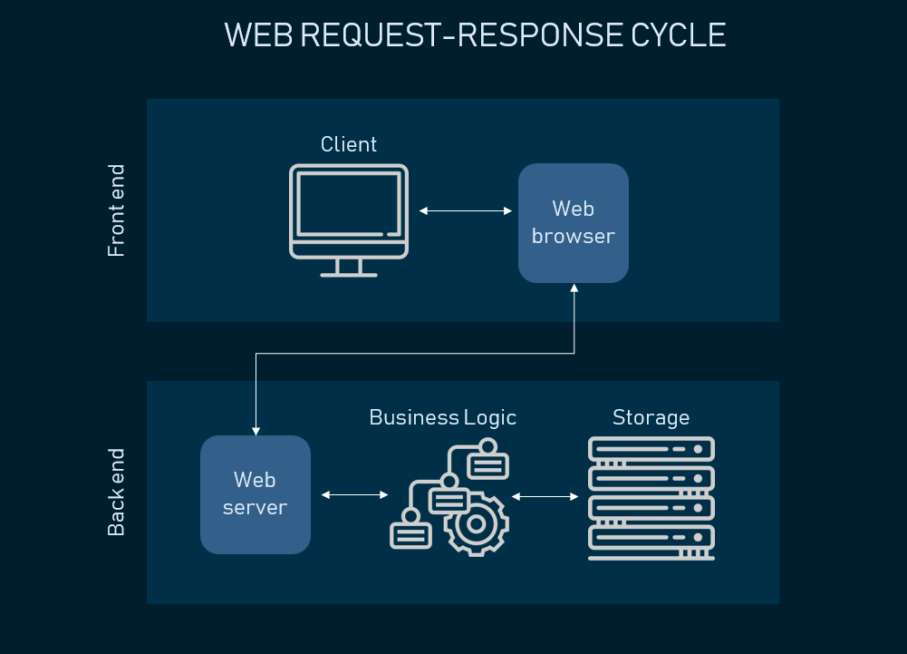
Figure 5. Diagram of the web request-response cycle (AltexSoft, 2019)

Web applications can be accessed through various devices such as desktop, laptop or mobile and can run on multiple browsers. Although they require an active internet connection in order to be used, they eliminate any storage limitation concerns, as there is no need to download the program to the user’s device. They are developed using a variety of programming languages for client-side and server-side; the chosen technology stack depends on the projects size and complexity.

4.2.2. Progressive Web Applications
A progressive web application (PWA) combines the latest and greatest features of web applications with the user experience of native mobile applications; in other words, it is a website built using web technologies that acts and feels like a mobile app. A progressive web application utilises application program interfaces (APIs) along with progressive enhancement strategies to deliver a reliable, responsive and engaging experience to every user regardless of their browser or device. “According to a 2016 comScore report, the average person spends 84% of his time on mobile devices using just the top 5 most popular apps.” [15] In this regard progressive web apps are gaining increased attraction because they make it easier to reach the desired target market, without the need to compete with a user’s most popular mobile apps.

PWAs provide an interactive user experience similar to a mobile device or tablet through the mimicking of the applications flow and navigation systems. They can also implement push notifications that can be sent to the users’ device regardless of whether the users’ browser is open or the application active. Another interesting feature of PWAs is their ability to be network independent. They can function offline through the integration of service workers, unlike standard web applications. [16]
Advantages:
- PWAs provide a responsive user experience on multiple devices and browsers whilst also maintaining low costs in development due to the technologies used.
- Security on these types of applications is high thanks to the use of Hypertext Transfer Protocol Secure (HTTPS), which provides secure communication over a network and protects users from viruses and cybercriminals attempts to hack private information.
- There is no need to install progressive web apps and therefore using them saves space on the user’s device.
Disadvantages:
- Limited access to the devices operating system means any features that revolve around the phone’s hardware cannot be harnessed such as proximity sensors, NFC or even contacts.
- A lack of store presence may negatively impact the number of users in the sense that some users will only search for apps on an app store and may be unaware that there is an alternative application available.
- Whilst PWAs do not take up space on device storage, the trade-off is that they have a higher battery consumption rate which might be a deterrent to users who are conscious of battery life and may not be able to charge their device throughout the day.

4.2.3. Web Application Security
While web apps are typically easy to develop, deploy and maintain, they are also considered high-priority targets to cybercriminals who will look to exploit vulnerabilities in the application’s source code. Due to the amount of personal and private data being handled and stored, it is vital that they are securely designed to prevent these vulnerabilities and deal with potential security threats. Failure to do so could result in the theft of confidential information which in turn will severely damage a business’s relationship with their clients and lead to possible legal proceedings. [17] Below are some of the common web app security vulnerabilities:
- SQL injections
- Cross-site scripting (XSS)
- Cross-site request forgery (CSRF)
- Session hacking
- Buffer Overflow
- Broken authentication
- Insecure communications
- Failure to restrict URL access

4.2.4. Single-Page Applications
Within web-based application development, some applications are designed as single-page applications or SPAs. With SPAs, the application dynamically loads in data from different pages, rather than require the user to load each page separately. In doing so, the overall speed and responsivity of the application are greatly enhanced, lending to an overall better user experience. Both Google Drive and GitHub are just two examples of everyday SPAs used.

4.3. Chosen Application Model
After reviewing existing healthcare applications and analysing the differences between mobile and web, it has been decided that this project will be developed as a progressive web application. “The top 1,000 mobile web properties have audiences that are almost 3 times the size of the top 1,000 apps and their audiences are growing twice as fast as native app audiences.” [15] By developing the project in this way it will be more accessible to a wider audience, whilst still offering an app-like user experience which will make it more engaging than a standard web application. It will be scalable to multiple devices and browsers, without the need to write code natively for any one specific device. The functionality intended for this project does not require the use of hardware specific features and therefore there would be no advantage in developing the application as a mobile application. Ideally, the project will also be a single page application, eliminating the need to regularly refresh the page as the user navigates the application.

5. Technologies
Having decided upon an appropriate method of development, the next requirement is to research technologies; languages, tools and development environments that can be used to develop the progressive web app. The core aspects of a web application are a web server, application server and a database and the baseline criteria for a site to qualify as a PWA are a web app manifest, a service worker and for it to be running under HTTPS.

5.1. Front-end Technologies
The front-end or client-side is essentially the structure, design, behaviour and any animations that appear when a user opens the application. Any technologies associated with this are used in the creation of a user-interface and web pages for a web application.

5.1.1. HTML5
HTML5 is “an effort to bring order to web development chaos by organizing common practices, embracing implementations from various browsers. It is massive, with over 100 specifications as part of the HTML5 specs.” [18] HTML5 is the latest version of Hypertext Markup Language (HTML) which is a standard markup language for web pages and can be used to create cross-platform web applications that can be accessed and function without a network connection. When used in conjunction with CSS and JavaScript, a basic functioning HTML page can be transformed into an attractive, modern and sleek web application.

5.1.2. CSS3
CSS3 is the latest version of Cascading Style Sheets (CSS) and is used alongside HTML to visually enhance a web page. It is used to separate the layout or structure from the presentation of a page by specifying the style, such as its colour and font, and making it easier to maintain and share style sheets across multiple pages. CSS3 “brings a lot of new features and additions, like rounded corners, shadows, gradients, transitions or animations, as well as new layouts like multi-columns, flexible box or grid layouts.” [19]

5.1.3. JavaScript
JavaScript (JS) is a client-side scripting language that enables interactivity within the web application. If HTML is the shell of the site and CSS is the style, then JS is responsible for the behaviour that enables functionality within the overall application. As JS is an interpreted language, it does not require prior compiling and “renders web pages in an interactive and dynamic fashion. This allowing the pages to react to events, exhibit special effects, accept variable text, validate data, create cookies, detect a user’s browser, etc.” [20]

5.1.4. XML
XML, which stands for eXtensible Markup Language, is a markup language that “stores data in a form where it can easily be retrieved and shared – even by incompatible applications.” [21] It is designed to be self-descriptive, does not use predefined tags and is designed to work with older versions of applications even as new data is added or removed.

5.1.5. JSON
JavaScript Object Notation (JSON) is similar to XML in that it is a minimal data format used to structure data so that it can be transferred between the server and web application. As an alternative to XML, some consider it easier to read and more capable of rapidly loading in data without negatively impacting load times. JSON is also used to create a web app manifest which stores information about a web application, necessary if the web app is to be downloaded to the user’s device.

5.1.6. AJAX
AJAX, otherwise known as Asynchronous Java and XML (Extensible Markup Language) is a set of development techniques used to create reliable and agile web applications with enhanced interactivity through a combination of XML, HTML, CSS and JS. Possibly one of the greatest benefits of using AJAX is that it allows for content to be dynamically reloaded; once the page has initially loaded up it can update its content without the need to refresh or reload creating a seamless user experience. [22]

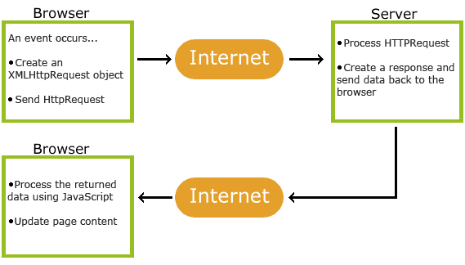
Figure 6. Diagram of how AJAX operates (W3schools.com, 2019)

5.2. Back-end Technologies
The back-end or server-side consists of a server, database and an application that operate in the background. The technology is not visible and cannot be interacted with by the user. The back-end is essentially the machine that runs the front-end, delivering functionality and providing information from the database to the application on a browser.

5.2.1. C#
C# is a hybrid of C and C++ and is a modern, multi-paradigm programming language, widely used in back-end development. It boasts a range of features, such as strong typing, garbage collection, simplified type-declarations, versioning and scalability support, which are designed for quick and easy development. It encompasses object-oriented and component-oriented programming practises which are ideal for developing web and network applications. C# supports cross-platform development and is open source, providing a vast amount of public documentation. [23]

5.2.2. Python
Python is “a multi-paradigm language offering developers the options of object-orientation, structured programming and functional programming” [24] with a philosophy of focuses on code readability and maintainability. It is easy to use and easy to deploy, so is often used to develop scalable web applications. It is ideal for faster development and processing when handling large volumes of data due to its’ concise coding standards and possesses strong integration and text processing capabilities. Python has an extensive library support and has a large, open-source and ever-expanding developer community.

5.3. Databases

5.3.1. SQL & MySQL
MySQL is an open-source, relational database system that integrates with SQL and is ideal for web-based applications. Structured Query Language (SQL) is used to store, manage and retrieve data in relational databases. It has become the industry standard for manipulating and querying data and can embed within other languages using SQL modules, libraries and pre-compilers. SQL can create components such as tables, schemas, stored procedures and domains.

5.3.2. MongoDB
“MongoDB is a general purpose, document-based, distributed database built for modern application developers and for the cloud era.” [25] MongoDB is classified as NoSQL and uses JSON documents which supports arrays, nested objects and allows for dynamic schemas. It is designed for storing Python web applications and handling large volumes of data.

5.4. Frameworks
A web development framework is a set of resources and tools used to build web applications. They define out-of-the-box content, user authentication features and administrative tools. Frameworks are used to save time by using pre-existing components that can be customised and built upon instead of writing basic functionality from scratch.

5.4.1. Semantic UI
Semantic Ui is a development framework with an expansive component library powered by LESS and jQuery that is used to create responsive layouts for front-end web development. It has over 3000 theme variables, over 50 UI components and 5000 commits on GitHub to date. Semantic UI strives to create a language for sharing UI by “leveraging a semantic, descriptive language for its classes and naming conventions. Instead of using abbreviations, as other frameworks do, it utilizes real words in a manner closer to plain English.” [26] Semantic UI also supports integration with other libraries, such as React and Angular.

5.4.2. Bootstrap
Bootstrap is a client-side framework for HTML, CSS and JavaScript that focuses on developing mobile-like applications for the web. Bootstraps developer toolkit provides the ability to create custom built web applications through the use of pre-built components that can also be customised to implement responsive features. “All of this allows frontend web development to be catapulted forward, building on a stable foundation of forward-looking design and development.” [27]

5.4.3. AngularJS
“AngularJS is a model-view-controller, client-side JavaScript framework. Dependency injection, HTML directives, and two-way binding are just some of the features that make AngularJS compelling.” [28] AngularJS is open source, functions across multiple platforms and browsers and is suitable for developing web applications with high-speed performance through web workers and server-side rendering. It has a multitude of tools that helps to develop features with ease using both pre-built and custom-made components.

5.4.4. Django
“Django is a high-level Python web framework that encourages rapid development and clean, pragmatic design”, built to reduce the “hassle of web development” so developers “can focus on writing the app without reinventing the wheel.” [29] Using Django, developers can create scalable and secure applications from start to finish with ease. Like Python, Django has a large community of developers, 12,549 to date, and a vast amount of open source documentation from tutorials to reference guides from which to learn from.

5.5. APIs

5.5.1 WebRTC
Web Real-Time Communications or WebRTC is a free, open-source project that was created by Google to enable peer-to-peer communications within applications. Whether web-based or mobile, WebRTC allows developers to implement real-time communications, such as audio, video and data transfers, through application programming interfaces. WebRTC functions by performing two different types of interactions over a network. The first, signalling, takes place over a HTTPS connection and is used to determine how two users will find one another to begin communicating. The second, media, goes through a separate connection known as a media channel, either using Secure Real-Time Transport Protocol (SRTP) or Stream Control Transmission Protocol (SCTP) depending on whether the media is voice and video or data transfers. The technologies three main API groups are “getUserMedia” which is used to provide a user with access to the camera, microphone and screen, “PeerConnection” which handles the core functionality of WebRTC and “DataChannel” which is used for sending any data. [31]

5.6. Additional Technologies

5.6.1. Blockchain
A blockchain is a database with all the information stored in blocks. A block is a collection of data; each block can store up to 1MB. When a block stores new data it is then added to the blockchain. Blocks store information about transactions, the participants in said transactions and unique codes, or cryptographic “signatures” known as a hash, that distinguish each of the blocks from one another. Blockchain such as Smart Contracts with Solidity, Ethereum and Geth utilises powerful cryptographic techniques to create this digital, distributed ledger. “While blockchains can be used systems of record and are ideal as transaction platforms, they are considered slow as databases when compared to what is possible for digital transaction technology.” [30] Blockchains are not ideal if the process involves confidential data or the data stored is large.

5.6.2. Lighthouse
Lighthouse is an open-source, automated tool developed by Google and used to assess and improve the quality of web applications. It is excellent for tracking the PWA progress of a web application by measuring the applications against a number of audits and identifying areas of improvement to maximise the overall efficiency. Each individual audit supplies a reference document detailing what the audit is, what its importance is and the solution to rectifying any issues.

5.6. Chosen Technologies
After taking a number of front-end technologies into consideration, it has been determined that the client-side of the application shall be developed using HTML5, CSS3 and JavaScript to create the shell, style and functionality of the user interface. JSON will be incorporated to produce a web app manifest for possible offline functionality. AJAX development techniques will be utilised to ensure that the application is reliable, agile and interactive and that any information is dynamically reloaded, giving the application a more professional edge. On the server-side of the application C# will be used along with a MySQL database, which is compatible with the front-end technologies, to process and return any information being requested from the server-side. Semantic UI will be used to develop the user interface and overall user experience. Googles Lighthouse tool will be used frequently to assess and improve the applications quality.

6. Conclusion
From the research carried out in this document, it is intended that the application will be designed as a progressive web application, capable of catering to a wide audience on multiple devices and browsers. It will include a number of features, some common to existing applications, such as communication methods and a record of personal information, while other features such as appointment tracking and reminders will be specific to this application. The goal is to provide patients with a service that allows them to easily avail of healthcare without having to leave their home, whilst still retaining a level of personal engagement so as to not detract from the social and personal aspect of health services.
The application will be designed using a number of technologies, HTML5, CSS3, JavaScript, JSON and AJAX for front-end, C# for back-end with a MySQL database and Semantic UI with Angular JS integration for frameworks as well as the Lighthouse auditing tool for achieving maximum efficiency.

7. Plagiarism Declaration
C00214010
Holly Gunning
01/11/2019

8. Bibliography

8.1. References
[1] McDermott, S. (2019). Poll: Have you had problems getting a doctor's appointment recently?. [online] TheJournal.ie. Available at: https://www.thejournal.ie/poll-doctors-appointment-4781419-Aug2019/ [Accessed 27 Oct. 2019].

[2] Sharma, S., Xu, H., Wickramasinghe, N. and Ahmed, N. (2006). Electronic healthcare: issues and challenges. International Journal of Electronic Healthcare.

[3] Booking.healthclinics.superdrug.com. (2019). Superdrug. [online] Available at: https://booking.healthclinics.superdrug.com/modules/connect/bookings.php?compid=8345 [Accessed 20 Oct. 2019].

[4] Healthclinics.superdrug.com. (2019). Health Clinics - Superdrug™. [online] Available at: https://healthclinics.superdrug.com/ [Accessed 20 Oct. 2019].

[5] Ribot.co.uk. (2019). ribot - A digital design studio for mobile, tablet, TV and beyond…. [online] Available at: https://ribot.co.uk [Accessed 22 Oct. 2019].

[6] Vhi.ie. (2019). Health Assistant | Vhi Healthcare Ireland. [online] Available at: https://www.vhi.ie/members/vhiapp [Accessed 22 Oct. 2019].

[7] VideoDoc. (2019). videoDoc - How It Works. [online] Available at: https://videodoc.ie/how-it-works/ [Accessed 23 Oct. 2019].

[8] Digitaldoctor.mygpsurgery.eu. (2019). Digital Doctor. [online] Available at: https://digitaldoctor.mygpsurgery.eu/online-services.php [Accessed 20 Oct. 2019].

[9] West, D. and Miller, E. (2009). Digital Medicine - Health Care In The Internet Era. 1st ed. Washington, D.C.: Brookings Institution Press, p.58, p.23.

[10] Wachter, R. (2015). The Digital Doctor: Hope, Hype, and Harm at the Dawn of Medicine’s Computer Age. 1st ed. McGraw-Hill, p.238.

[11] Clement, J. (2019). Annual number of mobile app downloads worldwide 2018 | Statista. [online] Statista. Available at: https://www.statista.com/statistics/271644/worldwide-free-and-paid-mobile-app-store-downloads/ [Accessed 21 Oct. 2019].

[12] Helios Blog. (2019). Why Mobile App Architecture is Vital for Mobile App Development? - Helios Blog. [online] Available at: https://www.heliossolutions.co/blog/mobile-app-architecture-vital-mobile-app-development/#targetText=Mobile%20app%20architecture%20is%20a,are%20also%20taken%20into%20consideration. [Accessed 24 Oct. 2019].

[13] FraudWatch International. (2019). What is Mobile App Security? (Including 8 Application Security Tips). [online] Available at: https://fraudwatchinternational.com/mobile-applications/what-is-mobile-app-security/ [Accessed 24 Oct. 2019].

[14] AltexSoft. (2019). Web Application Architecture: How the Web Works. [online] Available at: https://www.altexsoft.com/blog/engineering/web-application-architecture-how-the-web-works/ [Accessed 21 Oct. 2019].

[15] Ater, T. (2017). Building Progressive Web Apps: Bringing the Power of Native to the Browser. 1st ed. O’Reilly Media, p.17.

[16] Medium. (2019). Progressive Web App (PWA): what they are, pros and cons and the main examples on the market. [online] Available at: https://medium.com/iquii/progressive-web-app-pwa-what-they-are-pros-and-cons-and-the-main-examples-on-the-market-318f4538c670 [Accessed 28 Oct. 2019].

[17] SearchSoftwareQuality. (2019). Top 10 Web application security vulnerabilities. [online] Available at: https://searchsoftwarequality.techtarget.com/tutorial/Top-10-Web-application-security-vulnerabilities [Accessed 28 Oct. 2019].

[18] Techopedia.com. (2019). What is HTML5? - Definition from Techopedia. [online] Available at: https://www.techopedia.com/definition/1891/html5 [Accessed 29 Oct. 2019].

[19] Medium. (2019). What’s new in CSS 3. [online] Available at: https://medium.com/beginners-guide-to-mobile-web-development/whats-new-in-css-3-dcd7fa6122e1 [Accessed 29 Oct. 2019].

[20] Techopedia.com. (2019). What is JavaScript (JS)? - Definition from Techopedia. [online] Available at: https://www.techopedia.com/definition/3929/javascript-js [Accessed 29 Oct. 2019].

[21] Softwareengineerinsider.com. (2019). What is XML and How is it Used?. [online] Available at: https://www.softwareengineerinsider.com/programming-languages/xml.html [Accessed 29 Oct. 2019].

[22] W3schools.com. (2019). PHP - AJAX Introduction. [online] Available at: https://www.w3schools.com/php/php_ajax_intro.asp [Accessed 29 Oct. 2019].

[23] Glossarytech. (2019). What is С# — get to know on GlossaryTech. [online] Available at: https://glossarytech.com/terms/c-net/csharp [Accessed 29 Oct. 2019].

[24] Rongala, A. (2019). Benefits of Python over Other Programming Languages - Invensis Technologies. [online] Invensis Technologies. Available at: https://www.invensis.net/blog/it/benefits-of-python-over-other-programming-languages/ [Accessed 29 Oct. 2019].

[25] MongoDB. (2019). The most popular database for modern apps. [online] Available at: https://www.mongodb.com/ [Accessed 31 Oct. 2019].

[26] Gerchev, I. (2019). Introducing: Semantic UI Component Library. [online] SitePoint. Available at: https://www.sitepoint.com/introducing-semantic-ui-component-library/ [Accessed 31 Oct. 2019].

[27] Spurlock, J. (2013). Bootstrap. 1st ed. Farnham: O'Reilly, p.17.

[28] Moffitt, J. and Daoud, F. (2014). Seven web frameworks in seven weeks. Dallas, TX: Pragmatic Bookshelf, p.88.

[29] Djangoproject.com. (2019). The Web framework for perfectionists with deadlines | Django. [online] Available at: https://www.djangoproject.com/ [Accessed 31 Oct. 2019].

[30] CoinDesk. (2019). What is the Difference Between a Blockchain and a Database? - CoinDesk. [online] Available at: https://www.coindesk.com/information/what-is-the-difference-blockchain-and-database#targetText=Performance,today%20with%20Visa%20and%20PayPal. [Accessed 1 Nov. 2019].

[31] WebRTC. 2020. Webrtc. [online] Available at: <https://webrtc.org/> [Accessed 28 August 2020].

